SOLID STATE

Section –A: Learning points:

The characteristic properties of the solid state:

(i) They have definite mass, volume and shape.
(ii) Intermolecular distances are short.
(iii) Intermolecular forces are strong.
(iv) Their constituent particles (atoms, molecules or ions) have fixed positions and can only oscillate about their mean positions.
(v) They are incompressible and rigid.

Classification of Solids:

On the basis of the nature of order present in the arrangement of their constituent particles,
Solids are classified as crystalline and amorphous . The properties mentioned below
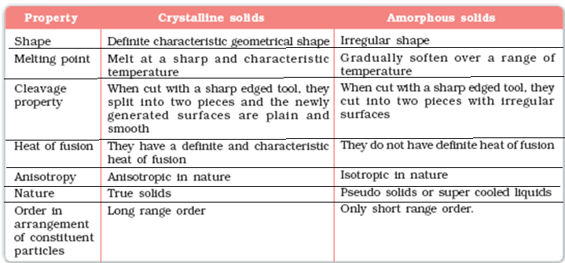

Amorphous solids :

i) On heating they become crystalline at some temperature.
ii) Some glass objects from ancient civilisations are found to become milky in appearance because of some crystallisation.
iii)These are called pseudo solids or super cooled liquids because Like liquids, they have a tendency to flow.
iv) Glass panes fixed to windows or doors of old buildings are invariably found to be slightly thicker at the bottom than at the top. This is because the glass flows down very slowly and makes the bottom portion slightly thicker.
v) Amorphous solids are isotropic in nature. It is because arrangement is irregular along all the directions. Therefore, the value of any physical property (electrical resistance or refractive index) would be same along any direction. Where as Crystalline solids are anisotropic in nature, that is, some of their physical properties like electrical resistance or refractive index show different values when measured along different directions in the same crystals.

Classification of Crystalline soilds:

All crystalline solids are classified in to 4 types. The nature , bonding with examples explained in following tabular form

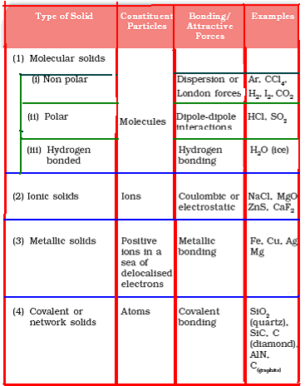

Crystal lattice:
A regular three dimensional arrangement of points in space is called a crystal lattice.

There are only 14 possible three dimensional lattices. These are called Bravais Lattices.

The following are the characteristics of a crystal lattice:

(a) Each point in a lattice is called lattice point or lattice site.

(b) Each point in a crystal lattice represents one constituent particle which may be an atom, a molecule (group of atoms) or an ion.

(c) Lattice points are joined by straight lines to bring out the geometry of the lattice.

Seven crystal structures : Cubic , Tetragonal, Orthorhombic, Monoclinic, Hexagonal, Rhombohedral, Triclinic

Unit cell :
The unit cell is the smallest portion of a crystal lattice which, when repeated in different directions, generates the entire lattice.

A unit cell is characterised by:

(i) Its dimensions along the three edges, a, b and c. These edges may or may not be mutually perpendicular.
(ii) Angles between the edges, α (between b and c) β (between a and c) and γ (between a and b). Thus, a unit cell is characterised by six parameters, a, b, c, α, β and γ.

Types of Unit Cells:

Unit cells can be broadly divided into two categories, i) Primitive and ii) Centred unit cells.

(a) Primitive Unit Cells : When constituent particles are present only on the corner positions of a unit cell, it is called as primitive unit cell.
(b) Centred Unit Cells : When a unit cell contains one or more constituent particles present at positions other than corners in addition to those at corners, it is called a centred unit cell.

Centred unit cells are of three types:

(i) Body-Centred Unit Cells: A unit cell contains one constituent particle (atom, molecule or ion) at its body-centre and eight particles are at its corners.

(ii) Face-Centred Unit Cells: A unit cell contains one constituent particle present at the centre of each face, along with eight particles at its corners.

(iii) End-Centred Unit Cells: A unit cell, one constituent particle is present at the centre of any two opposite faces along with eight particles at its corners.

Cubic crystal structure consists of three types of unit cells :

i) Primitive or simple cubic unit cell: A unit cell in which all the eight corners of the cube occupied by the particles.
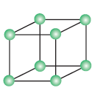
No of atoms present in this unit cell = 8 x 1/8 = 1

( Each Corner atom contributes 1/8th portion to the unit cell)

ii) Bodicentered cubic unit cell (B.C.C) : A unit cell contains one constituent particle present at the centre of each face, along with eight particles at its corners.
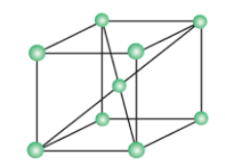

No of atoms present in this unit cell = (8 x 1/8) + 1 = 2
(Each Corner atom contributes 1/8th portion to the unit cell)
( Body centered atom is 1)

iii) Face centeed cubic unit cell (F.C.C): A unit cell contains one constituent particle present at the centre of each face, along with eight particles at its corners.
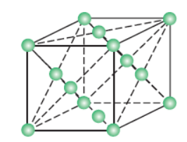
No of atoms present in this unit cell = (8 x 1/8) + (6 x ½) = 1 + 3 = 4
(Each Corner atom contributes 1/8th portion to the unit cell)
( Each face centered atom contributes ½ portion to the unit cell)
No. atoms per unit cell (Z):

Type of unit cell | No. of atoms  At corners | No. of atoms  In faces | No. of atoms  At the center | Total
Primitive cube | 8 x 1 / 8 = 1 | 0 | 0 | 1
Body Centered Cubic  (B.C.C) | 8 x 1 / 8 = 1 | 0 | 1 | 2
Face Centered Cubic  (F.C.C) | 8 x 1 / 8 = 1 | 6 x 1 / 2 = 3 | 0 | 4

Close packing structures: In solids, the constituent particles are closely packed, leaving the minimum vacant space

(a) Close Packing in One Dimension:

There is only one way of arranging spheres in a one dimensional close packed structure, that is to arrange them in a row and touching each other.



The number of nearest neighbours of a particle is called its coordination number.
Thus, in one dimensional close packed arrangement, the coordination number is 2.

(b) Close Packing in Two Dimensions:

Two dimensional close packed structure can be generated two different ways.

(a) Square close packing: The second row may be placed in contact with the first one
such that the spheres of the second row are exactly above those of the first row.
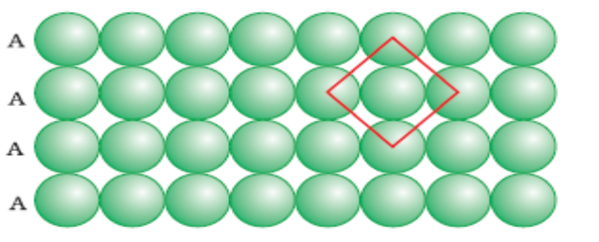
In this arrangement, each sphere is in contact with four of its neighbours. Thus, the two dimensional coordination number is 4. Also, if the centres of these 4 immediate neighbouring spheres are joined, a square is formed. Hence this packing is called square close packing.

(b) Hexagonal close packing: The second row may be placed above the first one in in the depressions of the first row. If the arrangement of spheres in the first row is called ‘A’ type, the one in the second row is different and may be called ‘B’ type. This arrangement is of ABAB type.
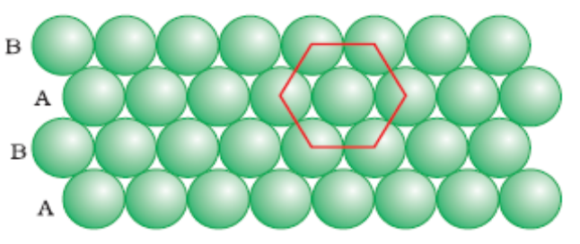
In this arrangement, each sphere is in contact with six of its neighbours and thus the coordination number is 6. The centres of these six spheres are at the corners of a regular hexagon hence this packing is called two dimensional hexagonal close packing.

The hexagonal close packing structure is better close packing structure than square close packing structure.
Voids:
Triangular void: In the hexagonal close packing 2-dimentional structure there are some voids (empty spaces). These are triangular in shape so, these voids are called triangular voids.
(c) Close Packing in Three Dimensions :

Three dimensional close packed structure can be generated by placing hexagonal close packed layers one over the other.

i) Covering Tetrahedral Voids: Tetrahedral voids of the second layer may be covered by the spheres of the third layer. In this case, the spheres of the third layer are exactly aligned with those of the first layer. Thus, the pattern of spheres is repeated in alternate layers. This pattern is often written as ABAB ....... pattern. This structure is called hexagonal close packed (hcp).
(ii) Covering Octahedral Voids: The third layer may be placed above the second layer in a manner such that its spheres cover the octahedral voids. When placed in this manner, the spheres of the third layer are not aligned with those of either the first or the second layer. This arrangement is called “C’ type. Only when fourth layer is placed, its spheres are aligned with A layer. Such arrangement is called ABCABC... (or) cubic closed packed (ccp) (or) face centred cubic (fcc) structure.

Voids:
Tetrahedral void:

A tetrahedron is formed when the centres of these four spheres are joined.

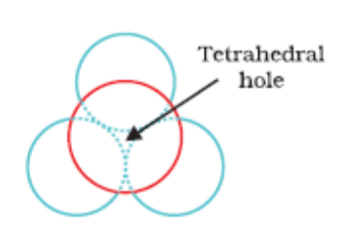
Octahedral void:

Voids are surrounded by six spheres and are called octahedral voids.
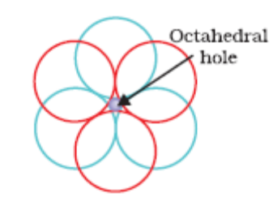

Let the number of close packed spheres be N, then:
The number of octahedral voids generated = N
The number of tetrahedral voids generated = 2N

Packing Efficiency:

i) In a Simple Cubic Lattice:

In a simple cubic lattice the atoms are located only on the corners of the cube.
The edge length or side of the cube = ‘a’,
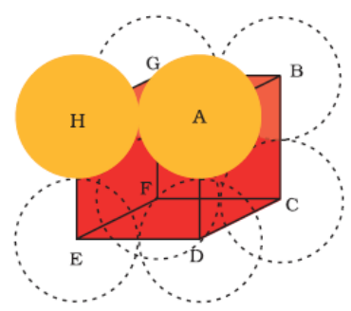
The radius of each particle = r
From the fig, a = 2r

The volume of the cubic unit cell = a³ = (2r)³ = 8r³
Since a simple cubic unit cell contains only 1 atom
The volume of one atom occupied space = 4/3π r³

Packing efficiency = (Volume of one atom / Volume of cubic unit cell) x100%
= 4/3π r³ / 8r³ x 100%
=52.38%
Thus, we may conclude that ccp and hcp structures have maximum packing efficiency

ii) In a Body-Centred Cubic Structures:

In a Body centered cubic lattice the atoms are located at the corners of the cube and one atom at the center of the cube.

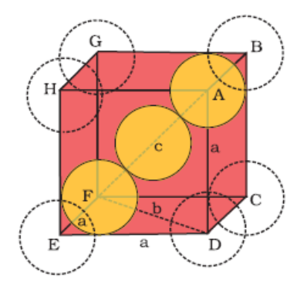
From Fig. it is clear that the atom at the centre will be in touch with the other two atoms diagonally arranged.
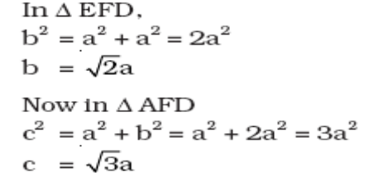

The length of the body diagonal c is equal to 4r,
Therefore
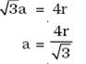
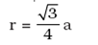
thus,

Total number of atoms is 2, and their volume = 2 x (4/3)π r³
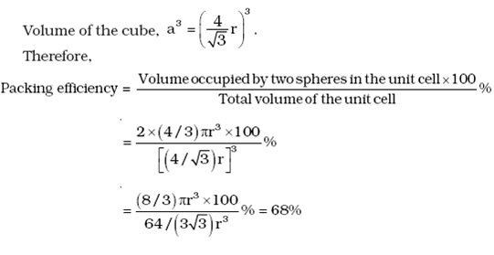
iii) In a Face-Centred Cubic (HCP and CCP) Structures:

In Fig let the unit cell edge length be ‘a’ and face diagonal AC = b.
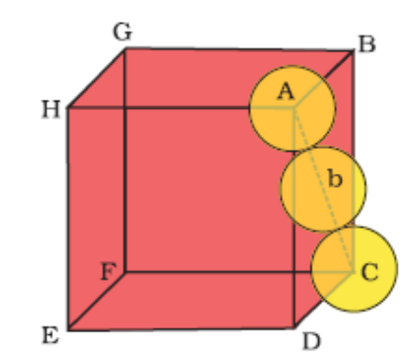
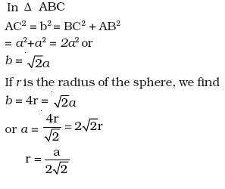
We know, that each unit cell in fcc structure has 4 atoms.
Total volume of four spheres is equal to 4 x (4/3) π r³
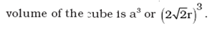
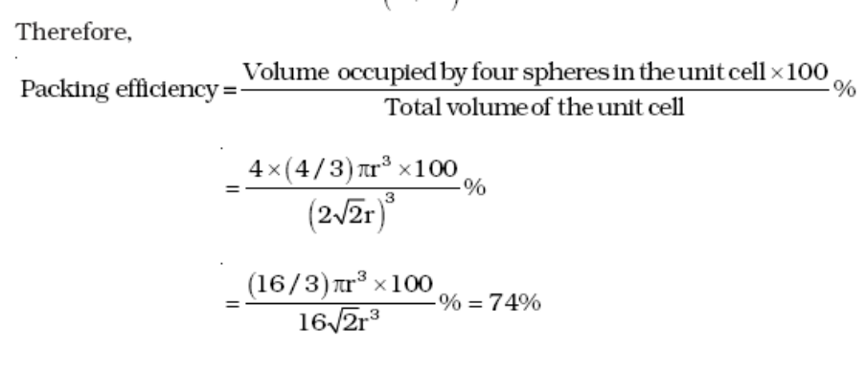
Thus, we may conclude that ccp and hcp structures have maximum packing efficiency.

CALCULATION OF DENSITY OF THE UNIT CELL:

→ Let us write the formula of density of the unit cell,

Mass of the unit cell
Density of the unit cell =------------------------------------ --------→ Eq (1)
Volume of the unit cell

Step1: Calculation of the volume of the unit cell:

a

a

a

Cell edge of the unit cell = a cm

Volume of the unit cell = a cm x a cm x a cm
= a ³ cm³ --------------- Eq (2)

Step2: Calculation of the mass of the unit cell
Mass of the unit cell = (No. Of atoms per unit cell) x (mass of each atom)

We know that mass of 1mole atoms/molecules is equal to its molar mass.
So, Mass of 6.023 x 10²³ atoms / molecules = molar mass
∴ Mass of 1 atom = molar mass / N₀ i.e M / N_{o}

∴ Mass of the unit cell = (Z) x (M / N_{o} ) ---------------→ Eq (3)

Substituting Eq(3) & Eq(2) in Eq(1),

Mass of the unit cell
∴ Density of the unit cell = ------------------------------------
Volume of the unit cell

(Z) x (M / N_{o} )
ρ = ----------------------------
a³

Z x M
∴ ρ = -----------
N_{o} x a³

Where Z = No. of atoms per Unit cell
M = Atomic mass / Molecular mass in gm
No = Avagadro number = 6.023 x 10²³.
A = Cell edge in cm
ρ = Density of the unit cell in gm cm⁻³

Values of Z and a:

Name of the unit cell with Example | Values of Z | Relation of  ‘a’ with ‘d’ | Relation of  ‘a’ with ‘r’ | Inter ionic  Distance
Simple cubic | 1 | d = 2r = a | a = 2r ⇒ r = a / 2
B.C.C(CsCl type) | 2 | d = 2r = (√3 a) / 2 | r = (√3 a) / 4 | r⁺ + r⁻ = (√3a) /2
F.C.C(NaCl type) | 4 | d = 2r = (√2 a) / 2 | r = a / (2 √2) | r⁺ + r⁻ = a / 2

Where d -----→ Distance between the nearest neighbor.
r ----→ Radius of the atom.
r+ --→ Radius of the cation
r- ----→ Radius of the Anion.

Defects or Imperfections:

The defects are basically irregularities in the arrangement of constituent particles.

The defects are of two types:

a) Point defects: The irregularities from ideal arrangement around a point or an atom in a crystalline substance.
b) Line defects: The irregularities from ideal arrangement in entire rows of lattice points. These irregularities are called crystal defects.

Point defects can be classified as:

(i) Stoichiometric defects:

The defects in which stoichiometry of the compound is not disturbed. The following two types of point defects are commonly found in the crystalline ionic substances.

Schottky Defects:

1) The absence of a cation or anion from the position which it is expected to occupy in
the periodic arrangement of ions is known as Schottky defect.
2) The vacant positions give rise to vacancies or voids in the structure of the
substance.
3) The Schottky defects are more common in ionic compounds with high coordination numbers and where the positive and negative ions are of similar size.
e.g., NaCl, CsCl, KCl and KBr.
4) Since the solid with a Schottky defect contains lesser number of ions as compared
to a prefect crystal, the density of the crystal exhibiting Schotky defect will be
less as compared to that of the perfect crystal.

Frenkel Defects:

1) In this type of defect, the ion, instead of being in its expected location, is found in
one of the interstices.
2) Frenkel defects are more common in ionic crystals where size of the cation is such
that it can be accommodated in the interstitial sites.
3) This type of defect is favoured by a large difference in size between the positive
and negative ions and since the size of cation is smaller than that of the anion,
the former can be accommodated in the interstitial position.
Examples are ZnS, AgCl, AgBr and AgI.
4) The density of crystals exhibiting Frenkel defect remains unchanged as the ions
are present in the interstitial sites without changing the volume of the substance.

ii) Non-Stoichiometric point defects:

The defects in which stoichiometry of the compound is disturbed.

There are two types 1) Metal excess defect 2) Metal deficiency defect.

i) Metal excess defects due to anionic vacancies:

i) Alkali halides like NaCl and KCl show this type of defect.

ii) When crystals of NaCl are heated in an atmosphere of sodium vapour, the sodium atoms are deposited on the surface of the crystals as Na⁺ ions and which traps the Cl⁻ ions from the lattice points. To make crystal electrically neutral electrons released will diffuse into the crystal and occupy anionic sites.

iii) The anionic sites occupied by unpaired electrons are called F-centres (from the German word Farbenzenter for colour centre).

Ex : a)They impart yellow colour to the crystals of NaCl.
b) Excess of lithium makes LiCl crystals pink.
c) Excess of potassium makes KCl crystals violet (or lilac).

ii) Metal excess defects due to presence of cations:

Zinc oxide is white in colour at room temperature. On heating it loses oxygen and turns yellow.
ZnO → Zn⁺² + ½ O₂ +2e⁻

Now there is excess of zinc in the crystal and its formula becomes Zn _{1+x}O. The excess Zn²⁺ ions move to interstitial sites and the electrons to neighbouring interstitial sites.

iii) Impurity Defects:

If molten NaCl containing a little amount of SrCl₂ is crystallised, some of the sites of
Na⁺ ions are occupied by Sr²⁺. Each Sr²⁺ replaces two Na⁺ ions. It occupies the site of one ion and the other site remains vacant. The cationic vacancies thus produced are equal in number to that of Sr²⁺ ions.

PROPERTIES OF SOLIDS:
I. Electrical properties:
Conductors:

1) Good conductors are those which allow the maximum current flow through them
and their conductivity is of the order 10⁸ ohm^{–1} cm^{–1}.
2) Metals are good conductors of electricity due to the presence of mobile
electrons. In the applied electric field all the electrons in the metals are
directed in one direction and therefore current flows through metals.
3) Conductivity of metals decrease with increase in temperature.

Insulators :

1) Those which do not allow the electric current to flow through them. The
electrical conductivity of insulators is the order of 10^{–22} ohm^{–1} cm^{–1}.

Semiconductors:

1) Electrical conductivity of a semiconductor at normal temperatures lies between a
good conductor and an insulator. The range of conductivity is 10^{–9} to 10² ohm^{–1} cm^{–1}.

2) Semiconductors are perfect insulators at absolute zero.

3) Silicon and germanium are semiconductors.

4) At room temperature the conductivity of silicon and germanium is extremely low
but at higher temperatures the bonds begin to break down ejecting the
electrons and hence conductivity increases.
5) Unlike metals the conductivity of semiconductors increases with temperature
because the weakly bound extra electron or positive hole become free by the
increased temperature and can be used for conduction.

6) The conduction in the crystal without adding any external substance is called
intrinsic conduction.

6) The conduction of intrinsic semi conductors can be increased by doping. Doping is
a process of mixing pure silicon or germanium with an impurity.

7) Doping enhances the conductivity and the products are called extrinsic semiconductors. They are two types :

(a) n- type semiconductor:

It is obtained by doping Si or Ge with a group 15 elements (Electron – rich impurities) like P. Out of 5 valence electrons , only 4 are involved in bond formation and the fifth electron is delocalized and can be easily provided to the conduction band.

( b) p – type semi conductor :

It is obtained by doping Si or Ge with a group 13th elements (Electron – deficit impurities) like Gallium which contains only 3 valence electrons. Due to missing of 4th valence electron, electron hole or electron vacancy is created. The movement of these positively charged hole is responsible for the conduction.

A large variety of solid state materials have been prepared by combination of groups 13 and 15 or 12 and 16 to simulate average valence of four as in Ge or Si.

Typical compounds of groups 13 – 15 are InSb, AlP and GaAs. Gallium arsenide (GaAs) semiconductors have very fast response and have revolutionised the design of semiconductor devices.

Typical compounds of groups 12 – 16 are ZnS, CdS, CdSe and HgTe .In these compounds, the bonds are not perfectly covalent and the ionic character depends on the electronegativities of the two elements.

Diagrammatic representation of conduction of an conductor, insulator and a semi conductor through a band theory:
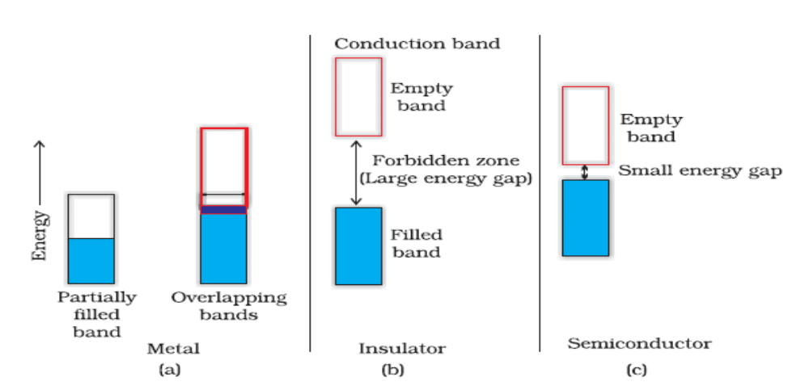
II. Magnetic properties:

Diamagnetic solids contain paired electron (↑↓) and repel the external magnetic field.
Ex: H2O, NaCl, C6H6, etc.,

Paramagnetic solids contain unpaired electrons, and are attracted into the applied external magnetic field. Ex : Fe +3, O2, Cu+2, etc.,

In ferromagnetic solids, the metal ions are grouped together into small regions called domains. When the substance is placed in a magnetic field all the domains get oriented in the direction of the magnetic field (↑↑↑↑↑). This interaction leads to an increase in magnetic moment.
Ex: Iron, Cobalt and Nickel are ferromagtnetic substances.

In antiferromagnetic solids, when the substance is placed in a magnetic field all the domains get oriented in the antiparallel (↑↓↑↓↑) direction of the magnetic field, which leads to a decrease in magnetic moment.
Ex: MnO, MnO2, Mn₂O₃.

In ferromagnetic solids when the substance is placed in a magnetic field all the domains get oriented randomly (↑↑↓↑↑↓) which leads to the presence of uncompensated spins in the opposite direction resulting in some magnetic moment.
Ex. Magnetite (Fe3O4), ferrite [M FeO4] where M = Mg (II), Cu (II), Zn (II).

For Higher achievers: ( Beyond the NCERT Text Book)
→ Radius ratio and coordination number:
Limiting radius ratio ( r+ / r-) | Polyhedron | Structure type | Coordination  number | Example
0.732 and more | Cube | CsCl type | 8 | CsI, CsBr
0.414 – 0.732 | Octahedron | NaCl type | 6 | MgO, NaBr
0.225 – 0.414 | Tetrahedron | ZnS type | 4 | CuCl, CuBr

→ Types of Crystal structure and their description:

Type of Crystal  structure | Description | Coordination Number
I. AB Type :  a) CsCl Type: →  b) NaCl type :→  c) ZnS type: → | All Cl⁻ ions occupies ccp, and all the cubic voids are occupied by Cs⁺ ions | Cl⁻ = 8  Cs⁺ = 8
 | All Cl⁻ ions occupies ccp, and all the Octahedral voids occupied by Na⁺ ions | Cl⁻ = 6  Na⁺ = 6
 | All S⁻² ions occupies ccp, and the Zn⁺² ions occupies alternate tetrahedral voids. | S⁻² = 4  Zn⁺² = 4
II. AB₂ Type: Fluorite structure :  CaF₂ Type: → | All Ca⁺² ions occupies ccp, and the all the tetrahedral voids are occupied by F⁻ ions | Ca⁺² = 8  F⁻ = 4
III. A₂B Type:  Anti Fluorite structure:  Na₂O type: → | All O⁻² ions occupies ccp, and all the tetrahedral voids are occupied by Na⁺ ions. | O⁻² = 8  Na⁺ = 4

Section – B : Important Conceptual Questions and Answers:

1Q. Classify following solids in to Molecular, Ionic, Metallic and Covalent.
Ans:
1 | P₄O₁₀ | Molecular solid
2 | Graphite | Covalent solid
3 | Brass | Metallic solid
4 | Ammonium Phosphate | Ionic solid
5 | SiC | Covalent solid
6 | Rb | Metallic solid
7 | I₂ | Molecular solid
8 | LiBr | Ionic solid
9 | P₄ | Molecular solid
10 | Si | Covalent solid

2Q) Write two differences between isotropy and anisotropy. (2 Marks )
Ans:

Isotropy | Anisotropy
i) It is property by which substances show identical, electrical and optical properties in all directions. | It is property by which substances show different electrical and optical properties in all directions.
(ii) Amorphous solids show isotropy | Crystalline solids show anisotropy.

3Q) Classify the following solids as metallic, molecular, amorphous, covalent or ionic.
(i) SO₂ (ii) Diamond (iii) I₂ (iv) MgO (iv) Ag (v) Quartz (vi) Ar (3 Marks )
(Ans) Metallic solid - Ag
Covalent solid - Quartz
Molecular solids - I₂, Ar, SO₂
Ionic solids - MgO

4Q) Atoms of element B form hcp lattice and those of the element A occupy 2/3rd of tetrahedral voids. What is the formula of the compound formed by the element A and B. (1 Mark)

(Ans) The number of tetrahedral voids formed is equal to twice the number of atoms of elements B.
A occupy only 2/3 of of tetrahedral voids
Thus, the ratio of number of atoms of A and B is given by
2 x (2/3) : 1 = 4:3
Hence, The formula of the compound is A₄B₃

5Q) A compound formed by elements X and Y crystallizes in a cubic structure in which the X atoms are at the corners of a cube and the Y atoms are at the face centres. What is the formula of the compound. (1 Mark)

(Ans) For a cubic structure,
No. of X atoms at the corner of the unit cell = 8 x1/8 =1
No. of Y atoms at the face centre of the unit cell =6 x1/2=3
Formula of the compound = XY₃

6Q) A compound formed by elements A and B crystallises in cubic structure where A atoms are at the corners of a cube and B atoms are at the face centre. What is the formula of the compound? (1 Mark)

(Ans) As we know that stoichiometric ratio of atoms in unit cell decide theemperical formula of the compounds. Here,
A atoms occupy the corners of the cube, thus the number of A atom in unit cell is 1
B atom occupy the centre of cube, thus the number of B atom in unit cell is also 1
Hence, the simplest formula of compound is AB

7Q) A compound is made of two atoms X and Y. Atom X is arranged in ccp and atom Y occupies tetrahedral site. Find the formula of compound. (2 Marks )
(Ans) No. of atoms of X = 8
No. of atoms of Y = (8/8) + (6/2) = 4
Ratio of X : Y is 2: 1
- Formula of compound is X₂Y.

8Q) A metal oxide crystallizes in a hexagonal close packed array of oxide ions with two out of every three octahedral holes occupied by metal. Find formula of metal oxide. (1 Mark)
(Ans) Let the no. of oxide ions = x
No. of octahedral holes = x
No. of octahedral hole occupied by metal =2/3 x
No. of metal ions: No. of oxide ions =2/3 x : x
= 2 : 3
- Formula of metal oxide M₂O₃
9Q) A cubic solid is made of two elements P & Q. Atoms Q are at the corners of the cube and P are at the body center. What is the formula of the compound. What are the Co-ordination numbers of P & Q. (1 Mark)
Ans: No of atoms of P = 1
No of atoms of Q = 8 x 1/8 =1
Formula of compound =PQ
Co-ordination no. of P =8, & Co-ordination no. of Q =8.

10Q) In a face centered cubic lattice atoms of A occupy corner of cell and that of B occupy face centers. One of the A atoms is missing from one corner of a unit cell. Find the simplest formula of compound. (2 Mark)

(Ans) Number of atoms of A at the corner of unit cell = 7 x (1/8) = 7/8
Number of atoms of B at faces of unit cell = 6 x ½ =3
A : B = (7/8) : 3
Simplest ratio = ((7/8) x 8) : (3 x 8) = 7 : 24
- Formula of compound = A₇ : B₂₄

11Q) Ferric oxide Crystallises in a hexagonal close packed array of oxides with two out of every three octahedral holes occupied by ferric ions. Derive the formula of ferric oxide. (1Mark)
Ans: No. of Ferric ions for each oxide ion = 2/3
Chemical formula= Fe_{2/3} O ≅ Fe₂O₃

12Q) A solid has bcc structure. Distance of closest approach between two atoms is 1.73A⁰. Find edge length of cell. (2 Marks)
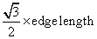
(Ans) In bcc, distance of closest approach =
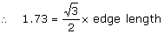
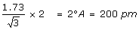
Edge length =

13Q) The density of an atom is 7.2g cm^{–3}. It has bcc structure. The edge length is 288pm. How many atoms of element does 208g of element has? (3 Marks)
(Ans) Volume of unit cell = (288pm) ³
=
Volume of 208g of element = mass / density = 208 /7.2 =28.8cm³
No. of unit cells = 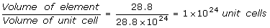
bcc cube has 2 atoms.
Total number of atoms in 208g =
=
14Q) Find the type of lattice for cube having edge length of 400 pm, atomic wt. = 60 and density = 6.25 g/cc. (3 Marks)
(Ans) Let the no. of atoms in a unit cell = x
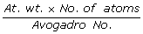
Mass of one unit cell =
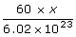
=
Volume of unit cell = (edge length) ³ =
= 64 x 10⁻²⁴ cm³
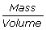
Density =
Mass =
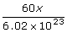
=
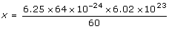
= 4
- The unit cell has 4 atoms, It is face centered cubic lattice.

15Q) KF has NaCl structure. Its density is 2.48g cm^{–3}. Find distance between K⁺ and F– ions in KF. (3 Marks )
(Ans) For fcc Z = 4, Molecular mass of KF = 58
In fcc ,
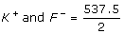
- Distance between = 268.7 pm

16Q) The density of NaCl crystal is 2.155g cm^{–3} and distance between Na⁺ and Cl– is 280 pm. Find value of Avogadro’s number. (3 Marks)
(Ans) NaCl has fcc structure.
In fcc, a (edge length) =
= pm
= 560 pm
For fcc , Z = 4, Na = Avogadro number =?
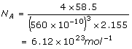
17Q) A metallic element has cubic lattice. Edge length of lattice cell is 2A⁰. The density of metal is 2.4g cm^{–3}. How many units cell are present in 200g of metal. (3 Marks )
(Ans) Edge length =
Volume of cell =
Mass of unit cell =Volume x density
=
No. of unit cells in 200g of metal = Mass of the metal / Mass of the Unit cell
= 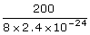
=
=

18Q) Silver crystallizes in FCC lattice. If edge length of unit cell is 4.077 x 10⁻⁸ cm and density is 10.5 g/cm³ , calculate atomic mass of silver.
Ans: ρ = (Z m ) / (a³ x N₀)
10.5 = (4 x M)/(4.077 x 10⁻⁸)³ x 6.023x10²³
M=107.09 g/mol.

19Q) Niobium crystallizes in body centred cubic structure. If density is 8.55 g/cm³. If Density is 8.55 g/cm³. Calculate atomic radius of niobium (At. Mass of Niobium=93).

Ans: ρ = (Zm)/(a³N₀)
8.55 = (2 x 93)/a³ x 6.023 x 10²³, a³=2x93/(8.55x6.023x10²³),
a=[3.6x10⁻²³ ]^{1/3} = 3.302 x 10⁻⁸ cm

20Q) Copper crystallizes in face lattice with edge length 3.61 x 10⁻⁸ cm. Show that the calculated density is in agreement with its measured value of 8.92 g/cm³.

Ans: a=3.61x10⁻⁸ cm, Z=4,
ρ = (4x63.5)/(3.61x10⁻⁸)³ x 6.023x10²³
=9 g/cm³

21Q) Formula mass of NaCl is 58.45 g/mol and density of it’s pure form is 2.167 g/cm³.
Average distance between adjacent sodium and chloride ions in the crystal is 2.814x10⁻⁸. Calculate Avogadro constant.

Ans: M=58.45 g/mol
ρ =2.167 g/cm³
A=2xdistance between Na⁺ and Cl⁻
P=(Zm)/(a³ x N₀)
N₀ = 4 x 58.45/(2.814x10⁻⁸)x(2.167)
=6.023x10²³
22Q) Thallium chloride, TlCl crystallizes in either a simple cubic lattice or a face centred cubic lattice or a face centred cubic lattice of Cl⁻ ion with Tl⁺ ion in the holes. If the density of the solid is 9 gcm⁻³ and edge of the solid is 9 gcm⁻⁸ cm, what is the unit cell geometry?
Ans: ρ =Z.m/a³N₀ ,
9 = Z x 240/(9x10⁻⁸)³x 6.023x10²³
Z=9 x 3.85 x 3.85 x 3.85 x 10⁻²⁴x 6.023x10²³/240
Z=1.289 ≈ 1, So, TlCl is simple cubic.
23Q) Gold (atomic radis =0.144 nm). Crystalises in face centred Unit cell. What is the length of a side of a cell?
a² = 8 x 0.144 x 0.144
=> a = 0.4nm.
24Q) Calculate the value of Avogadro constant from the following data. Density of NaCl= 2.165 g/cm^{3.} Distance b/w Na⁺ & Cl⁻ 281 pm.
P= Z m / a³ N₀ , N₀= 4x 58.5 / [2.165 x (562x10⁻¹⁰)³]
=6.023x10²³
25Q) A mineral contains Ca, O and Ti. Oxygen atoms are present at face centres, calcium atoms are present at corners and titanium atoms at centre of cube. Find the oxidation number of titanium in the mineral. (3 Marks )
(Ans)
No. of Ca atoms =
No. of O atoms =
No. of Ti atoms =
Formula of mineral is CaTiO₃
Let oxidation number of
So, In CaTiO₃
- Oxidation state of titanium is + 4 in this mineral.

26Q) What are voids? How a tetrahedral void differ from octahedral void? (3 Marks )
(Ans) A crystal is formed by close packing of atomsor ions, which are spherical in shape. Since, spheres touch each other only at points, some empty space is left between them. This space is called void or hole.
Tetrahedral void: Tetrahedral void is surrounded by four spheres (atoms), which lie at vertices of regular tetrahedron.
Octahedral void: Octahedral void is surrounded by six spheres (atoms).

27Q) What is doping? How does n type and p type semiconductors differ from each other? (2 M )
(Ans) The process of introducing atoms of other elements as impurity into an insulator to make it semiconductor is called doping. Doping with electron rich impurities like P, As, Sb forms n-type semiconductors whereas p type semiconductors have acceptor impurities like B, Ga.

28Q) What are-(i) Molecular solids (ii) Metallic solids .(2 Marks )
(Ans) (i) In molecular solids, the individual molecules are the constituents which are are held together by van der Waals forces of attraction. e.g. I₂.
(ii)Metallic solids consist of positive ions in a sea of electrons. The metal atoms are held together by metallic bonds. e.g. Ag, Cu.

29Q) Define: (i) Crystal lattice (ii) Co-ordination number (2 Marks )
(Ans) (i) Crystal lattice is well-defined regular arrangement of atoms, molecules or ions in three-dimensional space.
(ii) Co-ordination number is the number of atoms or ions, which surround another atom in crystal lattice.

30Q) What is rank? Find rank of face centered cubic unit cell. (2 Marks )
(Ans) Rank is the number of atoms per unit cell of a crystal.
In f c c -
Contribution of atoms of corner = 8 x 1/8 = 1
Contribution of atoms at faces = 6 x ½ = 3
Rank = 1 + 3 = 4.

31Q) What happens the density of KCl crystal by the addition of CaCl₂ crystal. (1 Mark)
(Ans) In KCl crystal, the Ca²⁺ion from CaCl₂ will replace K⁺ ions. Since one Ca²⁺ion will replace two K⁺ ion in order to make the system electrically neutral. Thus, the density of KCl crystal will decrease.

32Q) How many particles are there in a fcc unit cell of a mono atomic substance? (1 Ma)
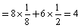
(Ans) An fcc crystal contains atoms in a unit cell

(33Q) A metallic crystal crystallizes into a lattice containing a sequence of layers AB AB AB ……Any packing of spheres leaves out voids in the lattice. What % by volume of this lattice is empty space? (1 Mark)
(Ans) AB-AB type of packing means cubic close packing in which 74% space is occupied and 26% is empty.

34Q) Why is the window glass of the old building thick at the bottom? (1 Mark)
(Ans) Glass is a pseudo solid, that is, it is a supercooled liquid of high viscosity. It is not a true solid. So, it has the property to flow.

35Q) What do you mean by F-center? (1 Mark)
(Ans) The anion sites which are cccupied by unpaired electron are called F-centres.
36Q) Sometimes, common salt is yellow instead of being pure white. Why? (1 Mark)
(Ans) Sometimes, common salt is yellow instead of being pure white due to the presence of electrons in some lattice sites in place of anions. These sites acts F-centers and impart colour to common salt.
37Q) a) What is meant by co-ordination number?
b) What is the co-ordination number of atoms in i) Cubic close packed structure ii) Body centred cubic structure.
Ans: a) It is the number of nearest neighbours of each atom or ion in a solid structure.
b) 6 & 8

38Q) Distingush between Hexagonal close packing and cubic close packing.
Ans: In a three dimentional Close packed structure of solid, the atoms of the Second layer (B) are kept in the depressions of first layer(A), two types of voids are formed – octahedral void and tetrahedral voids.
If third layer is covering the tetrahedral voids, such packing is called hexagonal close packing (ABABAB-----)
If third layer is covering the octahedral void, such packing is called cubic close packing. (ABCABCABC--------)

39Q) Analysis shows that nickel node has formula Ni_{0.98} O_{1.00}. What fractions of Nickel exist as Ni²⁺ and Ni³⁺ ion?
Ans: Let no of Ni²⁺ ions = ‘p’ and
The no. of Ni³⁺ions = ’98-p’.
Magnitude of the total Charge present on the Nickel = p (+2) + (98-p)(+3)
Magnitude of the total Charge present on the Oxygen = (2) x 100 = 200
Total charge present on Metal and oxygen are equal,
(p x 2) + (98-p) x 3 = 200
2p + 294 – 3p = 200
p = 94,
No of Ni+2 ions = 94, % of Ni+2 ions = (94 / 98) x 100 = 95.91.
No of Ni+3 ions = 98 – p = 98 -94 = 4, % of Ni+3 ions = 4/98 x 100 =4.08.
40Q) Classify each of the following as P type and N-type semiconductors.
i) Ge doped with In ans: P-type
ii) B Doped with Si : P-type

41Q) In terms of band theory, what is the difference between a conductor, semicoductor and an insulator
Ans: Energy gap between filled band and conduction band is high in insulator. In
conductors, there is no energy gap between filled band.
Conductors, Semi conductors & Conduction band
In semiconductors there is energy gap between conduction band and filled band, but
not so high as in insulators. In conductors there is no energy gap.

42Q) Aluminium crystalises in a cubic close packed structure. Its’ metallic radius is 125 pm.
(a) What is the length of the side of the unit cell.
(b) How many unit cells are there in 1cm³ of aluminium?
Ans: A) 4r=√3a, a=4x125/1.71=292 pm
B) Volume of one unit cell of Al = a³,
(292x10⁻¹⁰ cm)³=292x292x292x10⁻³⁰ cm³
No. of unit vells in 1cm³=1/(292x292x292x10⁻³⁰)= 4x10²²
43Q) If Nacl is doped with 10⁻³ mol%SrCl₂ , what is the concentration of cation vacancies.
concentration of cation vacancies=10⁻³ mol % = 10⁻³ mol/100=10⁻⁵ mol

Section –C :CBSE Question papers : Questions and Answers:

1Q. Examine the illustrate of a portion of the defective crystal given below and answer the following questions: ( CBSE –Samp 1-2008 -2M)
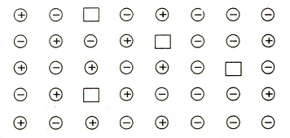
i) What are these type of vacancy defects called?
ii) How is the density of a crystal affected by these defects?
iii) Name one ionic compound which can show this type of defect in the crystalline state.
iv) How is the stoichiometry of the compound affected?

Ans: i) Schotty defect ii) Density decreases iii) Kcl shows this type of defect
iv) Stoichiometry remains same.

2Q. Analysis shows that a metal oxide has the empirical formula M 0.96 O 1.00. Calculate the percentage of M⁺² and M⁺³ ions in this crystal? CBSE –Samp 1-2008 -2M)

Ans: Let no of M²⁺ ions = ‘p’ and
The no. of M³⁺ions = ’96-p’.
Magnitude of the total Charge present on the Metal = p (+2) + (96-p)(+3)
Magnitude of the total Charge present on the Oxygen = (2) x 100 = 200
Total charge present on Metal and oxygen are equal,
(p x 2) + (96-p) x 3 = 200
2p + 288 – 3p = 200
p = 88.

No of M⁺² ions = 88, % of M⁺² ions = (88 / 96) x 100 = 91.66.
No of M⁺³ ions = 96 – p = 96 -88 = 8, % of M⁺³ ions = 8/96 x 100 =8.33.
3Q. In an ionic compound the anion( N-) form cubic close type of packing. While the cation (M+) ions occupy one third of the tetrahedral voids. Deduce the empirical formula of the compound and the coordination number of ( M+) ions. (CBSE –Samp 1-2008 -2M)

Ans: Anion N⁻ forms CCP arrangement.
The number of tetrahedral voids formed is equal to twice the number of atoms of N.
Since only 1/3 of tetrahedral voids are occupied by cations, M⁺ = 2 x 1/3 = 2/3
The ratio of number of M⁺ and N⁻ is = 2/3 :1 = 2:3
The formula of the compound is M₂N₃

4Q. A compound contains two types of atoms X and Y. It crystallizes in a cubic lattice with atom X at the corners of the unit cell and atoms Y at the body centers. What is the simplest possible formula of this compound. (CBSE –Samp 2-2008 -1M)

Ans : No of atoms of X = 8 x 1/8 = 1
No of atoms of Y = 1
The formula of the compound is XY.

5Q. An element X with an atomic mass of 60g/mol has density of 6.23g cm-3. If the edge length of its cubic unit cell is 400 pm, identify the type of cubic unit cell. Calculate the radius of an atom of this element. (CBSE –Samp 2-2008 -3M)

Ans:
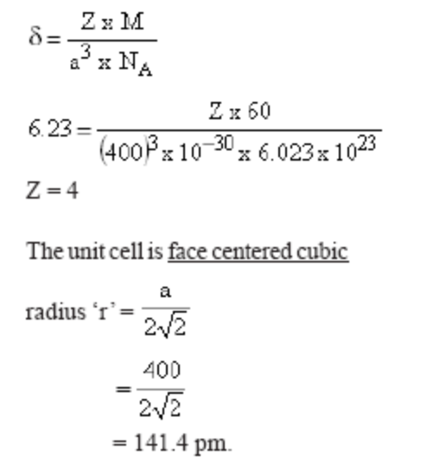

6Q. Name the type of point defect that occurs in a crystal of zinc sulphide.
(CBSE –Samp 3-2008 -1M)
Ans: Frenkel defect

7Q. How many octahedral voids are there in l mole of a compound having cubic close packed structure?
(CBSE –Samp 3-2008 -1M)
Ans: 1 Mole or 6.023 x 10 ²³ .

8Q. An element E crystallizes in body centered cubic structure. If the edge length of the cell is1.469 x 10⁻¹⁰m and the density is 19.3g/cm3, calculate the atomic mass of this element. Also calculate the radius of an atom of this element.(CBSE –Samp 3-2008 -2M)

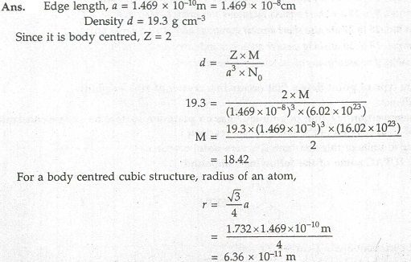
9Q.What is the coordination number of each ion in a rock –salt type structure?
(CBSE –Samp 4-2008 -2M)
Ans: Each ion has coordination number is 6.

10Q. What is a semi conductor? Name the two main types of semiconductors and explain their conduction mechanisms. (CBSE –2008 -3M)
Ans: The solids with intermediate conductivities between insulators and conductors are termed semiconductors.

(i) n- type semiconductor : It is obtained by doping Si or Ge with a group 15 element like P. Out of 5 valence electrons , only 4 are involved in bond formation and the fifth electron is delocalized and can be easily provided to the conduction band. The conduction is thus mainly caused by the movement of electron.

(ii) p – type semi conductor : It is obtained by doping Si or Ge with a group 13th element like Gallium which contains only 3 valence electrons. Due to missing of 4th valence electron, electron hole or electron vacancy is created The movement of these positively charged hole is responsible for the conduction.

11Q. What is the total number of atoms per unit cell in a face-centered cubic (fcc) crystal structure?
(CBSE –2008 -1M)
Ans: (8 x 1/8) + (6 x ½) = 4

12Q. Silver crystallizes in an fcc lattice. The edge length of its unit cell is 4.077 x 10⁻⁸cm and its density is 10.5g/cm³. Calculate on this basis the atomic mass of silver.(N₀ =6.023 x 10²³)
(CBSE –2008 -3M)
Ans: Since the lattice is fcc, the number of silver atoms per unit cell = z = 4
Molar mass of silver = M
Edge length of unit cell = a = 4.077 x 10⁻⁸ cm
Density = 10.5 g/cm³

We know that, ρ = (z x M) / (N x a³)

Atomic size = M = (ρ x N x a³) / z
= 10.5 x 6.023 x 10²³x (4.077 x 10⁻⁸)³ / 4
= 107.1 gm/mol.
13Q. What is the two-dimentional coordination number of a sphere in square close packing?
(CBSE –Supply-2008 -1M)
Ans : 4

14Q.Account for the following:
i) Fe₃O₄ is ferromagnetic at room temperature but becomes paramagnetic at 850K.
ii) Zinc oxide on heating becomes yellow.
iii) Frenkel defect does not change the density of AgCl crystals.
(CBSE –Supply-2008 -3M)

Ans: i) As the temperature increases the mixed oxide in which the metal ions in domains randomly distributed. The metal ions Fe⁺³ or Fe⁺² contains unpaired electrons which are weakly attaracted by the magnet, so they become paramagnetic in nature.

ii) Zinc oxide is white in colour at room temperature. On heating it loses oxygen and turns yellow.

ZnO → Zn⁺² + ½ O₂ +2e⁻

Now there is excess of zinc in the crystal and its formula becomes Zn _{1+x}O. The excess Zn²⁺ ions move to interstitial sites and the electrons to neighbouring interstitial sites.
iii) In Frenkel defect one of the lattice point is missing from the regular position and occupies the interstitial position, no lose of cation or anion occurs in the crystal lattice. So, the density does not change.

15Q. With the help of suitable diagrams, on the basis of band theory, explain the difference between
i) A conductor and an insulator.
ii) A conductor and a semi conductor. (CBSE –Supply-2008 -3M)
Ans:

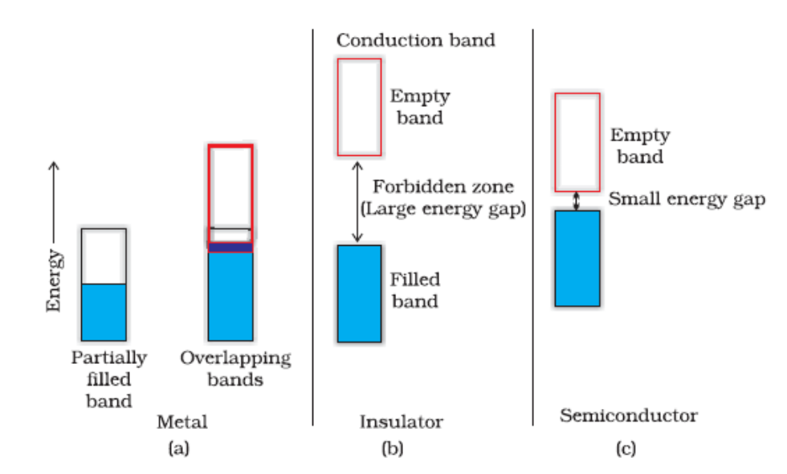

16Q In an fcc arrangement of P and Q atoms, P atoms are at the corners of the unit cell. What is the formula of the compound? (CBSE –Samp 4-2008 -2M)

Ans. No. of P atoms per unit cell = 8 x (1/8) =1 ( P atoms are present at the corners)
No. of Q atoms per unit cell = 6 x ½ =3 ( Q atoms are present at the corners)
- The formula of the compound = PQ₃

17Q Atoms of element B form hcp lattice and those of the element A occupy 2/3rd of tetrahedral voids. What is the formula of the compound formed by the elements A and B? (CBSE –Samp 4-2008 -2M)
Ans.
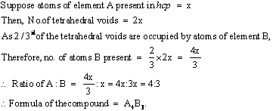

18Q Atomic mass of an element is 100. It has bcc structure. Its density is 5.96 g cm⁻³. Calculate the volume of the unit cell. (CBSE –Samp 5-2008 -2M)

Ans. Let the length of unit cell = a
Volume of unit cell = a3
Z = 2(for bcc)
Molar mass (M) = 100
Avogadro's number(N0) = 6.02 x 1023 , Density of unit cell = 5.96g.cm-3
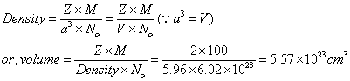

19Q What is F-centre? (CBSE –Samp 6-2008 -1M)

Ans. The site where electron is entrapped in the anion vacancy is called F-centre.

20Q An element crystallizes into fcc unit cell type of a structure. The edge length of unit cell is 150 pm. If 150 g of this element have 12 x 10²³ atoms, then calculate the density of the element. (CBSE –Samp 6-2008 -3M)
Ans. Volume of unit cell = (length)³ = (150 x 10⁻¹⁰cm)³ =
Mass of an atom = 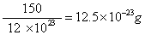
Z = 4 (for fcc)
Mass of unit cell =Mass of an atom x Z= g
Density of unit cell = 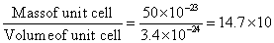 g.cm⁻³
=147 g.cm⁻³
21Q X-ray diffraction studies show that copper crystallizes in an fcc unit cell with cell edge of 3.608 x 10-8 cm. In a separate experiment, copper is determined to have a density of 8.92 g/cm3. Calculate the atomic mass of copper. (CBSE –Samp 7-2008 -3M)
Ans.
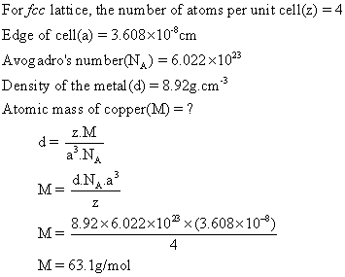
22Q An element is found to have fcc structure. How many atoms are present in its one unit cell? (CBSE –Samp 7-2008 -1M)
Ans. Four

23Q (i) Name a solid which shows both Frenkel and Schottky defect.
(ii) Why Frenkel defect is not found in pure alkali metal halides?
(iii) Name point defect a crystal which lowers the density of Crystal.
(iv) Name the nonstoichiometric point defect responsible for colour in alkali metal
halides. (CBSE –Samp 8-2008 -2M)

Ans. (i) AgBr (silver bromide)
(ii) Frenkel defect is not found in pure alkali metal halides because the size of ions is large and they do not fit into interstitial spaces.
(iii) Schottky defect
(iv) Metal excess non stoichiometric point defect.

24Q What is the difference between (i) Schottky defect (ii) Frenkel defect?
(CBSE –Samp 8-2008 -2M)
Ans.

Schottky defect | Frenkel defects
If an atom or ion is missing from its lattice site, The vacancy created is termed as a Schottky defect. | These defects are commonly found in ionic solids. Whenever an ion leaves its lattice site and occupies an interstitial site, such defect is called Frenkel defect.

25Q Distinguish between ‘Face-centred, body-centred and end-centred unit cells.
(CBSE –Samp 9-2008 -2M)
Ans. A face- centred unit cell has one constituent particle present at the centre of each face in addition to the particles present at the corners. While an end-face centred has one constituent particles each at the centre of any two opposite faces in addition to the particles present at the corners.

Section D: Higher Order questions for high achievers:
Q1) (a) Explain radius ratio. b) Predict the form of the crystal structure in each case.
Li⁺=74 Rb⁺=140
Na⁺=102 Cs⁺=170
K⁺=138 Br⁻=195
MULTIPLE CHOICE QUESTIONS:

- Which of the following is amorphous substance
1) CuSO₄5H₂O 2) NaCl 3) gelatinous Al(OH)₃ 4) ACl3

- The characteristic features of solids are
1) Definite shape 2) Definite size,
3) Definite shape and size 4) Definite shape, size and rigidity

- The constituent particles of a solid have
1) translatory motion only 2) rotatory motion only
3) vibratory motion only 4) all the above types of motion

- Amorphous substances show (A) Short and long range order (B) Short range order (C) Long range order (D) have no sharp m.p.
1) A and C are correct 2) B and C are correct 3) C and D are correct 4) B and D are correct

- Which of the following is not a characteristic of crystalline solids?
1) They have a regular geometry 2) They have sharp melting points 3) They are isotrophic
4) They undergo a clean cleavage

- When molten form of crystalline solid is rapidly cooled, it changes into
1) crystalline solid 2) amorphous solid 3) insulator 4) superconductor

- Which among the following will show anisotropy?
1) Glass 2) Barium chloride 3) Wood 4) Paper

- Amorphous solids are
1) Solid substances in real sense 2) Liquids in real sense
3) Supercooled liquids 4) Substances with definite M.P.

- Which of the following is not a crystalline solid?
1) Common salt 2) Sugar 3) Iron 4) Rubber

- Which of he following is a non-crystalline solid?
1) CsCl 2) NaCl 3) CaF₂ 4) Glass

- Amorphous solids
1) poses sharp melting points 2) undergo clean cleavage when cut with knife
3) do not undergo clean cleavage when cut with knife 4) possess orderly arrangement over long distances

- A pseudo solid is
1) glass 2) pitch 3) KCl 4) glass and pitch

- If heat is supplied to a pure substance which is just beginning to melt, the
1) critical temperature will rise 2) temperature will remain constant
3) temperature will immediately rise 4) temperature will fall

- An example of a covalent crystalline solid is
1) Si 2) NaF 3) Ar 4) Al

- ZnS is a example of
1) Ionic crystal 2) Covalent crystal 3) Molecular crystal 4) Metallic crystal

- LiF is an example of
1) Ionic crystal 2) Metallic crystal 3) Covalent crystal 4) Molecular crystal

- Graphite is an example of
1) Ionic crystal 2) Covalent crystal 3) Molecular crystal 4) Metallic crystal

- Solid CO₂ is an example of
1) Ionic crystal 2) Covalent crystal 3) Molecular crystal 4) Metallic crystal

- Wax is an example of
1) Ionic crystal 2) Covalent crystal 3) Molecular crystal 4) Metallic crystal

- Which of the following is an example of covalent crystalline solid?
1) Si 2) Al 3) Ar 4) NaF

- An example of a metallic crystalline solid is
1) Si 2) C 3) P 4) W

- In solids, the constituent particles may be
1) Atoms 2) Ions 3) Molecules 4) any of the above three

- Iodine crystal are
1) Metallic 2) Ionic 3) Molecular 4) Covalent

- NaCl crystal is made up of
1) NaCl molecules 2) Na⁺ and Cl– ions 3) Na and Cl atoms 4) Polymers of NaCl

- A molecular crystalline solid
1) is very hard 2) is volatile 3) has a high melting point 4) is a good conductor

- Which one has highest melting point?
1) Ionic crystal 2) Molecular crystal 3) Covalent crystal 4) Metallic crystal

- Ionic solids are characterised by
1) Good conductivity in solid state 2) High vapour pressure
3) Low melting point 4) Solubility in polar solvents

- Crystals which are good conductor of electricity and heat are
1) Ionic 2) Covalent 3) Metallic 4) Molecular

- Among the following which crystal will be soft and have low melting point
1) SiC 2) NaCl 3) Graphite 4) Ice

- An example of a substance possessing gaint covalent structure is
1) Iodine crystal 2) Silica 3) Solid carbon dioxide 4) White phosphorus

- Which one of the following will have a low heat of fusion?
1) a covalent solid 2) an ionic solid 3) a metallic solid 4) a molecular solid

- The number of atoms present in a unit cell of a monoatomic substance (element) of a simple cubic lattice, body-centred cubic and face-centred cubic respectively are
1) 8, 9 and 14 2) 1, 2 and 4 3) 4, 5 and 6 4) 2, 3 and 5

- Bravais lattices are of
1) 10 types 2) 8 types 3) 7 types 4) 14 types

- NaCl crystal belong to the crystal system
1) tetragonal 2) cubic 3) orthorhombic 4) monoclinic

- Diamond belongs to the crystal system
1) cubic 2) triclinic 3) tetragonal 4) hexagonal

- The substance which posses zero resistance at OK is called
1) Conductor 2) Super conductor 3) Insulator 4) Semiconductor

- Glass is
1) Super cooled liquid 2) Metallic crystal, 3) Molecular crystal 4) Covalent crystal

- Select the correct statement
1) A cubic close packed structure has eight tetrahedral and six octahedral interstices
2) Graphite has three dimensional crystal lattice
3) Diamond has two dimensional crystal lattice
4) Coordination number of body centred cubic lattice is eight

- For the various types of interactions the correct order of increasing strength is
1) covalent < hydrogen bonding < van der Waals < dipole-dipole
2) van der Waals < hydrogen bonding < dipole-dipole < covalent
3) van der Waals < dipole-dipole < hydrogen bonding < covalent
4) dipole-dipole < van der Waals < hydrogen bonding < covalent

- The type of bonding in ice is
1) hydrogen bonding 2) covalent bonding 3) ionic forces 4) metallic boning

- Germanium is an example of
1) An instrinsic semiconductor
2) An n-type semiconductor
3) A p-type semiconductor
4) Insulator

- Which one of the following is a two dimensional covalent solid?
1) graphite 2) quartz
3) carborundum 4) pure germanium

- When n and p-type semiconductors are allowed to come into contact
1) some electrons will flow from n to p
2) some electrons will flow from p to n
3) the impurity element will flow from n to p
4) the impurity element will flow from p to n

- How many Cl– ions are there around Na⁺ ion in NaCl crystal?
1) 3 2) 4 3) 6 4) 8

- The 8 : 8 type of packing is present in
1) NaCl 2) KCl 3) CsCl 4) Cu

- The number of atoms contained in a fcc unit cell of a monoatomic substance is
1) 1 2) 2 3) 4 4) 6

- An octahedral void is surrounded by how many spheres?
1) 6 2) 4 3) 8 4) 12

- Most crystals show good cleavage because their atoms, ions or molecules are
1) weakly bonded together 2) strongly bonded together
3) spherically symmetrical 4) arranged in planes

- In a solid lattice the cation has left a lattice site and is located at an interstitial position, the lattice defect is
1) Interstitial defect 2) Vacancy defect
3) Frenkel defect 4) Schottky defect

- In the fluorite structure, the coordination number of Ca²⁺ ion is
1) 4 2) 6 3) 8 4) 3

- On doping Ge metal with a little of In, one gets
1) p-type semi conductor 2) n-type semi conductor 3) insulator 4) rectifier

- Potassium crystallizes in a bcc lattice, hence the coordination number of potassium in potassium metal is
1) 0 2) 4 3) 6 4) 8

- Space lattice of CaF₂ is
1) fcc 2) bcc, 3) simple cubic 4) hcp

- Which of the following describes the hexagonal close packed arrangement of spheres?
1) ABCABA 2) ABCABC 3) ABABA 4) ABBABB

- If we mix a pentavalent impurity in a crystal lattice of germanium, what type of semiconductor formation will occur?
1) p-type 2) n-type 3) both (1) and (2) 4) none of the two

- Schottky defect in crystals is observed when
1) unequal number of cations and anions are missing from the lattice
2) equal number of cations and anions are missing from the lattice
3) an ion leaves its normal site and occupies an interstitial site
4) density of the crystal is increased

- How many kinds of space lattices are possible in crystals ?
1) 23 2) 7 3) 230 4) 14

- A compound formed by elements A and B crystallises in the cubic structure where A atoms are at the corners of a cube and B atoms are at the face-centres. The formula of the compound is
1) AB₂ 2) AB 3) A₃B 4) A₂B₂

- The number of unit cells in 58.8 g of NaCl is nearly
1) 6×10²⁰ 2) 3×10²² 3) 1.5×10²³ 4) 0.5×10²⁴

- In a solid AB having the NaCl structure, ‘A’ atoms occupy the corners of the cubic unit cell. If all the face-centred atoms along one of the axes are removed, then the resultant stoichiometry of the solid is
1) AB₂ 2) A₂B 3) A₄B₃ 4) A₃B₄

- When molten zinc is cooled to solid state, it assumes HCP structure. Then the number of nearest neighbours of zinc atom will be
1) 4 2) 6 3) 8 4) 12
- A substance A_{x}B_{y} crystallizes in a face centred cubic (FCC) lattice in which atoms ‘A’ occupy each corner of the cube and atoms ‘B’ occupy the centres of each face of the cube. Identify the correct composition of the substance A_{x}B_{y}
1) AB₃ 2) A₄B₃ 3) A₃B 4) composition cannot be specified

- Which of the following crystals does not exhibit Frenkel defect
1) AgBr 2) AgCl 3) KBr 4) ZnS

- Due to Frenkel defect, the density of ionic solids
1) decreases 2) increases 3) does not change 4) changes

- Which of the following is Bragg’s equation?
1) nλ = 2θ sinθ 2) nλ = 2d sinθ
3) 2nλ = d sinθ 4) n θ/2 = d/2 sinθ

- A compound formed by elements A and B has a cubic structure in which A atoms are at the corners of the cube and B atoms are at the face centres. The formula of the compound will be
1) A₈B₆ = A₄B₃ 2) A₈B₄ = A₂B
3) AB₃ 4) A₂B₃
- A compound contains P and Q elements. Atoms Q are in ccp arrangement while P occupy all tetrahedral sites. Formula of compound is
1) PQ 2) PQ₂ 3) P₂Q 4) P₃Q

- A binary solid (A⁺B–) has zinc blende structure with B– ions constituting the lattice and A⁺ ions occupying 25% tetrahedral holes. The formula of solid is
1) AB 2) A₂B 3) AB₂ 4) AB₄

- In a metal oxide, the oxide ions are arranged in hexagonal close packing and metal ions occupy two-third of the octahedral voids. The formula of the oxide is
1) MO 2) M₂O₃ 3) MO₂ 4) M₂O

- A solid AB has NaCl type structure. If the radius of the cation A is 100 pm, then the radius of the anion B will be
1) 241 pm 2) 414 pm 3) 225 pm 4) 44.4 pm

- The radius of Na⁺ is 95 pm and that of Cl– ion is 181 pm. Hence the co-ordination number of Na⁺ will be
1) 4 2) 6 3) 8 4) unpredictable

- The ionic radii of Rb⁺ and I– are 1.46 and 2.16 Å respectively. The most probable type of structure exhibited by it is
1) CsCl type 2) NaCl type 3) ZnS type 4) CaF₂ type

- If the radius of K⁺ and F– are 133 pm and 136 pm respectively, the distance between K⁺ and F– in KF is
1) 269 pm 2) 134.5 pm 3) 136 pm 4) 3 pm

- The second order Bragg diffraction of X-rays with λ = 1.00 Å from a set of parallel planes in a metal occurs at an angle of 60°. The distance between the scattering planes in the crystal is
1) 0.575 Å 2) 1.00Å 3) 2.00 Å 4) 1.15 Å

- The wavelength of X-rays which gives a diffraction angle, 2θ, equal to 16.80° for a first order diffraction for a crystal with interplanar distance 0.200 nm, is (given sin 8.4° = 0.146)
1) 0.0584 nm 2) 0.1168 nm 3) 0.0292 nm 4) 0.2336 nm

- If NaCl is doped with 10^{–3} mol % SrCl₂ then the concentration of cation vacancies will be
1) 1×10^{–3} mol% 2) 2×10^{–3} mol% 3) 3×10^{–3} mol% 4) 4×10^{–3} mol%

- A binary solid (A⁺B–) has a rock salt structure. If the edge length is 40 pm and radius of cation is
75 pm, the radius of anion is
1) 100 pm 2) 125 pm 3) 250 pm 4) 325 pm

- A metal has bcc structure and the edge length of its unit cell is 3.04 Å. The volume of the unit cell in cm³ will be
1) 1.6×10^{–21} cm³ 2) 2.81×10^{–23} cm³ 3) 6.02×10^{–23} cm³ 4) 6.6×10^{–24} cm³

- The radius of an atom of an element is 500 pm. If it crystallises as a face-centred cubic lattice, the length of the side of unit cell is
1) 176.8 cm 2) 1154.7 pm 3) 1414 pm 4) 1000 pm

- In a face centred cubic arrangement of A and B atoms in which A atoms are at the corners of the unit cell and B atoms at the face centres, one of the A atom is missing from one corner in unit cell. The simplest formula of compound is
1) A₇B₃ 2) AB₃ 3) A₇B₂₄ 4) A_{7/8}B₃

- An alloy of copper, silver and gold is found have copper constituting the ccp lattice. If silver atoms occupy the edge centres and gold is present at body centre, the alloy has a formula
1) Cu₄Ag₂Au 2) Cu₄Ag₄Au 3) Cu₄Ag₃Au 4) CuAgAu

- Which of the following statement s is correct in the antifluorite structure of an ionic compound?
1) Coordination number of anion is four and that of cation is eight
2) Coordination number of anion is eight and that of cation is four
3) Coordination number of each cation and anion is four
4) Coordination number of each cation and anions is six

- If the anions (A) form hexagonal closest packing and cations (C) occupy only 2/3 octahedral voids in it, then the general formula of the compound is
1) CA 2) CA₂ 3) C₂A₃ 4) C₃A₂

- In the spinel structure, oxides ions are cubical-closest packed whereas 1/8th of tetrahedral voids are occupied by A²⁺ cations and 1/2 of octahedral voids are occupied by B³⁺ cations. The general formula of the compound having spinel structure is
1) A₂B₂O₄ 2) AB₂O₄ 3) A₂B₂O₂ 4) A₄B₂O₂

- The expression to compute the density of metals crystallizing in cubic crystal is
1) 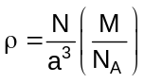 2) 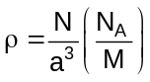 3) 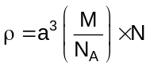 4) 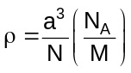

- In the body-centred cubic unit cell of closest packed atoms, the radius of atom in terms of edge length (a) of the unit cell is
1) a/2 2) 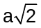 3) 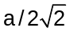 4) 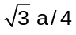

- In the face-centred cubic unit cell of closest packed atoms, the radius of atoms in terms of edge length (a) of the unit cell is
1) a/2 2) 3) 4)

- Which of the following expressions is correct in case of a sodium chloride unit cell (edge length, a)?
1) r_{c} + r_{a} = a 2) r_{c} + r_{a} = a/2 3) r_{c} + r_{a} = 2a 4) r_{c} + r_{a} = 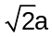

- If ‘a’ is the edge length of unit cell of sodium chloride, the distance between two nearest Na⁺ ions is
1) a 2) 3) 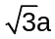 4) 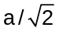

- Which of the following statements for crystals having Schottky defect is not correct?
1) Schottky defect arises due to the absence of a cation or anion from the position which it is expected to occupy
2) Schottky defects are more common in ionic compounds with high coordination numbers
3) The density of the crystals having schottky defect is larger than that of the perfect crystal
4) The crystal having Schottky defect is electrical neutral as a whole .

- Which of the following statements for crystals having Frenkel defect is not correct
1) Frenkel defects are observed where the difference in sizes of cations and anions is large
2) The density of crystals having Frenkel defect is lesser than that of a pure perfect crystal
3) In an ionic crystal having Frenkel defect may also contain Schottky defect
4) Pure alkali halides do not have Frenkel defect

- Which of the following statements is not correct?
1) The coordination number of each type of ion in CsCl is 8.
2) A metal that crystallises in bcc structure has a coordination number of 12
3) A unit cell of an ionic crystal shares some of its ions with other unit cells
4) The length of the unit cell in NaCl is 552 pm. 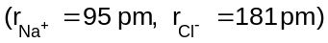

KEY :

- 3 | - 4 | - 3 | - 4 | - 3
- 2 | - 2 | - 3 | - 4 | - 4
- 1 | - 1 | - 2 | - 1 | - 1
- 1 | - 2 | - 3 | - 3 | - 1
- 4 | - 4 | - 3 | - 2 | - 2
- 1 | - 4 | - 3 | - 4 | - 2
- 4 | - 2 | - 4 | - 2 | - 1
- 2 | - 1 | - 4 | - 3 | - 1
- 1 | - 1 | - 1 | - 3 | - 3
- 3 | - 1 | - 4 | - 3 | - 3
- 1 | - 4 | - 1 | - 3 | - 2
- 2 | - 4 | - 1 | - 3 | - 4
- 4 | - 1 | - 3 | - 3 | - 2
- 3 | - 3 | - 3 | - 2 | - 1
- 2 | - 2 | - 1 | - 4 | - 4
- 1 | - 2 | - 2 | - 3 | - 3
- 3 | - 2 | - 3 | - 2 | - 3
- 4 | - 3 | - 2 | - 4 | - 3
- 2 | - 2

