SECTION-A (ELECTRO CHEMISTRY)
A brief review of the basic concepts

- Electrochemistry: The branch of chemistry which deals with the study of the conversion of chemical energy into electrical energy or vice versa and their mutual relationship is called electrochemistry.

- Oxidation and reduction: oxidation is the process in which an atom, molecule or ion loses one or more electrons. For example,
H → H⁺ + e - Cl⁻ → Cl + e⁻
Fe²⁺ → Fe³⁺ + e⁻ MnO²⁻₄ → MnO₄⁻ + e⁻

- Oxidation is always followed by an increase in the oxidation number of the substance undergoing oxidation.

- Reduction is the process in which an atom, molecule or ion gains one or more electrons. For example,
H⁺ + e⁻ → H S + 2e⁻ → S²⁻
Cu²⁺ + e⁻ → Cu⁺ O₂ + 4e⁻ → 2O²⁻

- Reduction is always followed by a decrease in the oxidation number of the substance undergoing reduction.

- Oxidation and reducing agents: an oxidizing agent is the substance which gains electrons while a reducing agent is the substance which loses electrons. For example,
Zn(s) + 2H⁺ (aq) → Zn²⁺(aq) + H₂(g)

- Redox reaction, oxidation and reduction half reactions: the reaction which involves the simultaneous occurrence of both oxidation and reduction processes is called a redox reaction. The redox reaction can be spilt into two half equations, one corresponding to the oxidation process (called oxidation half reaction) and the other corresponding to the reduction process (called reduction half reaction). For example, the oxidation and reduction half reactions of the redox reaction are as follows..
Zn(s) + Cu²⁺⁽aq) → Zn²⁺ (aq) + Cu(s)
Zn(s) → Zn²⁺(aq) + 2e⁻ (oxidation half reaction)
Cu²⁺(aq)+ 2e⁻ → Cu ( reduction half reaction)

- Single electrode (half cell) and single electrode potential: when a metal rod is dipped in its salt solution. It develops a positive or negative potential. This assembly is known as a single electrode or half cell and the potential developed on it is called single electrode potential.
- Oxidation electrode (oxidation half cell) and oxidation potential: when the electrolytic solution pressure of the metal is greater than the osmotic pressure of the solution the metal rod develops a negative potential due to the following oxidation process.
M → M^{n+} + e⁻
Such an electrode is called an oxidation electrode or oxidation half cell and the potential developed on it is called oxidation potential. It is represented as E_{oxi} or E_{M/M}^{n+}

- Reduction electrode (reduction half cell) and reduction potential: when the electrolytic solution pressure of the metal is less than the osmotic pressure of the solution, the metal rod develops a positive potential due to the following reduction process.
M^{n+}(aq) + ne⁻ → M(s)
Such an electrode is called a reduction electrode or reduction cell and the potential developed on it is called reduction potential. It is represented as E_{red} or E_{M}^{n+}_{/M}

- Null electrode: when the electrolytic solution pressure of the metal is equal to the osmotic pressure of the solution, neither oxidation nor reduction process takes place and no potential is developed on the metal rod . Such an electrode assemble is called a null electrode.

- Standard electrode potential(E⁰): the potential of an electrode assembly is said toe be the standard electrode potential when i) The temperature of the electrode assembly is 25⁰C ii) The ion solution used in the assembly has a concentration of 1 mol L⁻¹ , and iii) The pressure of the gas, if used in the assemble , is 1 atm,

- For a particular type of assembly, the standard oxidation potential ( E_{oxi} or E_{M/M}^{n+})
and the standard reduction potential (E_{red} or E_{M}^{n+}_{/M}.) are numerically equal but their signs are opposite. Thus,
E_{M/M}^{n+}= - E_{M}^{n+}_{/M}
For example,
E⁰_{Zn / Zn+2} = -E⁰_{Zn+2 / Zn} and E⁰_{Cu/ Cu+2} = -E⁰_{Cu+2 / Cu}
- According to the IUPAC convention, the term standard potential refers to standard reduction potential. Thus, if no subscript is mentioned, E⁰ represents the standard reduction potential.

- Standard hydrogen electrode (SHE or NHE): standard hydrogen electrode is set up by passing pure hydrogen gas at 1 atm. Pressure in a solution of H+ (More correctly H3O+) ions of concentration 1 mol L-1 in contact with a Platonized platinum foil and can be represented as

Pt, H₂ (g) (1 atm )/H⁺ (1 mol L-1)

The half cell reactions are as follows
½ H₂ (g) → H⁺(aq) + e-; 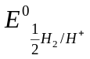 (when the electrode works as anode)
H⁺ (aq) + e- → ½ H₂(g); 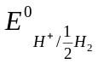 (when the electrode works as cathode)
By convention, = = 0
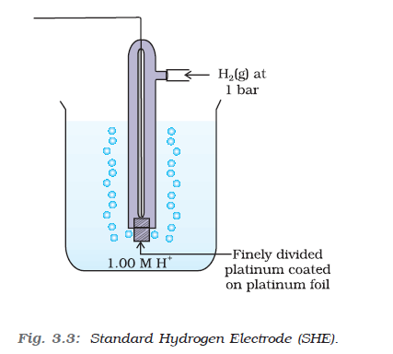

- Measurement of standard electrode potential: the standard electrode potential of an electrode assembly is measured by connecting it to a standard hydrogen electrode and measuring the potential difference. The measured value of potential difference is numerically equal to the standard electrode potential of the given electrode assembly because the potential of standard hydrogen electrode is zero by convention.
The sign of the electrode potential thus measured is ascertained by ascertaining the direction of the flow of current. The direction of flow of current is regarded opposite to the direction of flow of electrons. In a galvanic cell, electrons flow from anode to the cathode. The potential difference between the anode and the cathode in a galvanic cell in the standard state is represented by E cell. This is given by
E⁰ _{cell} = E⁰ _{cathode}- E⁰ _{anode}
Thus identifying the anode and the cathode, in the galvanic cell constructed for the measurement of electrode potential, the sign of the electrode potential can be ascertained with the help of the above equations. For example let us consider the following two cases.

- When a zinc electrode in the standard state is connected to a standard hydrogen electrode, the current flows from hydrogen electrode towards the zinc electrode and a potential difference of 0.76 volts is obtained. Obviously, the electrons flow from zinc electrode to hydrogen electrode. Thus , in this case, zinc electrode acts as anode whereas the hydrogen electrode as the cathode, hence,
E⁰ _{cell} = E⁰ _{cathode}- E⁰ _{anode} 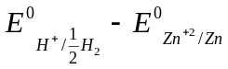
0.76 = 0 - 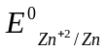
= -0.76 volts.

- When a copper electrode in the standard state is connected to standard hydrogen, electrode, the current flows from the copper electrode towards the hydrogen electrode. Obviously electrons flow from hydrogen electrode to copper electrode. Therefore, in this case, hydrogen electrode acts as anode and the copper electrode as cathode. The measured potential difference is 0.34 volts. Hence.
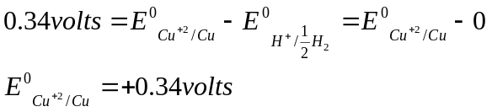

- Electrochemical series: the electrochemical series is the arrangement of various electrode systems in the increasing order of their standard reduction potentials.. the electrochemical series consisting of some electrode systems along with their half cell reactions is give below.

Electro chemical series
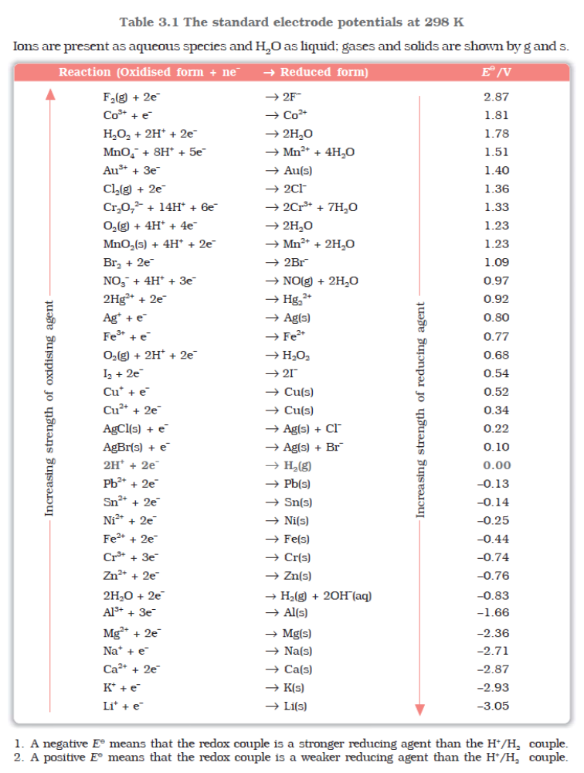

Important features of electrochemical series:

- the electrode systems having negative values of standard reduction potetentials act as
anode when connected to a standard hydrogen electrode whiles those having positive values as cathode.

- The metal placed at the top (Li) of the series has the minimum value of standard reduction potential i.e. it has the minimum tendency to get reduced or maximum tendency to get oxidized. Therefore it is the strongest oxidizing agent and can reduce any other substance placed below it. In fact, any substance can reduce any other substance placed below it in the series. The reducing power of the substances decreases in going down the series.

- The substance placed at the bottom of the series (F) possesses the highest value of standard reduction potential i.e. it has the strongest tendency to get reduced. Consequently, it acts as the strongest oxidizing agent. The oxidizing power of the substances decreases in going from bottom to the top of the series.

Some important conclusions from the electrochemical series:
  - The reactivity of metals decreases on moving down the series.
  - Any metal placed above hydrogen in the series can displace hydrogen from a dilute acid
  - The electropositive character of metals decreases on moving down the series.
  - A metal can displace any other metal placed below it in the series from its salt solution.
  - The stability of the oxides of metals decreases on moving down the series.
  - A redox reaction is feasible when the substance having higher reduction potential gets reduced and the one having lower reduction potential gets oxidized.

- Galvanic cells: a galvanic cell is a device in which chemical energy is concerted into electrical energy. A galvanic cell generates electric current on account of a redox reaction occurring in it. Daniel cell, dry cell, Leclanche cell etc, are the cell of this type.

Construction of a galvanic cell: a galvanic cell can be constructed by uniting an oxidation electrode with a suitable reduction electrode. The solutions involved in the two electrodes can be made in communication with each other either by a direct contact through a porous diaphragm. Or through a salt bridge. In outer circuit, the two electrodes are connected to a device which is capable of utilizing the electrical energy produced.

- A salt bridge is a U-shaped glass tube filled with the concentrated solution of an inert electrolyte such as KCl, KNO₃, K₂SO₄ etc. it completes the electrical circuit by allowing the ions to flow from one half cell to another half cell and maintains the electrical neutrality of the solutions present in the two half cells.

- In a galvanic cell, the electrode at which oxidation process occurs is called the anode while the one at which the reduction process takes place is called the cathode. It is to be moved that the anode is of negative polarity while the cathode is of positive polarity in a galvanic cell.

Representation of a galvanic cell: a galvanic cell is always represented by waiting oxidation electrode (anode) at the left and the reduction electrode (cathode) at the right. Direct contact of the two solutions is represented by a vertical line (|) while the contact of the two solutions through a salt bridge is shown by two parallel vertical lines (||). For example a Daniel cell involving a salt bridge is represented as given below

Zn|Zn²⁺(C₁)|| Cu²⁺(C₂)|Cu
Anode Cathode

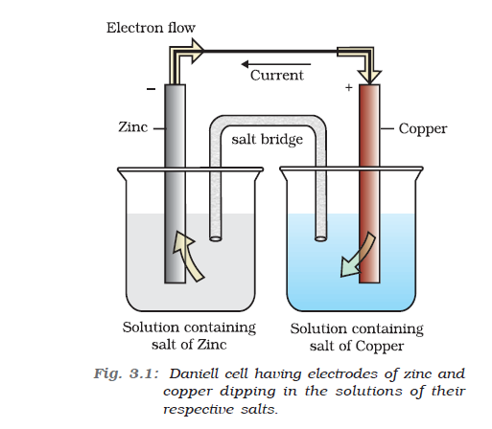

The cell reaction: The EMF of a galvanic cell is due to a redox reaction. It can be obtained by adding oxidation and reduction reactions in such a way that electrons get cancelled. For example, the cell reaction of a Daniel cell can be obtained as follows

Zn → Zn²⁺ + 2e⁻ (at anode)
Cu²⁺ + 2e⁻ → Cu ( at cathode)

Zn + Cu²⁺→ Zn²⁺ + Cu (over all reaction)

- E.M.F.of a galvanic cell: the electromotive force (E.M.F) of a galvanic cell is defined as the difference of electrical potential which causes the flow of current from one electrode to another when virtually no current is drawn from the cell.
- According to the I.U.P.A.C convention, the EMF of a cell is given by
E⁰ _{cell} = E⁰_{Right} - E⁰_{Left}
Where E⁰_{R} = standard reduction potential at the right had electrode (cathode) and E⁰_{L}= standard reduction potential at the left hand electrode (anode).

- Dependence of E.M.F on concentration and temperature: the electrode potential of an electrode assembly depends upon i) the nature of metal and its ions, ii) the concentration of ions in the solution and iii) temperature.

- Nernst equation for a single electrode: for an electrode involving the processes of reduction, Nernst equation can be written as follows.
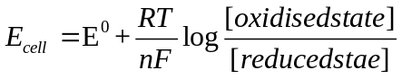

Where E_{cell}= reduction potential of the electrode assembly,
E⁰ = standard reduction potential of the same electrode assembly,
R= gas constant,
n= number of electrons involved in the electrode reduction,
F= 1 Faraday (96500 coulombs)
[Oxidized state]=conc. Of the substance undergoing reduction,
[Reduced state]=conc. Of the substance obtained on reduction.

For the electrode reaction
M^{n+}(aq) + ne⁻ → M(s)
The above equation can be written as
E_{Mn+/M} = E⁰_{Mn+/M} + 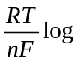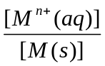
E_{Mn+/M} = E⁰_{Mn+/M} + 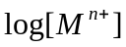

If T=298 K(25⁰C) the above equation can be written as
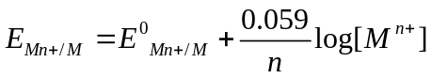
For an oxidation electrode involving the process M(s) → M^{n+}(aq) + ne⁻ , the Nernst equation can be written as follows.
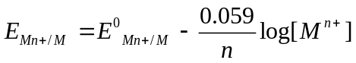

- Nernst equation for the E.M.F of a cell: for a galvanic cell involving the cell reaction
aA + bB 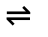 cC + dD,
Nernst equation can be written as follows.
E_{cell} = E⁰_{cell} - 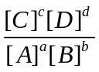
At T= 298 K (25⁰ C) , we have
E_{cell} = E⁰_{cell} =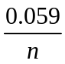 log
- Equilibrium constant from Nernst equation: The term is equal to the concentration quotient (Q) of the cell reaction. Therefore, the above equation can be used to calculate the equilibrium constant of a redox reaction if the reaction is in equilibrium. When the cell reaction is in equilibrium, E cell= 0 hence,
From the above equation we have
0 = Eº _{cell} - 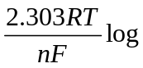Kc
E⁰_{cell}= Kc
- Gibbs free energy and E.M.F. of a cell: the E.M.F. of a cell in the standard state is related to the standard free energy change as
∆G⁰ = - n FE⁰ _{cell}
From this equation following conclusions can be obtained:
- When E_{cell} is positive , the cell reaction is feasible
- When E_{cell} is negative; the cell reaction is not feasible.
- When E_{cell} is zero, the cell reaction is in equilibrium.

- Conductors and insulators: The substances which allow the passage of current through the n are called conductors. All metals, fused ionic compounds and the aqueous solutions of ionic compounds are the substances of this type.

The substances which do not allow the passage of the electric current through them are called insulators. Rubber, glass, plastic, sulphur, dry wood etc. are the substances of this type.

The conduction of current by a conductor is either due to the flow of electrons or due to the movement of ions. The metallic conduction decreases with increase in temperature whereas the electrolytic conduction increases with a rise in temperature.

- Electrolytic conductance: the ease of flow of current through a conductor is called its electrical conductance or electrical conductivity. The ease of flow of current through an electrolytic solution is termed as electrolytic conductance.
The conductance ( C) is defined as the reciprocal of the resistance ( R ) i.e.
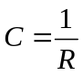
The unit of conductance is ohm⁻¹,
1 S =ohm⁻¹

Specific resistance: the resistance of a conductor is directly proportional to its length l and inversely proportional to its area of cross section A i.e.
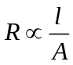
R =  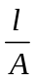
The constant is called the specific resistance or resistivitty of the conductor. It may be defined as the resistance of the conductor having a length of 1 cm and area of cross section equal to 1 cm². The units of specific resistance are ohm cm.

Specific conductivity (k): it is defined as the conductance of a conductor whose length is 1 cm and area of cross section equal to 1 cm2. It is equal to the reciprocal of specific resistance (p) of the solution.
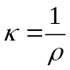
For an electrolytic solution, specific conductivity is defined as the conductance of 1 cm3 of the solution.
The units of specific conductivity are ohm ⁻¹ cm⁻¹

Molar conductivity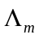: molar conductivity of an electrolytic solution at dilution V_{m} is the conductance of the solution containing 1 mole of the electrolyte dissolved in V_{m} cm³ of the solution.
is related to the specific conductivity k as
= k X V_{m}
Where V_{m} is the volume of the solution containing one mole of the electrolyte
The units of are ohm ⁻¹cm² mol⁻¹

For an electrolytic solution, is related to 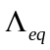 as
=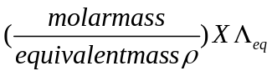
Variation of and with dilution: Both and of an electrolytic solution increase of a dilution and approach limiting values when dilution approaches to infinity. The limiting values are expressed as 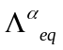and 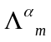 respectively, thus,
= equivalent conductivity at infinite dilution
= molar conductivity at infinite dilution.

- Kohlrausch law: The molar conductivity at infinite dilution of an electrolyte is equal to the sum of molar conductance sod its cations and anions, with each conductance term multiplied by the number of respective ion present in the formula unit of the electrolyte.
Thus, for HCl, 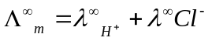
For CH₃COOH, 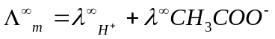
For BaCl₂ 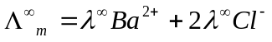

- Kohlrausch law can also be stated as follows.
The equivalent conductance of an electrolyte at infinite dilution is equal to the sum of the equivalent conductances of its cations and anions. Thus.
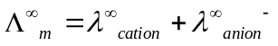
e.g. for Nacl, 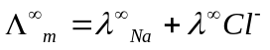

15. Electrolytic cell: The cell which converts electrical energy into chemical energy is called an electrolytic cell. The process involved in the conversion of electrical energy into chemical energy is called electrolysis. An electrolytic cell consists of two metallic or graphite rods dipping in the solution of an electrolyte and connected to a battery. The rod connected to the positive terminal of the battery acts as anode while that connected to the negative terminal of the battery acts as cathode. It is to be noted that the anode in an electrolytic cell is of positive polarity while the cathode is of negative polarity.

16. Electrolysis: Electrolysis is the process which involves the conversion of electrical energy into chemical energy. Electrolysis may be defined as the process which leads to a chemical change on the passage of electricity through an electrolyte present either in the dissolved state or in the molten state.

In the process electric current is passed through an electrolyte taken in an electrolytic cell either in the form of an aqueous solution or in the fused state. Under the influence of electric current, ions migrate towards the oppositely charged electrodes and get discharged at them. Thus, the electrolyte gets chemically decomposed into the species obtained at the two electrodes. For example, electrolysis of fused sodium chloride takes place as follows;

NaCl Na⁺ + Cl⁻ ( in the molten state)
At cathode: Na⁺ + e⁻ → Na (reduction)
At anode Cl⁻ - e- → Cl (oxidation, primary change)
Cl + Cl → Cl₂ (secondary change)
Thus, on account of electrolysis of fused sodium chloride, sodium is obtained at the cathode and chlorine gas at the anode.

17. Faraday’s laws of electrolysis: Michael Faraday (1832) formulated following two laws which govern the process of electrolysis.

- First law: the amount a substance liberated at an electrode during electrolysis is directly proportional to the quantity of electricity which passes through the electrolytic solution.
If w grams of a substance get liberated on a particular electrode on passing a current of I amperes for t seconds, we have
W ∞ I. t
W = Z. I.t
Where, Z is a constant known as electrochemical equivalent of the substance. It is given by
Z = 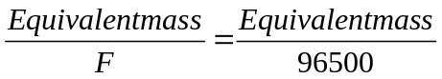

It has been found that the quantity of electricity required to liberate. 1 gram equivalent of a substance is 96500 coulombs. This quantity of electricity is called Faraday and is denoted by F. it is actually the charge carried by one mole of electrons.

The quantity of electricity needed to deposit 1 mole of an ion = nF, where n is the charge on the ion.

- Second law: when the same quantity of electricity is passed thorough the solutions of different electrolytes connected in series the masses of the substances liberated at the electrodes are in the ration of their equivalent masses. If w₁ and w₂ are respectively their equivalent masses, then according to this law,
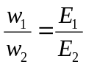

Criteria for product formation during electrolysis: when electrolytic solution contains several types of ions, the nature of products formed on account of electrolysis of the solution can be predicted on the basis of the following criteria.

- The substance which possesses higher standard reduction potential is preferentially reduced at the cathode.

- If the cation produced from the electrolyte in aqueous solution has higher standard reduction potential than that of water, the cation gets reduced at the cathode and the corresponding product is obtained. When the standard reduction potential of the cation is less than that of water, water gets preferentially reduced at the cathode and H₂ gas is liberated. This is why ions like Na⁺, Mg²⁺, Ca²⁺ etc. can not be reduced in aqueous solutions as their reduction potential are much lower than that of water.

- The substance which possesses lower standard reduction potential is preferentially oxidized at the anode.

If the anion produced from the electrolyte in aqueous solution has lower standard reduction potential then that of water, the anion will get oxidized at the cathode and the corresponding product will be obtained at the anode. When the reduction potential of the anion I higher than that of water, water gets preferentially oxidized and O₂ gas I liberated at the cathode.

18. Some examples of electrolysis: some examples of the electrolysis of aqueous solutions of some substances are given below

- Electrolysis of conc. Aqueous solution of NaCl: Since the standard reduction potential of Na⁺ (Na⁺ + e- → Na; E0 = -2.71 V) is less than that of water (2H₂O(l) + 2e- → H₂(g) + 2OH-(aq); E⁰= -0.83 V), water gets preferentially reduced at the cathode in this case.
At anode, Cl⁻ ions get oxidized in preference to water, although the former has a higher value of standard reduction potential. This is due to over voltage. Thus the electrolysis takes place as follows:
At anode: 2Cl- → Cl₂ + 2e⁻ (Oxidation)
At cathode: 2H₂O + 2e_ → H₂ + 2OH⁻ (Reduction)
Thus, during the electrolysis of aqueous NaCl solution, chlorine gas is evolved at the anode and hydrogen gas at the cathode.

- Electrolysis of aqueous copper sulphate solution using platinum electrodes: in this case the electrolysis takes place as follows:
At anode; H₂O → ½ O₂ + 2H⁺ +2e⁻
At cathode; Cu²⁺ + 2e⁻ → Cu
Thus, copper is obtained at the cathode and oxygen gas at the anode.

- Electrolysis of aqueous copper sulphate solution using copper electrodes: in this case copper gets deposited at the cathode and an equivalent amount of copper from the anode dissolves into the solution Cu²⁺ ions. This is because the reduction potential of copper is less than that fo So²⁻₄ ions and water. The electrolysis takes place as follows:
At anode: Cu → Cu²⁺ + 2e⁻
At cathode: Cu²⁺ + 2e⁻ → Cu

- Electrolysis of dilute aqueous H₂SO₄: in this case hydrogen gas is evolved at the cathode and oxygen gas at the anode as shown below.
At anode H₂O → ½ O₂ + 2H⁺ + 2e⁻
At cathode 2H⁺ + 2e⁻ → H₂

- Electrolysis of water: pure water is a very weak electrolyte and does not conduct much current. However, electrolysis of water can easily be carried out if a few drops of sulfuric acid are added to it. Addition of sulphuric acid makes water conducting and the electrolysis takes place as follows:
At anode 4OH⁻ → 2H₂O + O₂ + 4e⁻
At cathode 2H⁺ + 2e⁻ → H₂
Thus, oxygen gas is liberated at the anode and hydrogen gas at the cathode.

SECTION-B(ELECTRO CHEMISTRY)

- Write the name of a chemical substance which is used to prevent the corrosion.
Solution:
Bisphenol.

- What is the unit of specific conductance?
Solution:
Ohm⁻¹ cm⁻¹ or S cm⁻¹

- What is molar conductivity? Write two unit also.
Solution:
It is conduction power of all the ions produced by one mole of an electrolyte in given solution. Its unit is ohm⁻¹ or S cm² mol⁻¹.

- What is cell constant?
Solution:
Cell constant = 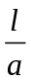
Where l is distance in cm between electrodes and a is cross-section area of electrodes.

- Why alternating current is used for measuring electrolytic conductivity?
Solution:
In order to avoid electrolysis, alternating current is used

- At what concentration, the molar conductance of an electrolyte approaches at maximum limiting value?
Solution:
At infinite dilution (Concentration approaches to zero)

- Define degree of dissociation in terms of molar conductance.
Solution:
The fraction of total number of molecules dissociated is called degree of dissociation
= 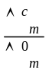

8. Write the factors affecting conductance of electronic or metallic conductor.
Solution:
- Nature and structure of the metal
- The number of valence electrons per atom
- Destiny of metal
- Temperature (conductance decreases with increase of temperature).

9. Which particles carry the charge in electrolytic conduction?
Solution:
In electrolytic conduction the charge is carried by the ions.
- What is the effect of temperature on resistance of electrolytic conductors?
Solution:
The resistance of electrolytic conductors generally decreases as temperature increases.

- Define specific conductivity.
Solution:
Specific conductivity: It is the reciprocal of specific resistance. It may be defined as the conductance of one centimeter cube of the conductor.
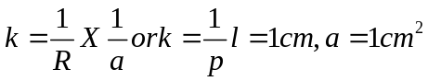
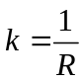

- Which metal has a greater tendency for oxidation, zinc or copper?
Solution:
Zinc (Zn)

- Which electrode can be used as a reference electrode?
Solution:
Standard hydrogen electrode or normal hydrogen electrode or calomel electrode.

- What is the function of salt bridge in electrochemical cell?
Solution:
  - To complete the electric circuit.
  - To maintain the electrical neutrality around the electrodes.

- Differentiate between metallic and electrolytic conductor.
Solution:

S.No | Metallic conductor | Electrolytic Conductor
1 | Flow of electric current takes place without the decomposition of material | Flow of electric current cause decomposition of substance.
2 | Flow of electricity is due to flow of electron | Flow of electricity is due to flow of ions.

- Differentiate between e.m.f and Potential difference.
Solution:
S.No | e.m.f | Potential difference
1 | It is the difference in potential of two electrodes when no current is flowing in an open circuit. | It is a difference in electrode potential of the two electrodes when the cell is sending current through the circuit.
2 | IT is maximum voltage obtained from the cell. | It is less than the maximum voltage obtained from the cell.

- Differentiate between electrochemical and electrolytic cell.
Solution:
S.No | Electrochemical cell | Electrolytic cell
1 | It is device to concert chemical energy into electrical energy. | It is a device to concert electrical energy to chemical energy.
2 | Consists of two electrodes in different compartments joined by a salt bridge. | Both the electrodes are immersed in same solution.

- What type of reaction is responsible for generation of electricity in voltaic or electrochemical cell?
Solution:
Red ox reaction.

- State and explain Faraday’s first law of electrolysis.
Solution:
It states that during electrolysis the amount of substance deposited at any electrode is proportional to amount of electric current passed
Q=I X t

- Define standard electrode potential.
Solution:
When a metal rod is immersed in the molar solution of its own salt at 1 atm. Pressure 25 ⁰ C, the potential developed in known as its standard electrode potential.

- State and explain Kohlrausch law of independent migration of ions.
Solution:
It states that the molar conductivity of solution at infinite dilution id equal to sum of molar conductance as anions and the cations respectively.
Mathematically, 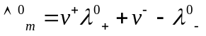
Where v+ and v- number of cations and anions per formula.
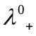 And 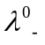 are molar conductivity of cation and anion at infinite dilution.

- Write Debye-Huckel-Onsager equation. What do different symbols signify?
Solution:
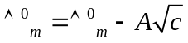, where 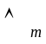 is the molar conductivity at concentration c, 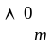 is the molar conductivity at infinite dilution and A is a constant.

- Which products will be obtained by electrolysis of aqueous solution of sodium chloride?
Support your answer in terms of electrode potential.
Solution:
In aqueous solution of sodium chloride electrolysed, Cl₂ and H₂ are produced at anode and cathode.
NaCl (aq) Na ⁺ (aq) ⁺ Cl⁻(aq)
At Cathode:
Na⁺(aq)+ e⁻ → Na(s), E⁰ = -2.71 V
H⁺(aq) + e⁻ → H₂(g), E⁰=0.00 V
As the reaction with higher value of E⁰ is preferred, therefore the reaction at the cathode.
H⁺(aq) + e⁻ → H₂(g)
But H⁺(aq) obtained due to dissociation of H₂O
H₂O(l) + e⁻ → H₂(g) + OH⁻(aq)
At anode: Oxidation occurs at anode, at anode the substance with lower oxidation potential will get oxidized preferably.
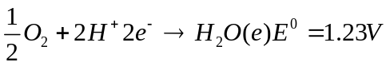
2Cl+2e → 2Cl⁻(aq) E⁰ = 1.36 V
Since the standard reduction potential of water is slightly less than of chlorine. Therefore it has a more chance of getting oxidized.
The net reaction may be represented as under

- Write in detail about the electrochemical series.
Solution:
  - Relative case of oxidation or reduction is predicted: A system with higher reduction potential has greater tendency to undergo reduction. Example: the reduction potential of F₂/F⁻ system is highest, so F ions are easily oxidized to F₂.
  - Placement tendency: Higher value of reduction potential shows the greater tendency to acquire the reduced form. Thus Zn will displace Cu from the solution of the latter.
  - Predicting spontaneity of red ox reaction: the value of E_{cell} indicates that the reaction
Is spontaneous. When E_{cell} is –ve, the reaction is not feasible.

- What are the fuel cells? Explain the working of H₂-O₂ fuel cell.
Solution:
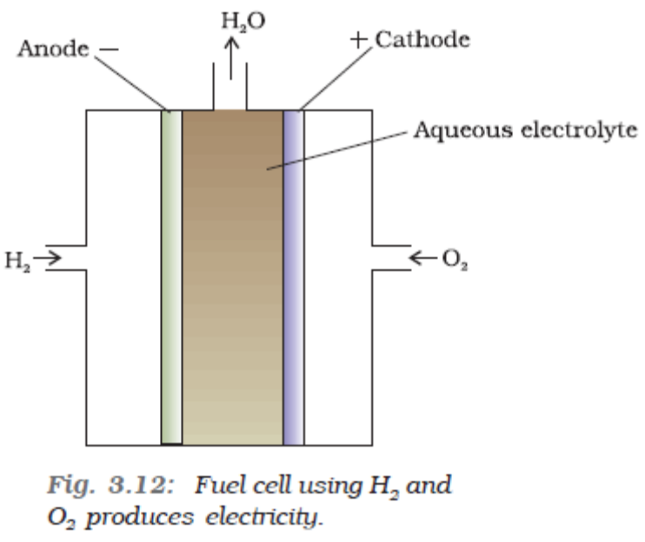
Fuel cells are galvanic cells which directly concerts the heat energy of fuel into electrical energy. In the cell hydrogen and oxygen are bubbled through porous carbon electrodes into concentrated aqueous NaOH or KOH solution. The electrode reactions are:
At anode H₂(g) + 2OH⁻(aq) → 2H₂O + 2 e⁻
At Cathode O₂(g) + 2H₂O(l) + 4e- → 4OH-(aq)
_________________________________
2H₂(g) + O₂(g) → 2H₂O(l)

- What is electrochemical series? List its various characateristics.
Solution:
The standard reduction, the arrangement of elements in order of increasing reduction potential values is called electrochemical series.
Characteristics:
- In electrochemical series Li/Li^{+ i}s at the top F₂/F⁻ is at bottom. It shows that lithium has greater tendency to form Li⁺
- The tendency of an element to undergo reduction increase from top to bottom.
- Fluorine occupying the total position shows greater tendency to undergo reduction and is powerful oxidizing agent.
- Electrochemical series helps to predict the activity as metals.
- Tendency to get reduced increases on moving downwards or the power of oxidizing agent increases on moving downwards in electrochemical series.

- Write Nernst equation.
Solution:
The Nernst equation for electrode reaction
M^{n+} + ne⁻ → M(s)
E _{Mn+/M} = E⁰ _{Mn+/M} - 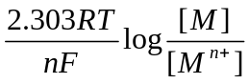
Here E _{Mn+/M} is standard electrode potential for molar solution of a metal ion M^{n+} at 298 K which is determined by using standard hydrogen electrode, R is gas constant. T is absolute temperature, n is number of moles of electrons, F is the Faraday’s number for chemical cell
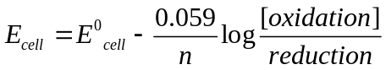

- Give a brief account of corrosion and its mechanism.
Solution:
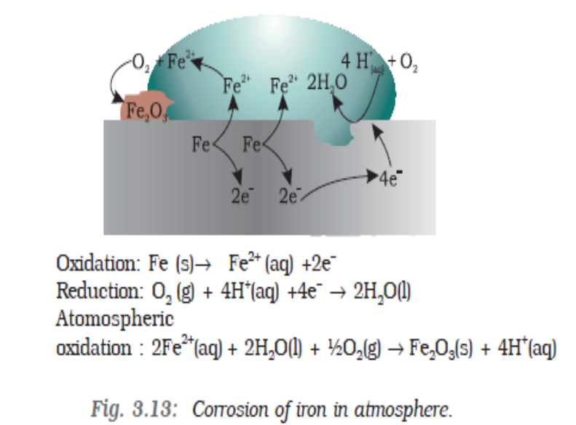

Corrosion is an electrochemical phenomenon. Initially the metal is oxidized by way of loss of electrons. Further it is oxidized to its oxide in the presence of water and air.
Mechanism:
Oxidation occurs at,
Anode: Fe(s) → Fe²⁺ (aq) + 2e⁻
Electrons released at anode move through the metal and go to another spot on the metal and reduce the oxygen in presence of H⁺ ions.
Cathode: O₂(g) 4H⁺(aq) + 4e⁻ → 2H₂O(l)
Here Fe²⁺ ions move through water on surface of iron object.
The overall reaction of the cell can be summarized as
2Fe (s) + O₂(g) 4H⁺(aq) +4e⁻ → 2H₂O(l)
4Fe²⁺(aq) + O₂(g) + 4H₂O(l) → Fe₂O₃(s) + 8 H⁺
H+ ions produced in above reaction help further in rusting.
The Fe²⁺ ions are now oxidized to Fe3+ ions, which form Iron (III) oxide, (Fe₂O₃.xH₂O).
If the water on the surface is saline or if impurities are present, the process of corrosion is quickened.

- Explain the electrolysis of sulphuric acid.
Solution:
During the electrolysis of H₂SO₄ hydrogen gas in liberated at cathode
At cathode
H⁺(aq) + e⁻ → ½ H₂ (g)
But following two processes can take place at the anode
At anode
2H₂O(l) → O₂(g) + 4H+(aq) +4e- E0=1.23 V
2SO₄ ²⁻(aq) → S₂Os²⁻(aq) + 2e⁻ E0=1.96 V
For dilute sulphuric acid, reaction (i) is preferred but at higher concentration of H₂SO₄ process ii) is preferred resulting in formation of solution of peroxodisulphuric acid (H₂S₂O₈)

- What are secondary cells? Give the anode or cathode reaction of Nickel Cadmium storage cell?
Solution:
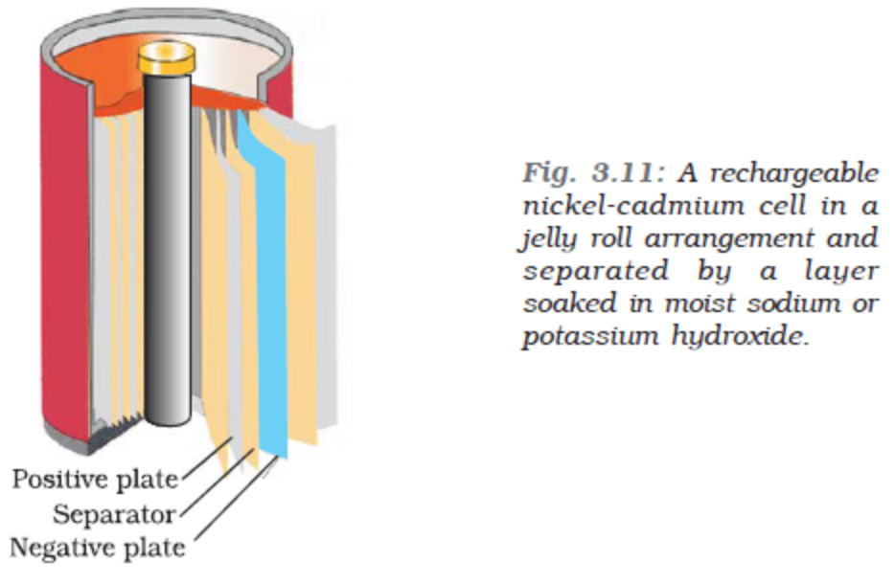

Secondary cells are those cells which can be recharged by passing a direct current through them and can be used again as a source of electric current.
Nickel-Cadmium storage cell
At anode
Cd(s) + 2OH-(aq) → Cd(OH)₂(s) + 2e⁻(Oxidation)
At cathode
NiO₂(s) + 2H₂O(l) + 2e_ → Ni(OH)₂(s) + 2OH⁻ (Reduction)
Over all
Cd(s) + NiO₂(s) + 2H₂O(l) → Cd(OH)₂(s) + Ni(OH)₂ (s)

- Why molar conductivity for CH₃COOH can not be determined experimentally?
Solution:
Molar conductivity of weak electrolyte keeps on increasing with dilution and does not become constant even at very large dilutions.

- What is the use of Platinum foil in the hydrogen electrode?
Solution:
It is used for the inflow and out low of electrons.

- Cu is conducting as such while CuSO₄ is conducting only in molten state or is aqueous
Solution. Why?
Solution:
Cu is conduction as such because it contains free electrons. CuSO₄ is conduction in molten state or in aqueous solution because it gives ions in the molten state or aqueous solution.

- Out of Zn and Sn which one protects iron better even after cracks and why?
Solution:
Zn protects better because oxidation potential of Zn is greater but that of tin is less than that of iron.

- Which cell was used in appollo space programme?
Solution:
Hydrogen-oxygen fuel cell.

- How is cathodic protection of iron different from its galvanization?
Solution:
In Cathodic protection, the iron is connected by a wire with amore active metal such as Zn or Al.Consequently, the more active metal acts as anode and loss electrons in preference Iron.

- CO₂ is always present in natural water. Explain its effect on rusting of iron.
Solution:
In the presence of dissolved CO₂ in H₂O the acidity of water adjacent to the iron object increase and its electrical conductivity also increases. The ions present, will favour the formation of more electrochemical cell and will thus promote rusting or corrosion.

- If a current of 5 A flows for 3.00minute, then what quantity of charge has flowed?
Solution:
Charge = Current X Time
= 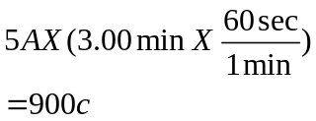
Charge on 1 mol of electrons is 96500 coulomb
Mole electrons = 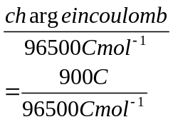
=9.33 X 10-3 mole electrons.

- The resistivity of 0.01 MA⁺ B⁻ solutions is 300Ω cm and a conductivity cell containing such as solution was found to have a resistance of 450 Ω. What is the cell constant?
Solution:
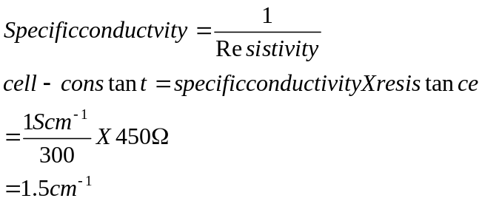

- The molar conductivity of 0.15M organic acid solution is 5.5 S cm² mol⁻¹. what is the
specific conductivity and resistivity of the solution?
Solution:
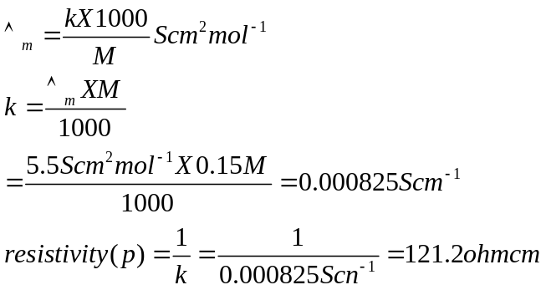

- Calculate molar conductance at infinite dilution for acetic acid. Given:
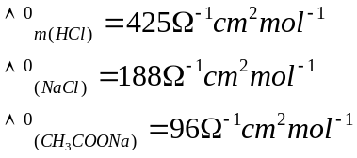
Solution:
According to Kohlraush’s law
a) 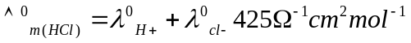
b) 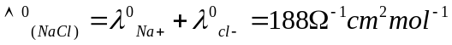
c)
Eq(a) +Eq (c) –Eq(b)
=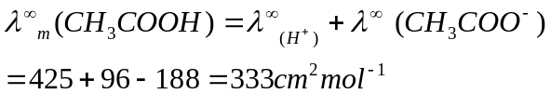

- The conductivity of 0.01M ethanoic acid is 0.145X110⁻³ S cm⁻¹ and the molar conductivity of H⁺ and CH₃COO⁻ are 350 and 41 S cm2 mol⁻¹ respectively. Calculate he dissociation constant of the acid.
Solution:
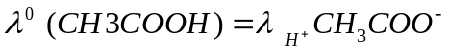
=350 S cm2 mol-1 + 41 S cm2 mol-1
=391 cm2 mol-1
Degree of dissociation = 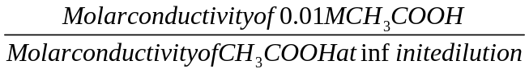
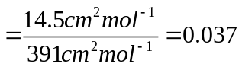
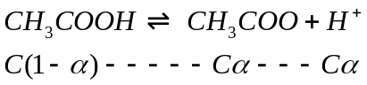
K_{a} = 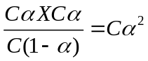
=0.01 M X (0.037)²=1.4X10⁻⁵

- An electrochemical cell is set-up between cadmium and nickel
Cd(s) | Cd²⁺ (1M) || Ni²⁺) (1M) | Ni(s)
If two half-cells work under standard conditions, calculate the cell potential (emf).
E⁰ _{cd2+/Cd} = -0.40 V, E⁰_{Ni2+/Ni}=-0.25V
Solution:
Cd (s) | Cd²⁺ (1M) || Ni²⁺ (1M) | Ni(s)
According to the convention, the right had side electrode is cathode and the left hand side electrode is anode.

Anode Half-reaction: Cd(s) → Cd2+ (aq) +2e-
Cathode Half reaction: Ni2+(aq)+2e- → Ni(s)
The cell reaction is :Cd(s)+Ni2+(aq) → Ni(s) +Cd2+(aq)

E0 _{cell}=E0_{red(right)}-E0_{red(left)}
= E0(_{redcathode)}-E0_{red(Anode)}
=E0_{Ni2+/Ni}-E0_{CD2+/Cd}
E0 _{cell}=-0.25 V-(-0.04V) = + 0.15 V

- Calculate the standard cell potential of the electrochemical cell in which following reaction occurs.Pb + 2Ag⁺ → Pb²⁺ + 2Ag(s) E⁰_{pb2+/Pb}=-0.13 V E⁰_{Ag+/Ag}=+0.80V
Solution:
Anode half reaction: Pb → Pb²⁺ + 2e-
Cathode half reaction: 2Ag⁺ + 2e- → 2Ag
According to the convention, cathode is written on the right hand side.
E⁰_{cell}=E⁰(_{redcathode)}-E0_{red(Anode)}
= E⁰ _{Ag+/Ag}-E⁰ pb²⁺/Pb
E⁰_{cell} = +0.80 V-(-0.13 V) = 0.93 V

- The E⁰ values for the two metal electrodes are given below:
  - Cr³⁺/Cr²⁺ = - 0.4 V
  - Fe³⁺/Fe²⁺ = + 0.8V
Comment on the result of treating a solution of Cr (II) with a solution containing Fe (III) ions.
Solution:
On the basis of above value we can say the value of reduction electrode potential of Cr³⁺/Cr²⁺ is -0.4 V. it is less than reduction electrode potential of Fe³⁺/Fe²⁺ is +0.8 V. in both cases Cr²⁺ will be oxidized to Cr³⁺ and Fe³⁺ will be reduced to Fe²⁺
Cr²⁺ + Fe³⁺ → Cr³⁺ + Fe²⁺
Thus when Fe3+ ion is added to Cr²⁺ solution, Fe³⁺ will be reduced to Fe³⁺ and Cr²⁺ will be oxidized to Cr³⁺

- What is the half –cell potential for Ag+/Ag electrode at 25⁰C in which concentration of silver ions is 0.5M? Eº _{Ag+/Ag}= +0.80 V
Solution:
Ag+(aq) + e- → Ag(s) n=1 [Ag(s)] = 1
E_{Ag+/Ag}=E⁰_{Ag+/Ag}-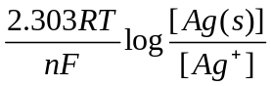
=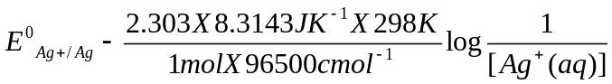
=+0.80 V- 0.05916 X log 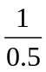
=+0.80 V- 0.05916 X log 2
=+0.80V-0.05916X0.3010
=+0.80-0.0178=+0.7822V

- Calculate the electrode potential of Mg²⁺/Mg electrode in which [Mg²⁺] is 0.1 M. E0_{Mg2+/mg}=-2.36 V
Solution:
Mg2+(aq) + 2e- → Mg(s) n=2
Log Q=log 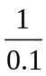=log 10=1
E_{Mg2+/Mg}= E0_{Mg2+/Mg}-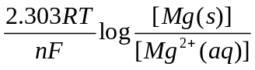
At 25⁰C E_{Mg2+/Mg}= E⁰_{Mg2+/Mg}-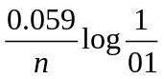
E_{Mg2+/Mg}= E0_{Mg2+/Mg}-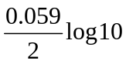
=-2.36 V -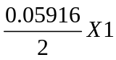
=-2.36 V-0.02958 V
=-2.36 V-0.03=-2.39 V

- Calculate the electrode potential of the following half cell:
Cr₂O₇²⁻(aq) + 14H⁺(aq) +6e⁻ → 2Cr³⁺ (aq) + 7H₂O(l) E⁰_{red}= + 1.33 V
When [Cr₂O₇²⁻]=0.2M;[H⁺]=1M;[Cr³⁺]=0.1M
Solution:
n=6
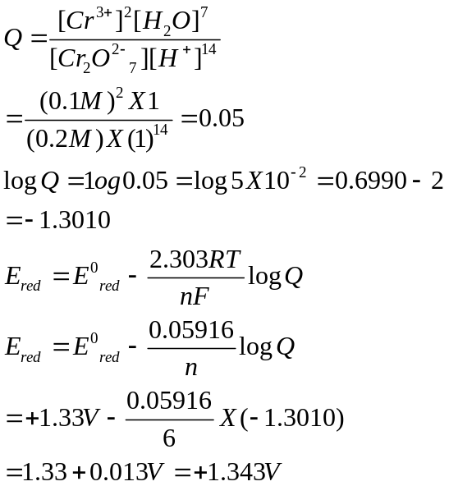

49. The measured cell potential of the following cell is 1.22 Calculate [Cd⁺²] in the anodic compartment. E⁰_{Cd2+/Cd} = -0.40V E⁰_{Ag+/Ag} = 0.80V: Cd / Cd⁺²_{(0.1M)} Ag⁺ _{(0.5M)} / Ag
Solution:
E⁰ _{cell} = E⁰ _{cathode} - E⁰ _{anode} = +0.80 - (-0.40) = +1.20V

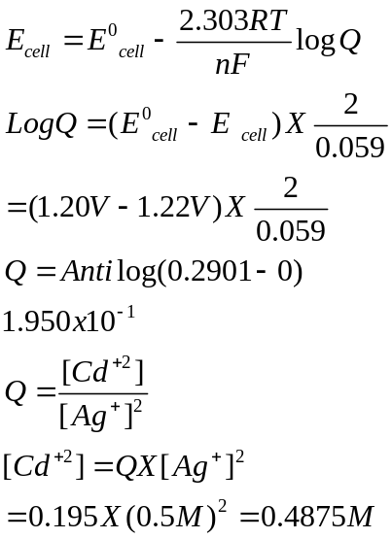

_{50.} _{For the cell reaction} Ni / Ni⁺² Ag⁺ / Ag, Calculate the equilibrium constant at 25⁰C.How much work would be obtained by operation of this cell? E⁰_{Ni2+/Ni} = --0.25V E⁰_{Ag+/Ag} = 0.80V:
Solution:
Ni → Ni⁺² + 2e⁻
2Ag⁺ 2e⁻ → 2Ag
____________________________________
Ni +2Ag⁺² → Cd⁺² +2Ag

Number of electrons lost or gained (n) = 2
E⁰ _{cell} = E⁰ _{cathode} - E⁰ _{anode} = +0.80 - (-0.25) = +1.05V

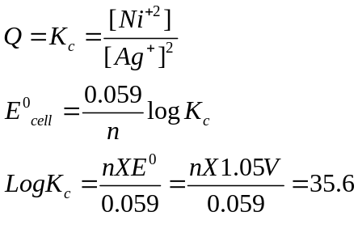
K_{c} = Anti log 35.6 = 3.981 X10³⁵ = 4 X X10³⁵
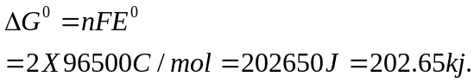

51. How many coulombs of electricity are required for the following reduction
processes: i) 1mole of Ag⁺ ii)1 mol of Cu²⁺ iii) 1 mol of Al^{3+.}
iv) 1 mole of water to dioxygen.
Solution:
i) Ag⁺¹ + e- → Ag
1mol 1mol 1mol
1mol 1F 1mol
1 mol Ag is deposited by 1 Faraday=1 FX96500 C mol -1=96500 C
ii) Cu₂₊ + 2e- → Cu
1mol 2mol 1mol
1mol 2F 1mol
1 mol Cu is deposited by 2 Faraday = 2FX96500 C mol-1=193000 C
iii) Al3+ + 3e- → Al
1mol 3mol 1mol
1mol 3F 1mol
1 mol Al is deposited by 3 Faraday=3 FX96500 C= 289500 C
iv) 2H2O(l) → 4H+(aq) O2(g) + 4e-
2mol 4mol
2mol 4F
2mol water is reduced by 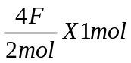
=2FX96500 C mol-1=193000 C

52. How many coulombs are required to produce 200 g calcium from CaCl₂.
Solution:
Ca⁺² + 2e⁻ → Ca(s)
1mol 2mol 1mol
Production of 40 g requires 2 F electricity. Production of 20 g Ca requires 1 F electricity.
1 F = 96500 C

53. How many grams of bromine can be produced by the electrolysis of molten magnesium bromide with a current of 3.2 ampere for 50 minutes? (Mg=12;Br=80amu)
Solution:
Q= I X t
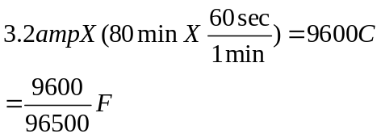
2Br⁻ → Br₂ + 2e⁻
2mol 1 mol 2mol
2mol 1mol 2F
2 F charge produce 1mol Br2 = 2 X80gXmol-1=160 g
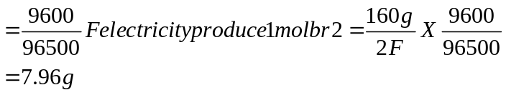

54. How long a current of 3 amps has to be passed through a solution of silver nitrate to coat a metal surface of 80cm² with a 0.005 mm thick layer? Density.
Solution:
Volume of silver to be deposited= Area X Thickness
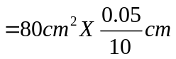
Mass of silver to be deposited
=Volume X Density
=80 cm2X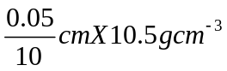
=0.42g
The cathode reaction is
Ag+ + e- → Ag
1mol 1mol 1mol
1mol 1F 1mol
108 g Ag is deposited by 96500 coulomb of electricity
0.42 g Ag us deposited by 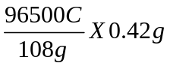=375.3 coulombs
Q = I X t
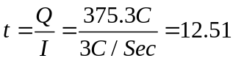

55. Predict if the following reaction is feasible or not , and
Solution:
Must be positive for cell reaction to be feasible. In the given reaction, Ag is oxidized. So, it is acting as anode and Cu is reduced so, it is acting as cathode.

=
= +0.34 – (+0.80)
= 0.34 – 0.80
= – 0.46 V
Since is having negative value, so the reaction is not feasible.

56. Chromium metal can be plated out from acidic solution containing CrO₃ according to
following reaction-
Calculate the mass of chromium that will be plated out by 12000 C of charge.
Solution:
6 mole of e– deposit = 1 mole of Cr = 52g of Cr
Quantity of electricity on 6 moles of e– = = 579000C
579000C of charge deposits on = 52g of Cr
12,000 C of charge deposits on = 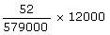
=
57. An unknown metal M displaces Ni from NiCl₂ solution but it does not displace Mn from MnCl₂ solution. Arrange metal M, Ni and Mn in correct order of reducing power.

Solution:
  - Oxidation potential of M is more than Ni because M displaces Ni²⁺ from NiCl₂.
(ii) Oxidation potential of M is less than Mn²⁺ because M cannot displace Mn²⁺ from MnCl₂.Order of oxidation potential is Ni < M < Mn . More the oxidation potential means stronger reducing power. Correct order of reducing powers is Mn > M > Ni

58. The resistance of 0.5 M CH₃COOH solution is 100 ohm. The cell constant is 0.035/cm.
Calculate molar conductivity of solution.
Solution:
Electrolyte Conductivity = 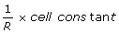
= 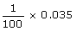
=
Molar Conductivity = 
= 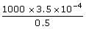 =
59. Find the emf of following cell - 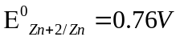
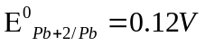
Solution:
From the cell representation, it is clear the Zn is anode and Pb is cathode.
E⁰_{cell} =
= –0.12 – (–0.76)
= –0.12 + 0.76
= + 0.64 V
Given
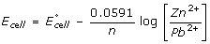
60. The resistance of 1N solution of CH₃COOH is 250 ohm. The cell constant is 1.15 cm^{–1}.
Calculate the equivalent conductance of solution
Solution:
Conductivity = 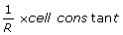
= 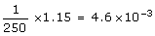
^eq. = 
= 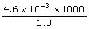
=
61. Calculate the number of coulombs required to deposited 7.25g of Al.
Solution:
27g (= 1 mole) of Al is deposited by = 3 moles of e–
Charge required to deposit 27g of Al =
Charge required to deposit 7.25g of Al = 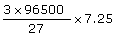
= 77736.11 C.

62. Calculate mass of copper deposited when a current 0.3 ampere is passed in aq solution of
copper sulphate for two hour.
Solution:
Equivalent wt. of Cu = 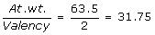
Z for Cu = 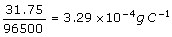
W = Z i t
=
= 0.7106 g.
63. The emf of Zn – Cu cell is 1.1 V at 298 K. Calculate equilibrium constant of the reaction.
Solution:
= 
1.1 = 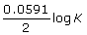
log K = 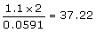
K = Antilog 37.22 =
64. Calculate standard free energy change for the following chemical reaction –
,
Solution:
It is clear from data that Ag is anode and Cd is Cathode.
=
= 0.80 – (– 0.40)
= 1.20 V
n = 2
=
=
= 231600 J = 231.6 kJ
65. Find emf of H₂–O₂ fuel cell from the following data -
Solution:
= – 235 kJ mol^{–1} =

=
= 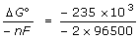
= 1.218 V

66. Calculate molar conductivity of solution of MgCl₂ at infinite dilution from the given data.
Solution:
=
=
= 107.12 + 152.68
= 259.8 ohm^{–1} cm² mol^{–1}
67. Find the value of equilibrium constant from the following data-
Solution:
=
0.295 = 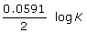
Log K = 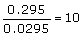
K =

SECTION “C”
(ELECTRO CHEMISTRY)

Q1. Write the cell reactions which occur in lead storage battery when the battery is use and when the battery is on charging.
Solution:
The cell reaction occurring in lead storage battery.
i) When battery is in use:
Anode: PbSO₄ + 2e⁻ → Pb + SO₄⁻²
Cathode PbO₂ + SO₄⁻² + 4H⁺ + 2e⁻ → PbSO₄ +2H₂O₂
ii) When battery is charging On charging the reaction is reversed and PbSO4(s) and on anode and cathode is converted in to Pb and PbO2 respectively.

Q2. Conductivity of 0.00241M acetic acid is 7.896 x 10⁻⁵S/cm.Calculate its molar conductivity. If acetic acid is 390.5Scm mol⁻¹, what is the dissociation constant?
Solution:
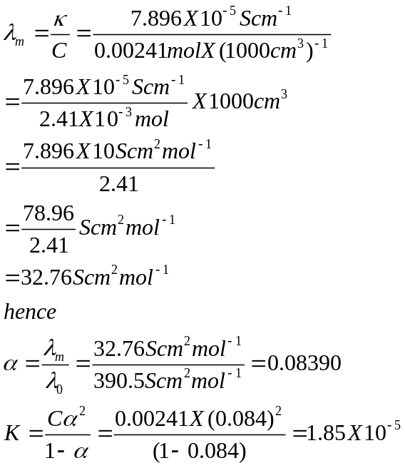

Q3 i) Define electrical conductivity and molar conductivity of a solution and write units of molar conductivity.
ii) The values corresponding to the following two reduction electrode processes are:
a)Cu⁺/Cu = +0.52 V b) Cu⁺²/Cu⁺ = 0.16 V.
Formulate the galvanic cell for their combination. What will be the standard cell potential for it? Calculate. 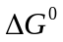 for the cell reaction.
Solution:
i) Electrical conductivity may be defined as the conductance produced by the ions when electric current is passed through an electrolyte.
Molar conductivity may be defined as the conductance of all the ions in one mole of electrolyte in the solution at given dilution.
This is mathematically represented as
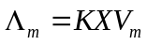 ; 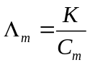 V_{m} = Volume of the solution.
C_{m} = Concentration the solution.
The units of molar conductivity is ohm⁻¹cm² or Scm²mol⁻¹
ii) The galvanic cell is represented as
Cu⁺ / Cu⁺² Cu⁺ / Cu
Anode Cathode
The cell reaction is Cu⁺ + Cu⁺ → Cu⁺² + Cu
Given Cu⁺/Cu = +0.52 Cu⁺²/Cu⁺ = 0.16 V.
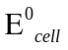= 0.52V - 0.16V = 0.36V

Calculation of free energy.
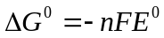
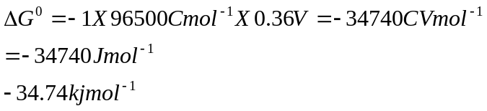

Q4 i) In the button cell widely used in watches and devices, the following reactions takes place:
Zn + Ag₂O +H2O → Zn⁺² + 2Ag +2OH⁻
Determine E⁰ and for the reaction. Given that 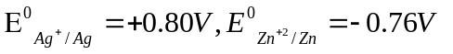
ii) Explain with examples the terms weak and strong electrolytes. How can these be distinguished?
Solution:
In galvanic cell, the anode has grater tendency to lose electron than cathode. When two electrodes are connected, the electrode having grater –ve (lesser +Ve) value of reduction electrode potential acts as anode, while the other electrode as cathode.
The reduction potential of Zinc
Zn⁺² + 2e⁻ → Zn 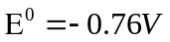
And silver oxide is
Ag₂O + H₂O + 2e⁻ → 2Ag + 2OH⁻ 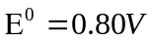
Reduction potential of silver electrode is higher than that of Zinc electrode.
Zn / Zn⁺² Ag₂O / Ag
Anode Cathode
At Ag electrode Reduction takes place
Ag₂O + H₂O + 2e⁻ → 2Ag + 2OH⁻
At Zn electrode Reduction takes place Zn →Zn⁺² + 2e⁻
_____________________________________________________
Ag₂O + H₂O + Zn → 2Ag +2OH⁻ E⁰_{cell}= 1.56V
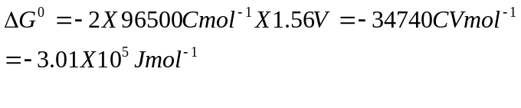
ii) A strong electrolyte is completely ionized at all dilutions and hence its equivalent or molar conductivity does not change much by increasing dilution (lowering the concentration) small in increase is due to increase in mobility if ions.
A weak electrolyte is not completely ionized at all dilutions and hence its equivalent or molar conductivity changes much by increasing dilution (lowering the concentration). The increase is due to a) Increase in ionization, which causes increase in number of ions. And
b) Mobility if ions.

Q5 i) Explain why electrolysis of aqueous solution of NaCl gives H₂ at cathode and Cl₂ at
anode. Write overall reaction.
ii) 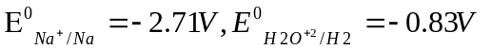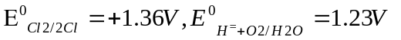
iii) Calculate the e,m.f of the cell Zn / Zn⁺²_{(0.1M)} Cd⁺²_{(0.01M)} / Cd at 298K
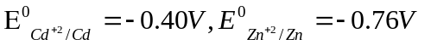
Solution:
Standard reduction potential for reduction of water (-0.83V) is more than the standard reduction potential of Na⁺(-2.71V).Hence ,reduction of water takes place in the preference to Na⁺
Ions and H₂ gas will liberate at cathode.
Reactions at cathode: Na⁺ + e⁻ → Na
2H₂O + 2e⁻ → H₂ +2OH⁻
Reactions at anode
2Cl⁻ → Cl₂ +2e⁻
2H₂O + 2e⁻ → O₂ + 2H⁺ + 2e⁻
Oxidation of water needs large activation due to slow transfer of electrons. It creates electrical resistance at anode surface; extra voltage is required to over come this resistance. Due to requirement of extra voltage for oxidation of Cl⁻ ions tales place in preference to water. Hence, chlorine is given out at anode.NaCl + H₂O → Na+ + OH- + H₂ +Cl₂
ii) The cell: Zn / Zn⁺²_{(0.1M)} Cd⁺²_{(0.01M)} / Cd at 298K
Anode Cathode

The cell reaction is Zn +Cd⁺² → Zn⁺² + Cd
E⁰ _{cell} = E⁰ _{cathode} - E⁰ _{anode} = -.40 - (-0.70) = 0.36V

Nerest equation
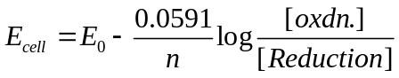
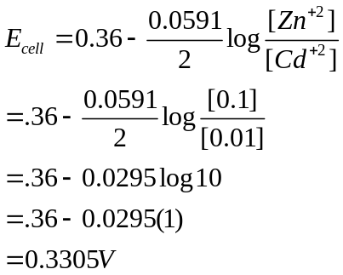

Q6 Account for the following
- Alkaline medium inhibits the rusting of iron.
- Iron does not rust even if the zinc coating is broken in galvanized iron pipe.
iii) Cu²⁺ + 2e⁻ → Cu ; E⁰ = + 0.34 V and Ag⁺ + 1e⁻ → Ag ; E⁰ = + 0.80 V
Constract a galvanic cell using The above equations.
- For what concentration of Ag⁺ ions will the emf of the cell be zero at 25⁰C,if the concentration of Cu²⁺ is 0.01M.
Solution:
i) Rusting takes p0lace in the presence of H⁺ ions more rapidly. An alkaline medium inhibits the rusting by neutralizing H⁺ ions. Thus the presence of OH_ furnished alkaline solution removes H⁺ ions from the reaction and hinders the rusting of Fe to Fe⁺² and Fe⁺³.

ii) Zinc is more reactive than iron. Zinc has lower reduction potential than iron. More electropositive zinc metal coated on iron acts as anode and loses electrons to iron which act as cathode. Thus, iron does not get rusted because any Fe²⁺ formed will gain electron from zinc to from Iron.

iii) Cu / Cu⁺² Ag⁺ / Ag at 298K E⁰_{Cu/Cu+2} = + 0.34 V and E⁰_{Ag/Ag+} = + 0.80 V
Anode Cathode

- Cu / Cu⁺²(0.01) Ag⁺(M₁) / Ag at 298K
At Anode. Cu → Cu⁺² + 2e⁻
At Cathode 2Ag + 2e⁻ →2Ag
_____________________________________________________
Cu + 2Ag → 2Ag +Cu⁺²
_____________________________________________________
n = 2 and E⁰ _{cell} = E⁰ _{cathode} - E⁰ _{anode} = 0.80 – ( 0.34) = 0.46V
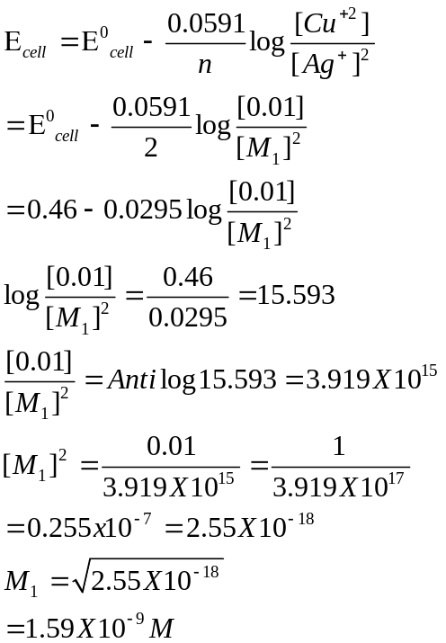

Q7 i) Calculate the emf of cell Mg / Mg⁺²(0.10) Cu⁺²(1X10⁻³) / Cu at 298K E⁰_{Cu/Cu+2} = + 0.34 V and E⁰_{Mg+2/Mg} = - 2.37 V
ii) Explain with examples the terms weak and strong electrolytes.
Solution:
The cell reaction is Mg + Cu → Mg⁺² + Cu n = 2
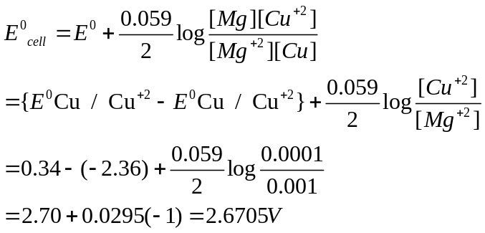
ii) Weak electrolytes are those which ionize partially and reversibly in aqueous solutions. Examples:NH₄OH,CH₃COOH,HCN.
Strong electrolytes are those which ionize completely at all dilutions. Examples: :NaOH,KOH,NaCl,HCl,HNO₃,H₂SO₄

Weak electrolytes | Strong electrolytes
1. These are not fully dissociated at high concentrations.  2. There are no strong interring ionic attractions between the ions even at high concentrations.  3. Their conductance increases with increase of dilution due to increase in ionization as well as mobility of ions, so this increase is very sharp and more. | 1. 1. These are Completely dissociated at all concentrations.  2. There are strong interring ionic attractions between the ions even at high concentrations.  3. Their conductance increases with increase of dilution due to increase in mobility of ions, so this increase is liner and less.

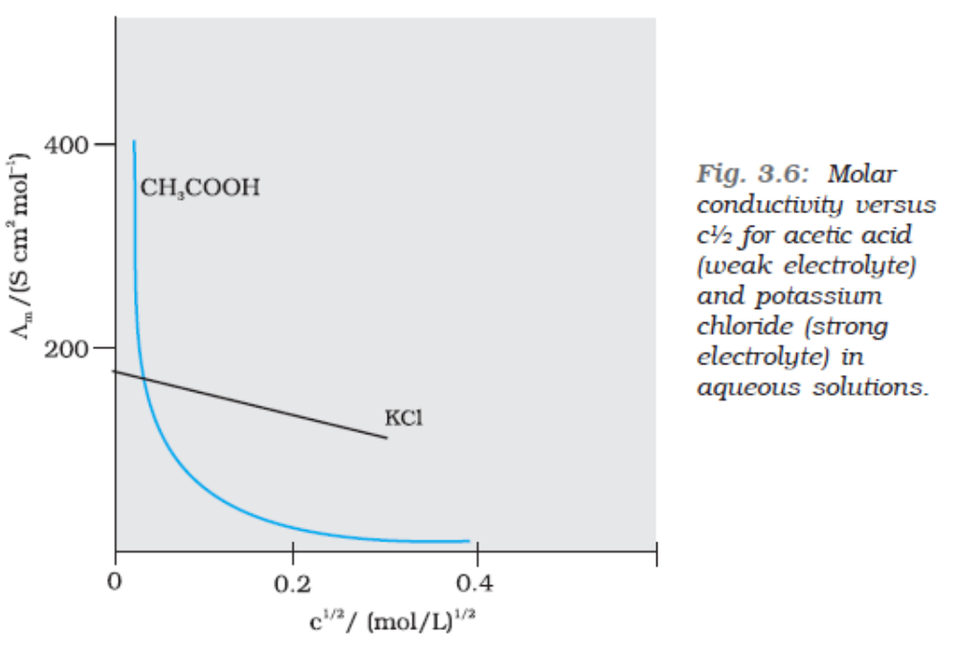
Q8 i)The resistance of a conductivity cell contain ).001M KCl solution at 298K is 1500.What is the cell constant ,if the conductivity of 0.001M KCl solution at 298K is 0.146 X 10⁻³ S cm⁻¹?
ii) Predict the products of electrolysis in the electrolysis of dilute H₂SO₄ with platinum electrodes.
Solution:
i) Cell constant = Conductivity X Resistance=0.146X10⁻³ S cm⁻¹ X1500=0.219cm⁻¹
ii) In electrolysis of H₂O, the two possible anode reactions are

a) 2H₂O → O₂ + 4H⁺ + 4e⁻
b) 2SO₄⁻² → S₂O₈⁻² + +2e⁻

For dilute solution of H₂SO₄ reaction a) is preferred and the product obtained at anode is O₂ gas. But at higher concentration of H₂SO₄ the reaction b) is preferred.
Cathode: 2H₂O + 2e⁻ → H₂ + 2OH⁻
Anode : 2H₂O → O₂ +4H⁺ + 4e⁻

Q9 Write the Nernest equation and calculate the emf of the following cell at 298K
Cu / Cu⁺²(0.130) Ag⁺ (1X10⁻⁴M) / Ag at 298K given that E⁰_{Ag+/Ag} = +0.80V
E⁰_{Cu+2/Cu} = + 0.34 V.
Solution:
The cell reaction can be written as Cu + 2Ag → Cu⁺² + 2Ag
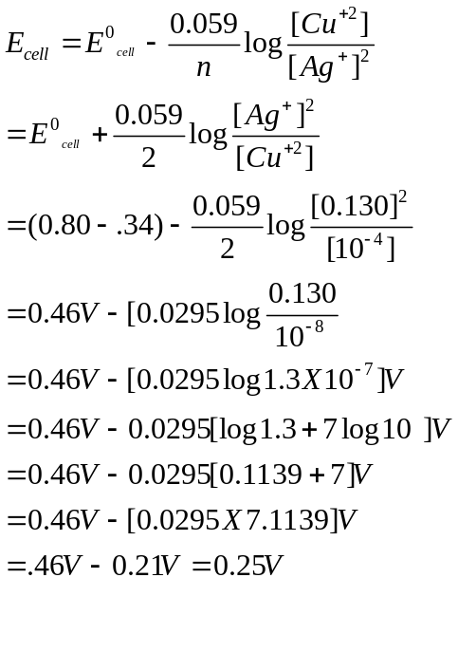
Q10 Predict the products of electrolysis obtained at the electrodes in each case when the electrodes used are platinum.
i)An aqueous solution of Ag NO₃ ii) An aqueous solution of H₂SO₄
Solution:
i) When aqueous solution of AgNO₃ is electrolyzed using platinum electrodes, deposition of silver would take place on inert cathode and the evaluation of oxygen would takes place at the anode.
At cathode: Ag⁺ + e⁻ → Ag
At anode: 2H₂O → O₂ +4H⁺ 4e⁻
ii) When an aqueous solution of sulphuric acid (H₂SO₄) is electrolyzed using platinum electrodes the evolution of hydrogen gas at the cathode and evolution of oxygen gas at anode would occur.
At cathode: H₂O + e⁻ → H₂ + OH⁻
At Anode: 2 H₂O → O₂ + 4H⁺ + 4e⁻

Q11. a) State two advantages of H2-O2 fuel cell over ordinary cell.
b) Silver is electrodeposited on a metallic vessel of total surface area 900 cm² by passing a current of 0.5 amps for two hours. Calculate the thickness of silver deposited.
[Given: density of silver=10.5 g cm⁻³, atomic mass of silver =108 amu, F=96500C mol-1]
Solution:
  - advantages of H₂-O₂ fuel cell over ordinary cell are:
- The fuel cell converts energy of fuel directly into electricity.
- The products formed by them do not cause pollution.
  - Given:I=0.5 amp, t = 2h, Q = I X t = 0.5 A X 2 X 60 X 60 s= 3600 C
Ag⁺ + e⁻ → Ag(deposited)
96500 C deposit silver =108 g
3600 C deposit silver = 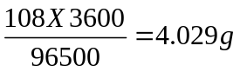
Volume of silver deposited = 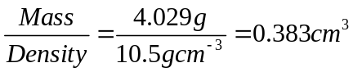
Thickness = 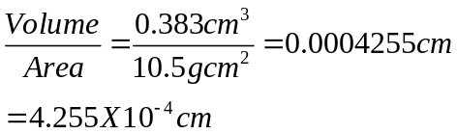

Q12. Give reasons for the following;
- Rusting of iron is quicker in saline water than in ordinary water.
- Aluminum metal cannot be produced by the electrolysis of aqueous solution of aluminum salt.
Solution:
- Rusting of iron is quicker in saline water than in ordinary water because conductivity of saline water is more than that of ordinary water.
- Aluminum metal is highly reactive and can not be reduced easily. As compared to water is reduced more easily.

Q13. Resistance of a conductivity cell filled with 0.1M KCl solution is 100 ohms. If the resistance of the same cell when filled with 0.02M KCl solution is 520 ohms, calculate the conductivity and molar conductivity of 0.02 M KCl solution. Conductivity of 0.1 M KCl solution is 1.29 S m-1.
Solution:
Cell constant (G*) = Conductivity X resistance = 1.29Sm⁻¹X100 ohms=129 m⁻¹
Conductivity of 0.02 M KCl solution =
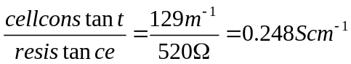
Concentration = 0.02 mol L⁻¹ = 1000 X 0.023 mol m⁻³
=20 mol m⁻³
Molar conductivity
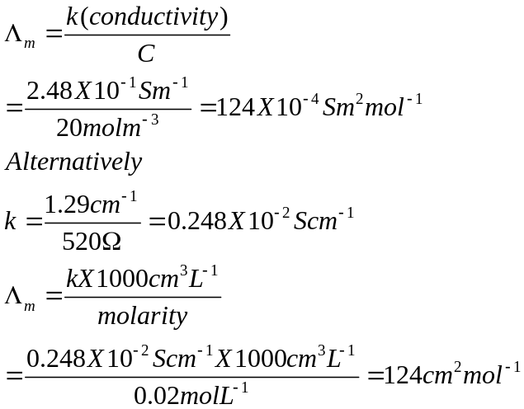

Q14. Calculate the standard cell potential of Galvanic cell in which the following reaction takes place.
2Cr + 3Cd⁺² → 2Cr³⁺ + 3Cd
Also calculate ∆G⁰ value for the reaction.
(Given: E⁰_{Cr+3/Cr} = - 0.74 V. E⁰_{Cd+2/Cd} = - 0.40 V.)
Solution:
E⁰ _{cell} = E⁰ _{cathode} - E⁰ _{anode} = -0.40 - (-0.74) = 0.34V
Number of electrons lost or gained n= 6
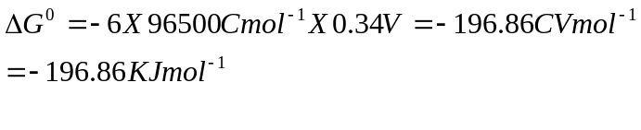
Q15. Define conductivity and molar conductivity of the solution of an electrolyte.
Solution:
The conductivity is defined as the conductance of any solution placed between the two electrodes of one unit area each, and separated by distance of one unit.
The conductivity measures the ease with which the current can be passed through an electrolytic solution. It is given by k (Kappa)
=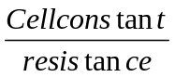
Molar conductivity () is the conducting power of cell the ions produced by one mol of an electrolyte. It is given by

=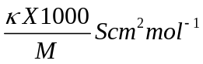
Variation of and with concentration
Conductivity decreases with dilution. Because the number of ions per unit volume that carry the current in a solution decreases.
Molar conductivity increases with decrease in concentration. This is because the total volume, V of a solution containing one mole of electrolyte also increases. Molar conductivity is the conductance of solution with unit length but the electrodes having area of cross section.
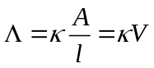
The decrease in k on dilution is more than compensated by increase in its volume. Hence
Increase with decrease in concentration.

SECTION- D (ELECTRO CHEMISTRY)

1. i) Which electrolyte is used in dry cell?
ii) What is fuel cell? Give the electrode reactions of H₂O₂ fuel cell.
iii) Why type of metals can be used for cathodic protection of iron against rusting.
iv) Give the mathematical expression which relates molar conductivity (A_{m}) of weak
electrolyte to its degree of dissociation (œ).

2. Explain the meaning o f the terms a) ionic mobility b) over voltage c) Cell constant d)
Corrosion.

3. How would you test whether the given electrolyte is strong electrolyte or weak electrolyte?
by the measurement of conductivity.

4. Explain the following in brief.
i) What is the use of platinum foil in hydrogen electrode?
ii) On the basis of E⁰ values given bellow comment whether it is safe or not to stir 1 M AgNO₃ solution with copper spoon. E⁰ Ag⁺ / Ag = 0.80 V; E⁰Cu²⁺ / Cu = 0.34
iii) Electrolysis of fused KHF₂ gives fluorine at anode but hydrogen at cathode.

5. i) How does electrical conduction of metals differ from that of electrolytic conduction. How
do the two change with the rise in temperature.
ii) What is a calomel electrode write its electrode reaction when it acts as anode.
iii) How would you arrive at the dimensions of ohm .

6. What is disproportionation? Calculate the equilibrium constant for the disproportionation of
copper (I) ion in aqueous solution. Given that E ⁰ _{Cu}²⁺ / Cu = + 0.34 V and
E ⁰ Cu¹⁺ / Cu = + 0.52 V.

7. 5 L of 0.1 M CuSO₄ was to be electrolysed using a current strength of 2.0 amperes. But
before electrolysis 10 g of zinc dust was added to the electrolytic cell. For how long the
electrolysis has to be carried out in order to completely deposit the copper ions from the
Solution? (Atomic masses of copper and zinc are 63.5 and 65 respectively).

8. Calculate the EMF of the cell Mg(s) / Mg²⁺(0.2 M) || Ag⁺ ( 1 x 10⁻³ M) / Ag; E ⁰ Mg²⁺ / Mg
= -2.37 V, E ⁰ Ag⁺ / Ag = + 0.80 V. What will be the effect on EMF if concentration of Mg²⁺
ion is decreased to 0.1 M?

9. Explain the following.
i) Rusting of iron becomes rapid in saline water than ordinary water. ii) Mobility of H ⁺ ions is high through the ice than the liquid water. iii) Why does a cell stops working after some time.

10. Zinc electrode is constituted at 298 K by placing zinc rod in 0.1 M aqueous solution of zinc
sulphate which is 95% dissociated at this concentration. What will be the electrode potential (E_{Zn}²⁺ / Zn) of the electrode given that E⁰ _{Zn}²⁺ / Zn = - 0.76 V.

11. Crude copper containing iron and silver as contaminations was subjected to electro refining
using a current of 175 A for 6.434 min. The mass of anode was found to decrease by 22.260g while that of cathode was increased by 22.011 g. Estimate the % age of Cu, Iron and silver
in crude copper.

12. Zn rod weighing 25 g was kept in 100 mL of 1 M CuSO₄ solution. After a certain time
interval, the molarity of Cu²⁺ was found to be 0.8 M. What is molarity of SO₄²⁻ ions in the
resulting solution and what should be the mass of Zn rod after cleaning and drying.

13. The emf of the cell, Ag / AgCl (Saturated Sol.) || 0.01 M AgNO₃ / Ag at 298 K is 0.169 V.
Calculate solubility and solubility product of AgCl at 298 K.

14. Consider the reaction given below Hg²⁺ + Ag → Ag⁺ + Hg. Comment on the feasibility of
reaction under different concentration of ions given below.
i) [Hg²⁺] = 10⁻⁴ M ; [Ag⁺] = 10⁻¹ M
ii) [Ag⁺] = 10⁻⁴ M ; [Hg²⁺] = 10⁻¹ M.
Given E⁰ _{Ag+ / Ag} = 0.80 V;
E0 Hg²⁺_{/ Hg} = 0.79 V

15. Given that E⁰ _{Mn}³⁺ _{/ Mn}²⁺ = + 1.51 V;
E⁰ _{Mn}²⁺ _{/ Mn} = - 1.18 V
E⁰ _{Cr}³⁺ _{/ Cr}²⁺ = - 0.41 V; E⁰ _{Cr}²⁺ _{/ Cr}= - 0.91 V
Which oxidation state (+2 or +3) will be more stable for manganese and chromium as per the
data.

16. For the galvanic cell: Ag / AgCl(s), KCl(0.2 M) || KBr (0.001 M). AgBr(s) / Ag assign
correct polarity to each electrode for a spontaneous process taking into account the cell
reaction at 25⁰ C
K_{sp}(AgCl) = 2.8 x 10⁻¹⁰;
K_{sp}(AgBr) = 3.3 x 10⁻¹³;

17. If a current of 0.200 A is passed through 50 ml of M / 10 NaCl solution for 10 min.
calculate the concentration of OH⁻ ions in the solution after the electrolysis.

18. The Edison storage cell is represented as Fe(s) / FeO(s) 1 Ni₂O₃(s) / Ni(s)
The half-cell reactions are

Ni₂O₃(s) + H₂O(l) + 2e⁻ ↔ 2N_{i}O(s) + 2OH⁻ ; E⁰ = + 0.40 V

FeO(s) + H₂O(l) + 2e⁻ ↔ F_{e}(s) + 2OH⁻; E⁰ = - 0.87 V
- What is the cell reaction?
- What is the cell emf ? How does it depend on the concentration of KOH ?
- What is the maximum amount of electrical energy that can be obtained from one mole of Ni₂O₃ ?

19. The standard reduction potential of the Ag⁺ / Ag electrode at 298 K is 0.799 V. Given that
for AgI, K_{sp} = 8.7 x 10⁻¹⁷, evaluate the potential of the Ag⁺ / Ag electrode in a saturated
solution of AgI. Also calculate the standard reduction potential of the I⁻ / AgI / Ag electrode.

20. The standard reduction potential for Cu²⁺ / Cu is 0.34 V. Calculate the reduction potential at
pH= 14 for the above couple . K_{sp} of Cu(OH)₂ is 1.0 x 10⁻¹⁹.

21. How many gram of silver could be plated out on a serving tray by electrolysis of a solution
containing silver in + 1 oxidation state for a period of 8.0 hrs at a current of 8.46 ampere?
What is the area of the tray if the thickness of silver plating is 0.00254 cm? Density of silver
is 10.5 g cm⁻³.

- Electrolysis of a solution of MnSO₄ in aqueous sulphuric acid is a method for the
preparation of MnO₂ as per the chemical reaction Mn²⁺(aq) + 2H₂O → MnO₂(s) + 2H⁺ +
H₂(g). Passing a current of 27 A for 24 hrs gives one kg of MnO_{2.} What ids the current
Efficiency and what are the reaction occurring at cathode and anode?

- Calculate the equilibrium constant for the reaction, 2Fe³⁺ +3F ↔ 2Fe²⁺ + I₃⁻. The standard
reduction potentials in acidic conditions are 0.77 and 0.54 V respectively for Fe³⁺ / Fe²⁺ and
I₃⁻ / I⁻couples.

24. Find the solubility product of a saturated solution of Ag₂CrO₄ in water at 298 K if the emf of
the cell Ag / Ag⁺ (saturated Ag₂CrO₄) || Ag⁺ (0.1 M) Ag is 0.164 V at 298.

25. A cell Ag / Ag⁺ || Cu²⁺ / Cu initially contains 1 M Ag⁺ and 1 M Cu²⁺ ions. Calculate the
change in cell potential after the passage of 9.65 A of current for 1 hour.

26. Silver electrode is immersed in saturated solution of Ag₂SO₄. The potential difference
between the silver and standard hydrogen electrode is found to be 0.711 V. Determine the K_{sp}
of Ag₂SO₄.

27. 250 ml of copper sulphate solution was electrolyzed using platinum anode and copper
Cathode. A constant current of 2 mA was passed for 16 minutes. It was found that after
electrolysis the absorbance of solution was reduced to 50% of its original value calculate
Concentration of copper sulphate solution to begin with.

- A solution containing 4.5 mM of Cr₂O₇²⁻ ions and 15 mM of Cr³⁺ ions shows a P^{H} 2.0. What
is the potential of half reaction?
Cr₂O₇²⁻ → Cr³⁺

29. Two students use same stock solution of ZnSO₄ and a solution of CuSO₄. The emf of one of
the cell is 0.03 V higher than the other. The conc. of CuSO₄ in the cell with higher emf is 0.5
M. calculate the conc. of CuSO₄ in the other cell. (2.303 RT / F = 0.06)

30. Find equilibrium constant at 298 K for the reaction Cu²⁺(aq) + In²⁺(aq) ↔ Cu⁺(aq) +
In³(aq)
Given that: E⁰ _{Cu}²⁺ _{/ Cr}⁺ = 0.15 V ;

E⁰ _{In}³⁺ _{/ In}⁺ = - 0.42 V ;

E⁰ _{In}³⁺ _{/ In}⁺ = - 0.40 V

