HALO ALKANES AND ARENES

Question 10.1:
Write structures of the following compounds:
(i) 2-Chloro-3-methylpentane
(ii) 1-Chloro-4-ethylcyclohexane
(iii) 4-tert. Butyl-3-iodoheptane
(iv) 1,4-Dibromobut-2-ene
- (v) 1-Bromo-4-sec. butyl-2-methylbenzene
(i)
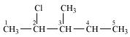
2-Chloro-3-methyl pentane
(ii)
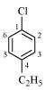
1-Chloro-4-ethylcyclohexane
(iii)
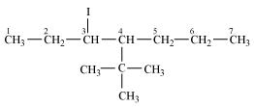
4- tert-Butyl-3-iodoheptane
(iv)
1, 4-Dibromobut-2-ene
(v)
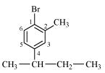
1-Bromo-4-sec-butyl-2-methylbenzene
Question 10.2:
- Why is sulphuric acid not used during the reaction of alcohols with KI?
In the presence of sulphuric acid (H₂SO₄), KI produces HI
Since is an oxidizing agent, it oxidizes HI (produced in the reaction to I₂₎.
As a result, the reaction between alcohol and HI to produce alkyl iodide cannot occur. Therefore, sulphuric acid is not used during the reaction of alcohols with KI. Instead, a non-oxidizing acid such as H₃PO₄ is used.
Question 10.3:
- Write structures of different dihalogen derivatives of propane.
There are four different dihalogen derivatives of propane. The structures of these derivatives are shown below.
(i)
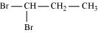
1, 1-Dibromopropane
(ii)
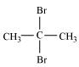
2, 2-Dibromopropane
(iii)
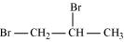
1, 2-Dibromopropane
(iv)
1, 3-Dibromopropane
Question 10.4:
Among the isomeric alkanes of molecular formula C₅H₁₂, identify the one that on photochemical chlorination yields
(i) A single monochloride.
(ii) Three isomeric monochlorides.
- (iii) Four isomeric monochlorides.
(i) To have a single monochloride, there should be only one type of H-atom in the isomer of the alkane of the molecular formula C₅H₁₂. This is because, replacement of any H-atom leads to the formation of the same product. The isomer is neopentane.
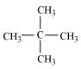
Neopentane
(ii) To have three isomeric monochlorides, the isomer of the alkane of the molecular formula C₅H₁₂ should contain three different types of H-atoms.
Therefore, the isomer is n-pentane. It can be observed that there are three types of H atoms labelled as a, b and c in n-pentane.
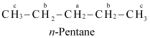
(iii) To have four isomeric monochlorides, the isomer of the alkane of the molecular formula C₅H₁₂ should contain four different types of H-atoms. Therefore, the isomer is 2-methylbutane. It can be observed that there are four types of H-atoms labelled as a, b, c, and d in 2-methylbutane.
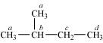
Question 10.5:
Draw the structures of major monohalo products in each of the following reactions:
(i)
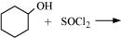
(ii)
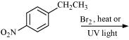
(iii)
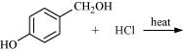
(iv)
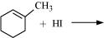
(v)
(vi)
- 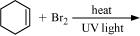
(i)
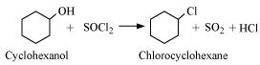
(ii)
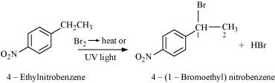
(iii)
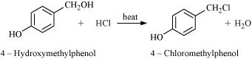
(iv)
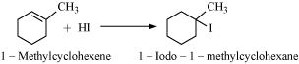
(v)
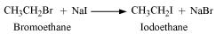
(vi)
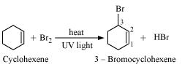
Question 10.6:
Arrange each set of compounds in order of increasing boiling points.
(i) Bromomethane, Bromoform, Chloromethane, Dibromomethane.
(ii) 1-Chloropropane, Isopropyl chloride, 1-Chlorobutane.
- Answer
(i)
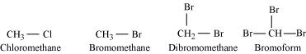
For alkyl halides containing the same alkyl group, the boiling point increases with an increase in the atomic mass of the halogen atom.
Since the atomic mass of Br is greater than that of Cl, the boiling point of bromomethane is higher than that of chloromethane.
Further, for alkyl halides containing the same alkyl group, the boiling point increases with an increase in the number of halides. Therefore, the boiling point of Dibromomethane is higher than that of chloromethane and bromomethane, but lower than that of bromoform.
Hence, the given set of compounds can be arranged in the order of their increasing boiling points as:
Chloromethane < Bromomethane < Dibromomethane < Bromoform.
(ii)
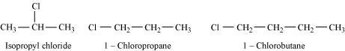
For alkyl halides containing the same halide, the boiling point increases with an increase in the size of the alkyl group. Thus, the boiling point of 1-chlorobutane is higher than that of isopropyl chloride and 1-chloropropane.
Further, the boiling point decreases with an increase in branching in the chain. Thus, the boiling point of isopropyl alcohol is lower than that of 1-chloropropane.
Hence, the given set of compounds can be arranged in the increasing order of their boiling points as:
Isopropyl chloride < 1-Chloropropane < 1-Chlorobutane
Question 10.7:
Which alkyl halide from the following pairs would you expect to react more rapidly by an S_{N}2 mechanism? Explain your answer.
(i)
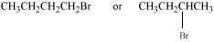
(ii)
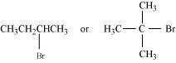
(iii)
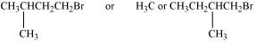
- Answer
(i)
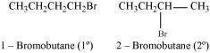
2-bromobutane is a 2° alkylhalide whereas 1-bromobutane is a 1° alkyl halide. The approaching of nucleophile is more hindered in 2-bromobutane than in 1-bromobutane. Therefore, 1-bromobutane reacts more rapidly than 2-bromobutane by an S_{N}2 mechanism.
(ii)
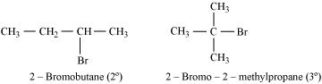
2-Bromobutane is 2° alkylhalide whereas 2-bromo-2-methylpropane is 3° alkyl halide. Therefore, greater numbers of substituents are present in 3° alkyl halide than in 2° alkyl halide to hinder the approaching nucleophile. Hence, 2-bromobutane reacts more rapidly than 2-bromo-2-methylpropane by an S_{N}2 mechanism.
(iii)
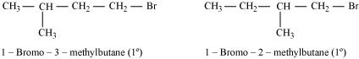
Both the alkyl halides are primary. However, the substituent −CH₃ is at a greater distance to the carbon atom linked to Br in 1-bromo-3-methylbutane than in 1-bromo-2-methylbutane. Therefore, the approaching nucleophile is less hindered in case of the former than in case of the latter. Hence, the former reacts faster than the latter by S_{N}2 mechanism
Question 10.8:
In the following pairs of halogen compounds, which compound undergoes faster S_{N}1 reaction?
(i)
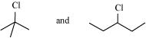
(ii)
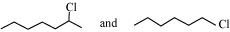
- Answer
(i)
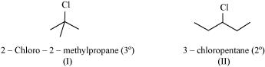
S_{N}1 reaction proceeds via the formation of carbocation. The alkyl halide (I) is 3° while (II) is 2°. Therefore, (I) forms 3° carbocation while (II) forms 2° carbocation. Greater the stability of the carbocation, faster is the rate of S_{N}1 reaction. Since 3° carbocation is more stable than 2° carbocation. (I), i.e. 2−chloro-2-methylpropane, undergoes faster S_{N}1 reaction than (II) i.e., 3-chloropentane.
(ii)
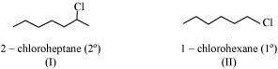
The alkyl halide (I) is 2° while (II) is 1°. 2° carbocation is more stable than 1° carbocation. Therefore, (I), 2−chloroheptane, undergoes faster S_{N}1 reaction than (II), 1-chlorohexane
Question 10.9:
Identify A, B, C, D, E, R and R¹ in the following:
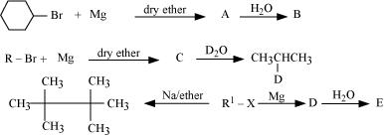
Answer 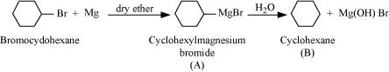
Since D of D₂O gets attached to the carbon atom to which MgBr is attached, C is
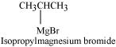
Therefore, the compound R − Br is
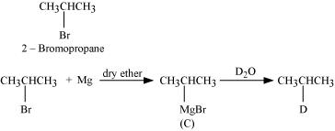
When an alkyl halide is treated with Na in the presence of ether, a hydrocarbon containing double the number of carbon atoms as present in the original halide is obtained as product. This is known as Wurtz reaction. Therefore, the halide, R¹−X, is
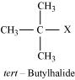
Therefore, compound D is
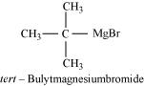
And, compound E is
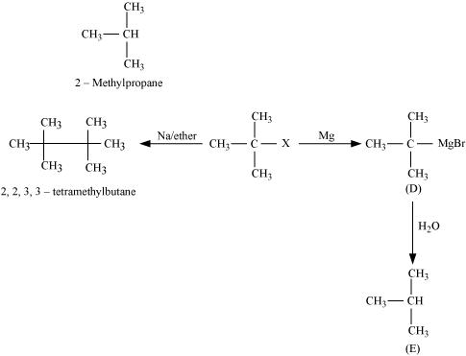
Question 10.1:
Name the following halides according to IUPAC system and classify them as alkyl, allyl, benzyl (primary, secondary, tertiary), vinyl or aryl halides:
(i) (CH₃)₂CHCH(Cl)CH₃
(ii) CH₃CH₂CH(CH₃)CH(C₂H₅)Cl
(iii) CH₃CH₂C(CH₃)₂CH₂I
(iv) (CH₃)₃CCH₂CH(Br)C₆H₅
(v) CH₃CH(CH₃)CH(Br)CH₃
(vi) CH₃C(C₂H₅)₂CH₂Br
(vii) CH₃C(Cl)(C₂H₅)CH₂CH₃
(viii) CH₃CH=C(Cl)CH₂CH(CH₃)₂
(ix) CH₃CH=CHC(Br)(CH₃)₂
(x) p-ClC₆H₄CH₂CH(CH₃)₂
(xi) m-ClCH₂C₆H₄CH₂C(CH₃)₃
(xii) o-Br-C₆H₄CH(CH₃)CH₂CH₃
- Answer
(i)
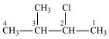
2−Chloro−3−methylbutane
(Secondary alkyl halide)
(ii)
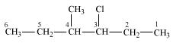
3−Chloro−4−methyhexane
(Secondary alkyl halide)
(iii)
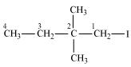
1−Iodo−2, 2 −dimethylbutane
(Primary alkyl halide)
(iv)
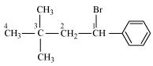
1−Bromo−3, 3−dimethyl−1−phenylbutane
(Secondary benzyl halide)
(v)
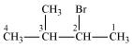
2−Bromo−3−methylbutane
(Secondary alkyl halide)
(vi)
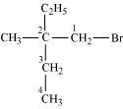
1−Bromo−2−ethyl−2−methylbutane
(Primary alkyl halide)
(vii)
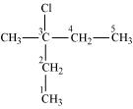
3−Chloro−3−methylpentane
(Tertiary alkyl halide)
(viii)
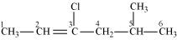
3−Chloro−5−methylhex−2−ene
(Vinyl halide)
(ix)
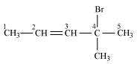
4−Bromo−4−methylpent−2−ene
(Allyl halide)
(x)
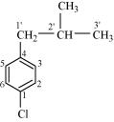
1−Chloro−4−(2−methylpropyl) benzene
(Aryl halide)
(xi)
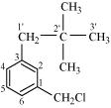
1−Chloromethyl−3−(2, 2−dimethylpropyl) benzene
(Primary benzyl halide)
(xii)
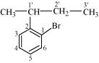
1−Bromo−2−(1−methylpropyl) benzene
(Aryl halide)
Question 10.2:
Give the IUPAC names of the following compounds:
(i) CH₃CH(Cl)CH(Br)CH₃
(ii) CHF₂CBrClF
(iii) ClCH₂C≡CCH₂Br
(iv) (CCl₃)₃CCl
(v) CH₃C(p-ClC₆H₄)₂CH(Br)CH₃
(vi) (CH₃)₃CCH=CClC₆H₄I-p
- Answer
(i)
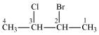
2−Bromo−3−chlorobutane
(ii)
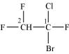
1−Bromo−1−chloro−1, 2, 2−trifluoroethane
(iii)
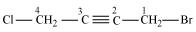
1−Bromo−4−chlorobut−2−yne
(iv)
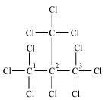
2−(Trichloromethyl)−1,1,1,2,3,3,3−heptachloropropane
(v)
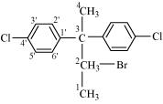
2−Bromo−3, 3−bis(4−chlorophenyl) butane
(vi)
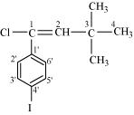
1−chloro−1−(4−iodophenyl)−3, 3−dimethylbut−1−ene
Question 10.3:
Write the structures of the following organic halogen compounds.
(i) 2-Chloro-3-methylpentane
(ii) p-Bromochlorobenzene
(iii) 1-Chloro-4-ethylcyclohexane
(iv) 2-(2-Chlorophenyl)-1-iodooctane
(v) Perfluorobenzene
(vi) 4-tert-Butyl-3-iodoheptane
(vii) 1-Bromo-4-sec-butyl-2-methylbenzene
(viii) 1,4-Dibromobut-2-ene
- Answer
- (i)
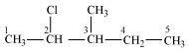
2-Chloro-3-methylpentane
(ii)
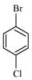
p-Bromochlorobenzene
(iii)
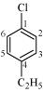
1-Chloro-4-ethylcyclohexane
(iv)
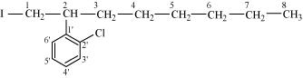
2-(2-Chlorophenyl)-1-iodooctane
(v)
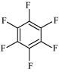
Perfluorobenzene
(vi)
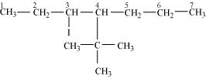
4-Tert-Butyl-3-iodoheptane
(vii)
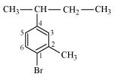
1-Bromo-4-sec-butyl-2-methylbenzene
(viii)
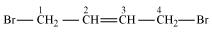
1,4-Dibromobut-2-ene
Question 10.4:
Which one of the following has the highest dipole moment?
(i) CH₂Cl₂
(ii) CHCl₃
(iii) CCl₄
- Answer
(i)
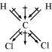
Dichlormethane (CH₂Cl₂)
μ = 1.60D
(ii)
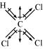
Chloroform (CHCl₃)
μ = 1.08D
(iii)
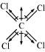
Carbon tetrachloride (CCl₄)
μ = 0D
CCl₄ is a symmetrical molecule. Therefore, the dipole moments of all four C−Cl bonds cancel each other. Hence, its resultant dipole moment is zero.
As shown in the above figure, in CHCl₃, the resultant of dipole moments of two C−Cl bonds is opposed by the resultant of dipole moments of one C−H bond and one C−Cl bond. Since the resultant of one C−H bond and one C−Cl bond dipole moments is smaller than two C−Cl bonds, the opposition is to a small extent. As a result, CHCl₃ has a small dipole moment of 1.08 D.
On the other hand, in case of CH₂Cl₂, the resultant of the dipole moments of two C−Cl bonds is strengthened by the resultant of the dipole moments of two C−H bonds. As a result, CH₂Cl₂ has a higher dipole moment of 1.60 D than CHCl₃ i.e., CH₂Cl₂ has the highest dipole moment.
Hence, the given compounds can be arranged in the increasing order of their dipole moments as:
CCl₄ < CHCl₃ < CH₂Cl₂
Question 10.5:
A hydrocarbon C₅H₁₀ does not react with chlorine in dark but gives a single monochloro compound C₅H₉Cl in bright sunlight. Identify the hydrocarbon.
- Answer
A hydrocarbon with the molecular formula, C₅H₁₀ belongs to the group with a general molecular formula C_{n}H_{2n}. Therefore, it may either be an alkene or a cycloalkane.
Since hydrocarbon does not react with chlorine in the dark, it cannot be an alkene. Thus, it should be a cycloalkane.
Further, the hydrocarbon gives a single monochloro compound, C₅H₉Cl by reacting with chlorine in bright sunlight. Since a single monochloro compound is formed, the hydrocarbon must contain H−atoms that are all equivalent. Also, as all H−atoms of a cycloalkane are equivalent, the hydrocarbon must be a cycloalkane. Hence, the said compound is cyclopentane.
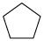
Cyclopentane (C₅H₁₀)
The reactions involved in the question are:
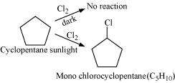
Question 10.6:
Write the isomers of the compound having formula C₄H₉Br.
- Answer
There are four isomers of the compound having the formula C₄H₉Br. These isomers are given below.
(a)
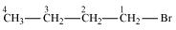
1−Bromobutane
(b)
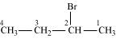
2−Bromobutane
(c)
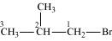
1−Bromo−2−methylpropane
(d)
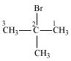
2−Bromo−2−methylpropane
Question 10.7:
Write the equations for the preparation of 1−iodobutane from
(i) 1-butanol
(ii) 1-chlorobutane
(iii) but-1-ene.
- Answer
(i)
(ii)
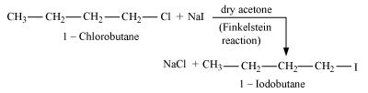
(iii)
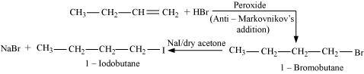
Question 10.8:
What are ambident nucleophiles? Explain with an example.
- Answer
Ambident nucleophiles are nucleophiles having two nucleophilic sites. Thus, ambident nucleophiles have two sites through which they can attack.
For example, nitrite ion is an ambident nucleophile.
Nitrite ion can attack through oxygen resulting in the formation of alkyl nitrites. Also, it can attack through nitrogen resulting in the formation of nitroalkanes.
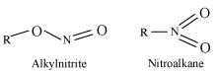
Question 10.9:
Which compound in each of the following pairs will react faster in S_{N}2 reaction with OH⁻?
(i) CH₃Br or CH₃I
(ii) (CH₃)₃CCl or CH₃Cl
- Answer
(i) In the S_{N}2 mechanism, the reactivity of halides for the same alkyl group increases in the order. This happens because as the size increases, the halide ion becomes a better leaving group.
R−F << R−Cl < R−Br < R−I
Therefore, CH₃I will react faster than CH₃Br in S_{N}2 reactions with OH⁻.
(ii)
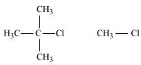
The S_{N}2 mechanism involves the attack of the nucleophile at the atom bearing the leaving group. But, in case of (CH₃)₃CCl, the attack of the nucleophile at the carbon atom is hindered because of the presence of bulky substituents on that carbon atom bearing the leaving group. On the other hand, there are no bulky substituents on the carbon atom bearing the leaving group in CH₃Cl. Hence, CH₃Cl reacts faster than (CH₃)₃CCl in S_{N}2 reaction with OH⁻.
Question 10.10:
Predict all the alkenes that would be formed by dehydrohalogenation of the following halides with sodium ethoxide in ethanol and identify the major alkene:
(i) 1-Bromo-1-methylcyclohexane
(ii) 2-Chloro-2-methylbutane
(iii) 2,2,3-Trimethyl-3-bromopentane.
- Answer
(i)
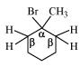
1−bromo−1−methylcyclohexane
In the given compound, all β-hydrogen atoms are equivalent. Thus, dehydrohalogenation of this compound gives only one alkene.
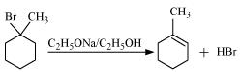
(ii)
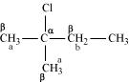
In the given compound, there are two different sets of equivalent β-hydrogen atoms labelled as a and b. Thus, dehydrohalogenation of the compound yields two alkenes.
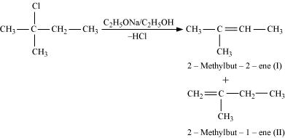
Saytzeff’s rule implies that in dehydrohalogenation reactions, the alkene having a greater number of alkyl groups attached to a doubly bonded carbon atoms is preferably produced.
Therefore, alkene (I) i.e., 2-methylbut-2-ene is the major product in this reaction.
(iii)
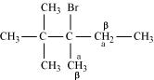2,2,3-Trimethyl-3-bromopentane
In the given compound, there are two different sets of equivalent β-hydrogen atoms labelled as a and b. Thus, dehydrohalogenation of the compound yields two alkenes.
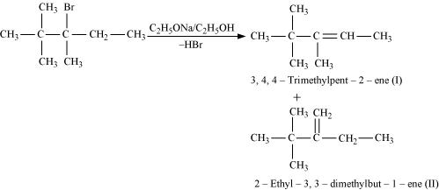
According to Saytzeff’s rule, in dehydrohalogenation reactions, the alkene having a greater number of alkyl groups attached to the doubly bonded carbon atom is preferably formed.
Hence, alkene (I) i.e., 3,4,4-trimethylpent-2-ene is the major product in this reaction
Question 10.11:
How will you bring about the following conversions?
(i) Ethanol to but-1-yne
(ii) Ethane to bromoethene
(iii) Propene to 1-nitropropane
(iv) Toluene to benzyl alcohol
(v) Propene to propyne
(vi) Ethanol to ethyl fluoride
(vii) Bromomethane to propanone
(viii) But-1-ene to but-2-ene
(ix) 1-Chlorobutane to n-octane
(x) Benzene to biphenyl.
- Answer
(i)
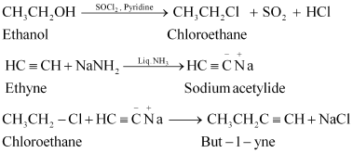
(ii)
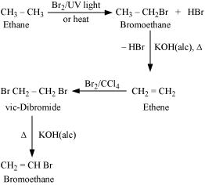
(iii)
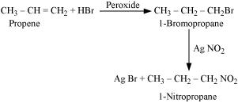
(iv)
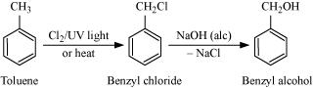
(v)
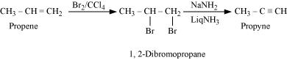
(vi)
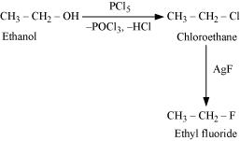
(vii)
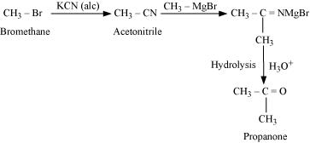
(viii)
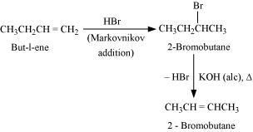
(ix)
(x)
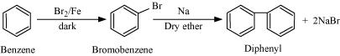
Question 10.12:
Explain why
(i) the dipole moment of chlorobenzene is lower than that of cyclohexyl chloride?
(ii) alkyl halides, though polar, are immiscible with water?
(iii) Grignard reagents should be prepared under anhydrous conditions?
- Answer
(i)
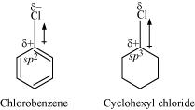
In chlorobenzene, the Cl-atom is linked to a sp² hybridized carbon atom. In cyclohexyl chloride, the Cl-atom is linked to a sp³ hybridized carbon atom. Now, sp² hybridized carbon has more s-character than sp³ hybridized carbon atom. Therefore, the former is more electronegative than the latter. Therefore, the density of electrons of C−Cl bond near the Cl-atom is less in chlorobenzene than in cydohexyl chloride.
Moreover, the −R effect of the benzene ring of chlorobenzene decreases the electron density of the C−Cl bond near the Cl-atom. As a result, the polarity of the C−Cl bond in chlorobenzene decreases. Hence, the dipole moment of chlorobenzene is lower than that of cyclohexyl chloride.
(ii) To be miscible with water, the solute-water force of attraction must be stronger than the solute-solute and water-water forces of attraction. Alkyl halides are polar molecules and so held together by dipole-dipole interactions. Similarly, strong H-bonds exist between the water molecules. The new force of attraction between the alkyl halides and water molecules is weaker than the alkyl halide-alkyl halide and water-water forces of attraction. Hence, alkyl halides (though polar) are immiscible with water.
(iii) Grignard reagents are very reactive. In the presence of moisture, they react to give alkanes.
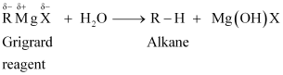
Therefore, Grignard reagents should be prepared under anhydrous conditions
Question 10.13:
Give the uses of freon 12, DDT, carbon tetrachloride and iodoform.
- Answer
Uses of Freon − 12
Freon-12 (dichlorodifluoromethane, CF₂Cl₂) is commonly known as CFC. It is used as a refrigerant in refrigerators and air conditioners. It is also used in aerosol spray propellants such as body sprays, hair sprays, etc. However, it damages the ozone layer. Hence, its manufacture was banned in the United States and many other countries in 1994.
Uses of DDT
DDT (p, p−dichlorodiphenyltrichloroethane) is one of the best known insecticides. It is very effective against mosquitoes and lice. But due its harmful effects, it was banned in the United States in 1973.
Uses of carbontetrachloride (CCl₄)
(i) It is used for manufacturing refrigerants and propellants for aerosol cans.
(ii) It is used as feedstock in the synthesis of chlorofluorocarbons and other chemicals.
(iii) It is used as a solvent in the manufacture of pharmaceutical products.
(iv) Until the mid 1960’s, carbon tetrachloride was widely used as a cleaning fluid, a degreasing agent in industries, a spot reamer in homes, and a fire extinguisher.
Uses of iodoform (CHI₃)
Iodoform was used earlier as an antiseptic, but now it has been replaced by other formulations-containing iodine-due to its objectionable smell. The antiseptic property of iodoform is only due to the liberation of free iodine when it comes in contact with the skin
Question 10.14:
Write the structure of the major organic product in each of the following reactions:
(i)
(ii)
(iii)
(iv)
(v)
(vi)
(vii)
(viii)
Answer
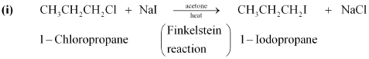
(ii)
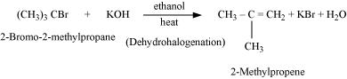
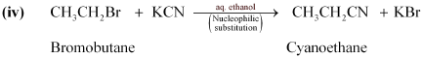
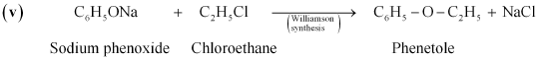
(viii)
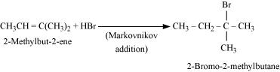
Question 10.15:
Write the mechanism of the following reaction:
- Answer
- Discussion
- Share
The given reaction is:
The given reaction is an S_{N}2 reaction. In this reaction, CN⁻ acts as the nucleophile and attacks the carbon atom to which Br is attached. CN⁻ ion is an ambident nucleophile and can attack through both C and N. In this case, it attacks through the C-atom.
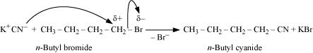
Question 10.16:
Arrange the compounds of each set in order of reactivity towards S_{N}2 displacement:
(i) 2-Bromo-2-methylbutane, 1-Bromopentane, 2-Bromopentane
(ii) 1-Bromo-3-methylbutane, 2-Bromo-2-methylbutane, 3-Bromo-2- methylbutane
(iii) 1-Bromobutane, 1-Bromo-2,2-dimethylpropane, 1-Bromo-2-methylbutane, 1-Bromo-3-methylbutane.
- Answer
- Discussion
- Share
(i)
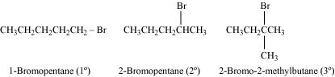
An S_{N}2 reaction involves the approaching of the nucleophile to the carbon atom to which the leaving group is attached. When the nucleophile is sterically hindered, then the reactivity towards S_{N}2 displacement decreases. Due to the presence of substituents, hindrance to the approaching nucleophile increases in the following order.
1-Bromopentane < 2-bromopentane < 2-Bromo-2-methylbutane
Hence, the increasing order of reactivity towards S_{N}² displacement is:
2-Bromo-2-methylbutane < 2-Bromopentane < 1-Bromopentane
(ii)
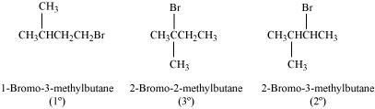
Since steric hindrance in alkyl halides increases in the order of 1° < 2° < 3°, the increasing order of reactivity towards S_{N}2 displacement is
3° < 2° < 1°.
Hence, the given set of compounds can be arranged in the increasing order of their reactivity towards S_{N}² displacement as:
2-Bromo-2-methylbutane < 2-Bromo-3-methylbutane < 1-Bromo-3-methylbutane
[2-Bromo-3-methylbutane is incorrectly given in NCERT]
(iii)
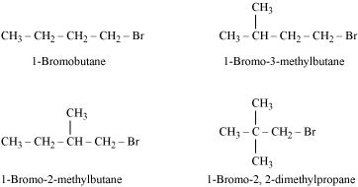
The steric hindrance to the nucleophile in the S_{N}2 mechanism increases with a decrease in the distance of the substituents from the atom containing the leaving group. Further, the steric hindrance increases with an increase in the number of substituents. Therefore, the increasing order of steric hindrances in the given compounds is as below:
1-Bromobutane < 1-Bromo-3-methylbutane < 1-Bromo-2-methylbutane
< 1-Bromo-2, 2-dimethylpropane
Hence, the increasing order of reactivity of the given compounds towards S_{N}2 displacement is:
1-Bromo-2, 2-dimethylpropane < 1-Bromo-2-methylbutane < 1-Bromo-3- methylbutane < 1-Bromobutane
Question 10.17:
Out of C₆H₅CH₂Cl and C₆H₅CHClC₆H₅, which is more easily hydrolysed by aqueous KOH?
- Answer
- Discussion
- Share
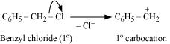
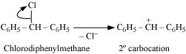
Hydrolysis by aqueous KOH proceeds through the formation of carbocation. If carbocation is stable, then the compound is easily hydrolyzed by aqueous KOH. Now, forms 1°-carbocation, while forms 2°-carbocation, which is more stable than 1°-carbocation. Hence, is hydrolyzed more easily than by aqueous KOH
Question 10.18:
p-Dichlorobenzene has higher m.p. and lower solubility than those of o- and
m-isomers. Discuss.
- Answer
- Discussion
- Share
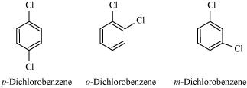
p-Dichlorobenzene is more symmetrical than o-and m-isomers. For this reason, it fits more closely than o-and m-isomers in the crystal lattice. Therefore, more energy is required to break the crystal lattice of p-dichlorobenzene. As a result, p-dichlorobenzene has a higher melting point and lower solubility than o-and m-isomers
Question 10.19:
How the following conversions can be carried out?
(i) Propene to propan-1-ol
(ii) Ethanol to but-1-yne
(iii) 1-Bromopropane to 2-bromopropane
(iv) Toluene to benzyl alcohol
(v) Benzene to 4-bromonitrobenzene
(vi) Benzyl alcohol to 2-phenylethanoic acid
(vii) Ethanol to propanenitrile
(viii) Aniline to chlorobenzene
(ix) 2-Chlorobutane to 3, 4-dimethylhexane
(x) 2-Methyl-1-propene to 2-chloro-2-methylpropane
(xi) Ethyl chloride to propanoic acid
(xii) But-1-ene to n-butyliodide
(xiii) 2-Chloropropane to 1-propanol
(xiv) Isopropyl alcohol to iodoform
(xv) Chlorobenzene to p-nitrophenol
(xvi) 2-Bromopropane to 1-bromopropane
(xvii) Chloroethane to butane
(xviii) Benzene to diphenyl
(xix) tert-Butyl bromide to isobutyl bromide
(xx) Aniline to phenylisocyanide
- Answer
(i)
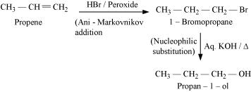
(ii)
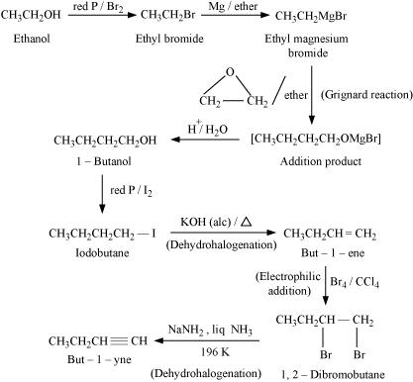
(iii)
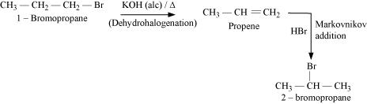
(iv)
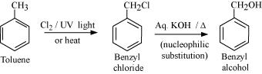
(v)
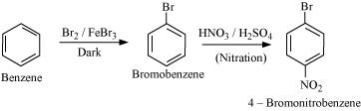
(vi)
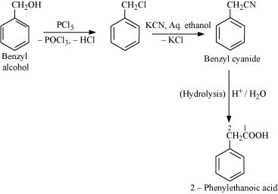
(vii)
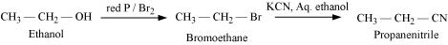
(viii)
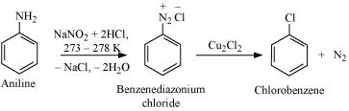
(ix)
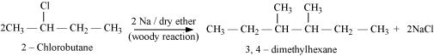
(x)
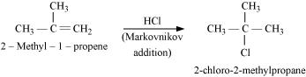
(xi)
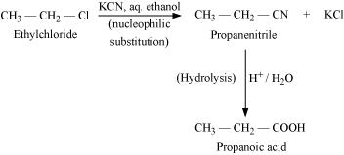
(xii)
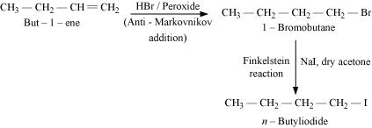
(xiii)
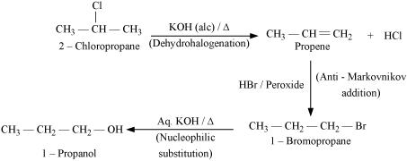
(xiv)
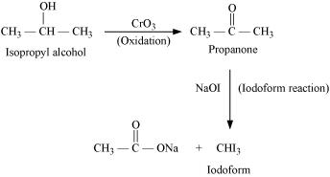
(xv)
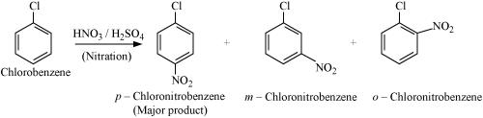
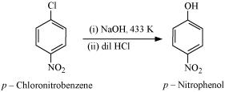
(xvi)
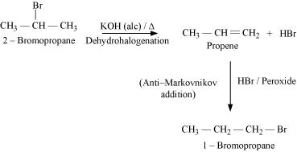
(xvii)
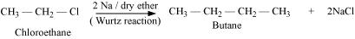
(xviii)
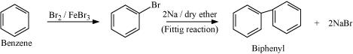
(xix)
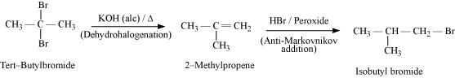
(xx)
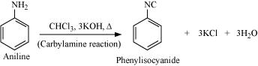
Question 10.20:
The treatment of alkyl chlorides with aqueous KOH leads to the formation of
alcohols but in the presence of alcoholic KOH, alkenes are major products. Explain.
- Answer
In an aqueous solution, KOH almost completely ionizes to give OH⁻ ions. OH⁻ ion is a strong nucleophile, which leads the alkyl chloride to undergo a substitution reaction to form alcohol.
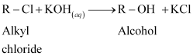
On the other hand, an alcoholic solution of KOH contains alkoxide (RO⁻) ion, which is a strong base. Thus, it can abstract a hydrogen from the β-carbon of the alkyl chloride and form an alkene by eliminating a molecule of HCl.
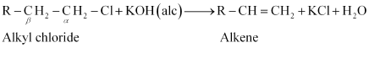
OH⁻ ion is a much weaker base than RO⁻ ion. Also, OH⁻ ion is highly solvated in an aqueous solution and as a result, the basic character of OH⁻ ion decreases. Therefore, it cannot abstract a hydrogen from the β-carbon.
Question 10.21:
Primary alkyl halide C₄H₉Br (a) reacted with alcoholic KOH to give compound (b).Compound (b) is reacted with HBr to give (c) which is an isomer of (a). When (a) is reacted with sodium metal it gives compound (d), C₈H₁₈ which is different from the compound formed when n-butyl bromide is reacted with sodium. Give the structural formula of (a) and write the equations for all the reactions.
- Answer
There are two primary alkyl halides having the formula, C₄H₉Br. They are n − bulyl bromide and isobutyl bromide.
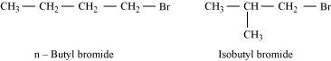
Therefore, compound (a) is either n−butyl bromide or isobutyl bromide.
Now, compound (a) reacts with Na metal to give compound (b) of molecular formula, C₈H_{18,} which is different from the compound formed when n−butyl bromide reacts with Na metal. Hence, compound (a) must be isobutyl bromide.
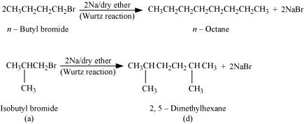
Thus, compound (d) is 2, 5−dimethylhexane.
It is given that compound (a) reacts with alcoholic KOH to give compound (b). Hence, compound (b) is 2−methylpropene.
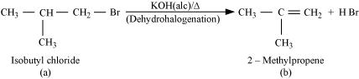
Also, compound (b) reacts with HBr to give compound (c) which is an isomer of (a). Hence, compound (c) is 2−bromo−2−methylpropane.
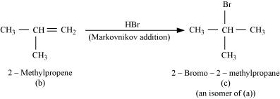
Question 10.22:
What happens when
(i) n-butyl chloride is treated with alcoholic KOH,
(ii) bromobenzene is treated with Mg in the presence of dry ether,
(iii) chlorobenzene is subjected to hydrolysis,
(iv) ethyl chloride is treated with aqueous KOH,
(v) methyl bromide is treated with sodium in the presence of dry ether,
(vi) methyl chloride is treated with KCN.
- Answer
(i) When n−butyl chloride is treated with alcoholic KOH, the formation of but−l−ene takes place. This reaction is a dehydrohalogenation reaction.
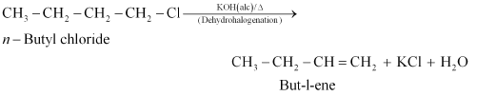
(ii) When bromobenzene is treated with Mg in the presence of dry ether, phenylmagnesium bromide is formed.
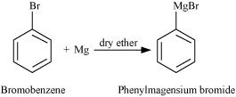
(iii) Chlorobenzene does not undergo hydrolysis under normal conditions. However, it undergoes hydrolysis when heated in an aqueous sodium hydroxide solution at a temperature of 623 K and a pressure of 300 atm to form phenol.
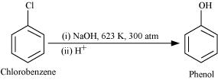
(iv) When ethyl chloride is treated with aqueous KOH, it undergoes hydrolysis to form ethanol.
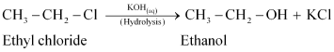
(v) When methyl bromide is treated with sodium in the presence of dry ether, ethane is formed. This reaction is known as the Wurtz reaction.
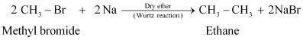
(vi) When methyl chloride is treated with KCN, it undergoes a substitution reaction to give methyl cyanide.


