Organic Chemistry Practice Multiple Choice Question Set 4
1. The best nomenclature for the geometry of the following compound is...
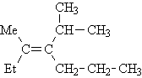
 | (a) | cis-
 | (b) | trans-
 | (c) | E-
 | (d) | Z-
2. Arrange the following groups in decreasing order of priority for E/Z nomenclature with the highest priority group listed first.
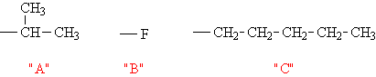
 | (a) | B>A>C
 | (b) | B>C>A
 | (c) | A>C>B
 | (d) | C>A>B
3. What is the best name for the following compound?
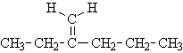
 | (a) | 3-methylenehexane
 | (b) | 2-propyl-1-butene
 | (c) | 4-ethyl-4-pentene
 | (d) | 2-ethyl-1-pentene
4. What is the best name for the following compound?
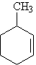
 | (a) | 2-methylcyclohexene
 | (b) | 3-methylhexene
 | (c) | 1-methylcyclohex-2-ene
 | (d) | 3-methylcyclohexene
5. The mechanism of the reaction of propene with H₃O⁺ will proceed through which of the following intermediates?
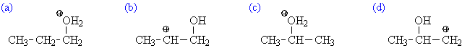
6. The reaction of propene with HBr in the presence of ROOR (peroxide) proceeds through which of the following intermediates?
7. What is the major product expected from the following reaction?
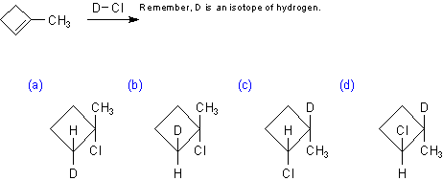
8. What is the major product expected from the following reaction?
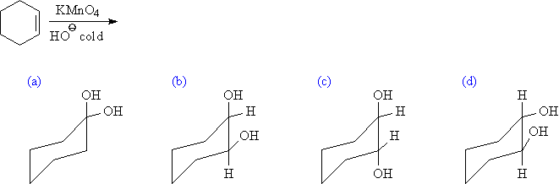
9. What is the major product expected from the following reaction?
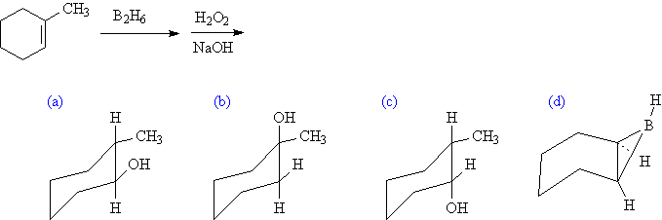
10. The mechanism of the reaction of propene with HOCl (Cl₂ + H₂O) will proceed through which of the following intermediates?

11. Which of the following transitions is the highest energy transition? (a) n to σ∗ (b) n to π∗ (c) σ to σ∗ (d) π to π∗

12. Which of the following alkenes would have the largest λ_{max}?
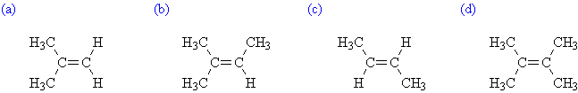
13. Which of the following alkenes would have the largest λ_{max}?
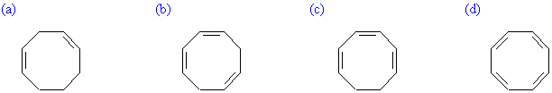
14. What is the λ_{max} for the following compound? Use the provided parameters for your calculation.
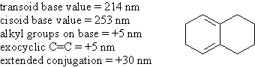
(a) 234 nm (b) 244 nm (c) 273 nm (d) 283 nm

15. What is the λ_{max} for the following compound? Use the above parameters for your calculation.
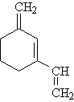
(a) 229 nm (b) 249 nm (c) 254 nm (d) 259 nm

