Selected Topics in Micro Economics with Review Points
- Central economic problems.
(Causes, Types, Solutions)
- Economic Systems.
(Types, Features)
- Production possibility curve.
(Meaning, Characteristics, Assumptions, Shifting)
- Consumer’s equilibrium.
(Conditions, Utility approach, Indifference curve approach)
- Demand and Supply.
(Meaning, Determinants, Elasticity, Changes)
- Market equilibrium.
(Meaning, Changes, Practical applications)
- Production Function.
(With one variable factor, With all variable factors)
- Cost and Revenue.
(Meaning & Relationships)
- Market Forms.
(Features)
10. Producer Equilibrium.
(TR-TC approach, & MR-MC approach)

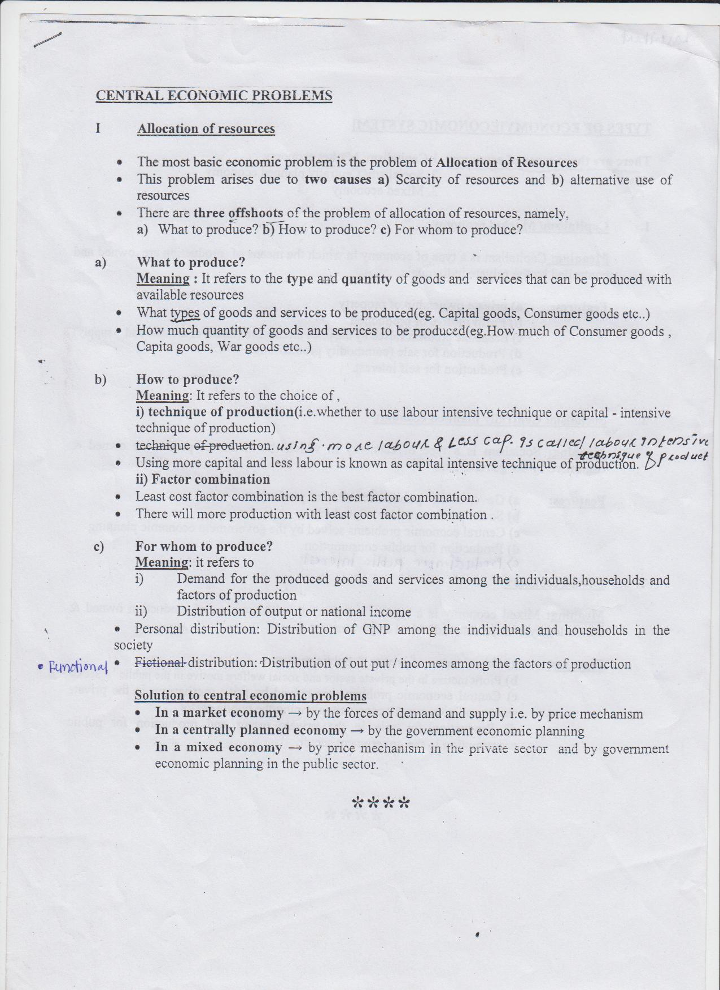
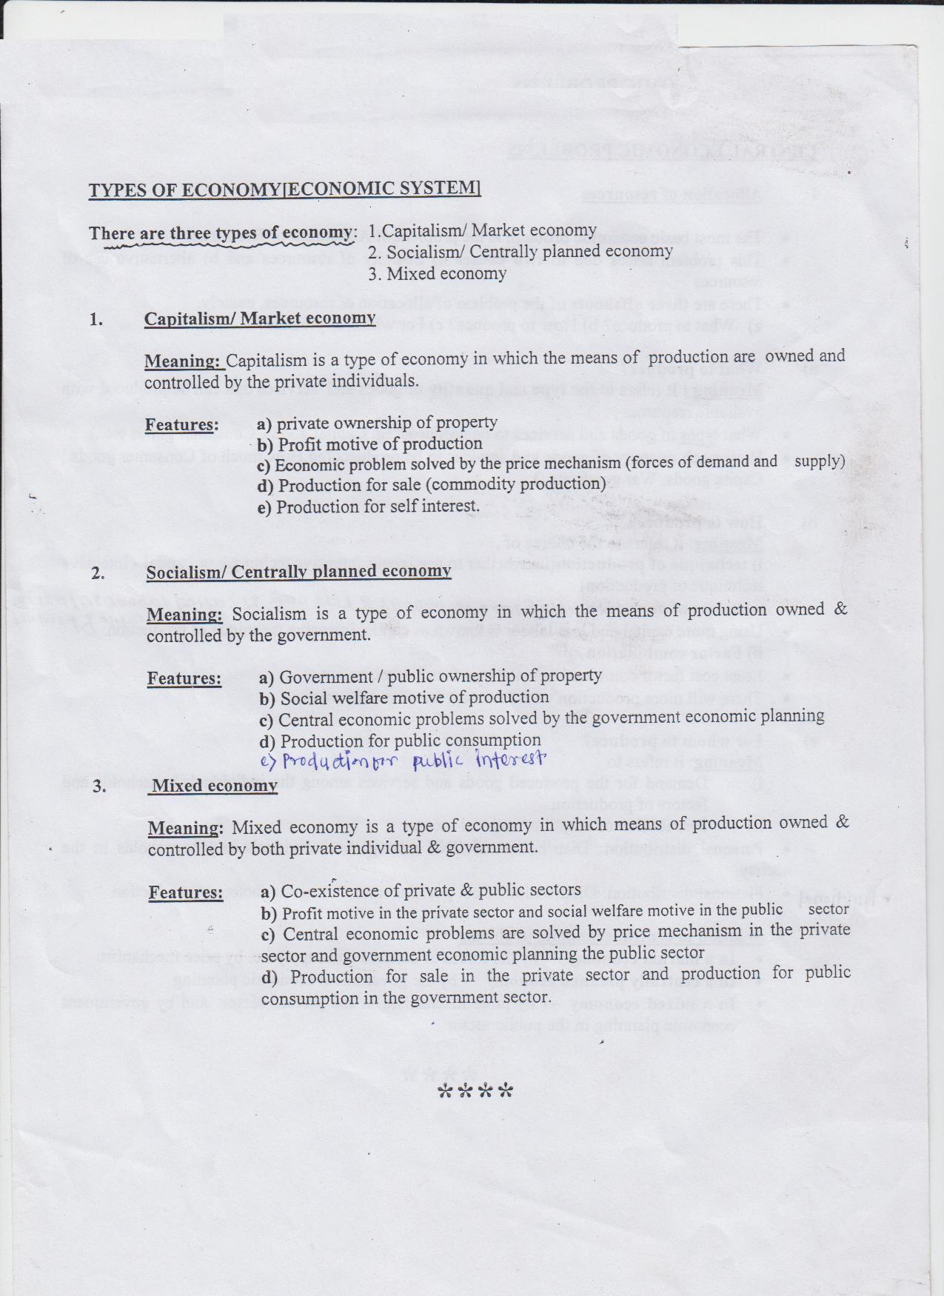
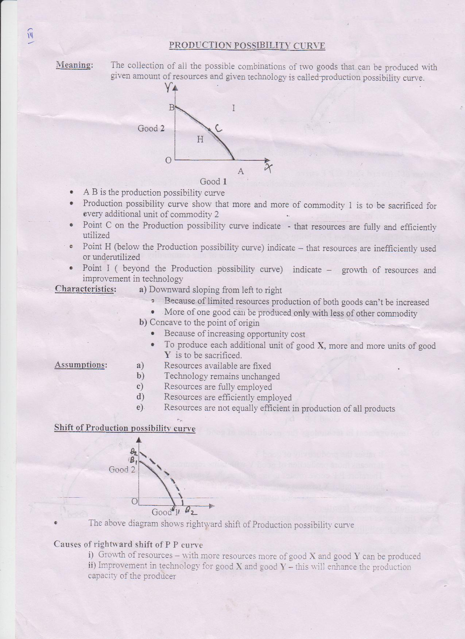
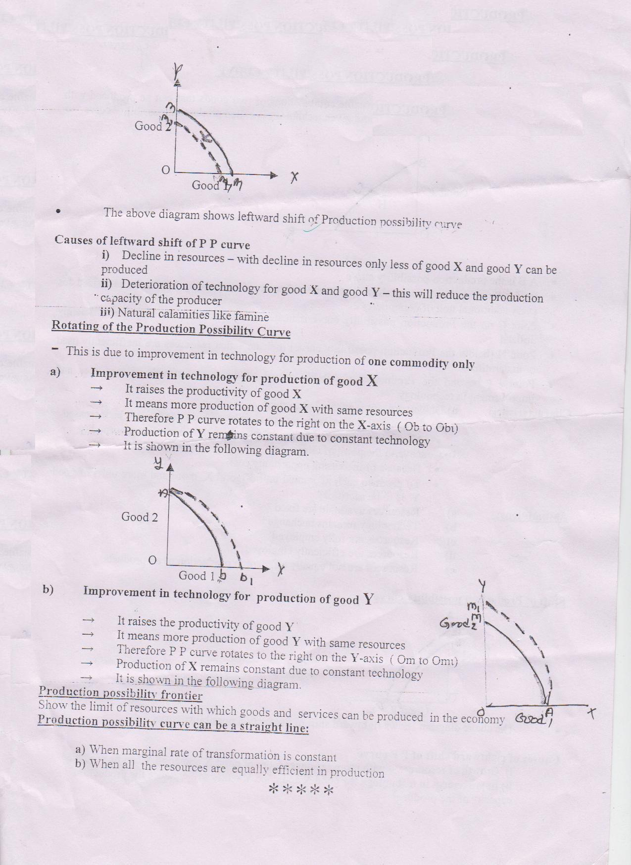
Consumer’s Equilibrium
- A consumer is one who buys goods and services for satisfaction of wants.
- A consumer’s equilibrium- It is defined as a situation when a consumer maximizes his satisfaction with given income and prices.
- There are two approaches for consumer equilibrium –
  - Utility approach.
  - Indifference curve approach.
1. Utility approach-
Some basic concepts
UTILITY- Utility is the wants satisfying power of a commodity or a service.
- Marginal utility- It is additional utility when one more unit of a commodity is consumed
MU nth =TUn-TUn-1
- Total utility- TU is the sum of the utility of all the units consumed .or It is the sum total of marginal utility.
TU = MU1+MU2 +MU3-------------MUn
Relation between TU and MU-
- TU = ∑MU
- TU increases so long as MU is positive.
- When MU is zero, TU is maximum.
- When MU is negative, TU starts declining.
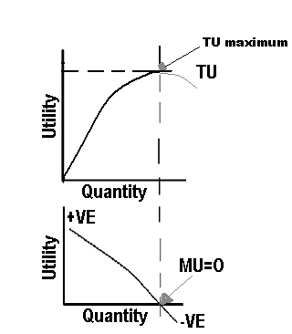
Law of diminishing marginal utility
* It states that MU tends to diminish as more and
more units of a commodity are consumed by a consumer.
Consumer’s Equilibrium (Utility Approach)
In case of one commodity -
A consumer is in equilibrium with respect to purchase of one good only
when following conditions are satisfied.
MUx/Px = MUm
OR
MUx = Px . MUm (MUm = MU of money)
Suppose a consumer is buying x goods.
  - Price of x = Px =Rs.4
  - MUm =4 utils (mrginal utility of money)

Marginal utility schedule of x is given as:
Unit of x MUx MUx/Px
1 20 5
2 18 4.5
3 16 4 = MUm
4 10 2.5
5 0 0
6 -5 -1.25
 The consumer will purchase 3 units of goods x and reaches equilibrium position. Because in the condition MUx/Px is equal to price of goods x.
- Before 3th units MUx/Px > Px and after 3th unit MUx/Px < Px.

Incase of two commodities -
-Suppose a consumer is buying goods X and Y with his given income In case of one commodity X a consumer strikes his equilibrium when-
MUx/Px=Mum ………………………..(1)
 Like wise , for commodity Y ,consumer will strike equilibrium when-
MUy/Py=MUm ..………………………..(2)
 Considering equ. (1) & (2)
MUx/Px=MUy/Py =MUm
 It means the consumer spend his income in such a way that the ratio of the MUx to its price (Px) is equal to the ratio of the MUy to its price(Py).
 Graphically, the consumer’s equilibrium in of two goods X & Y is shown in the following diagram.
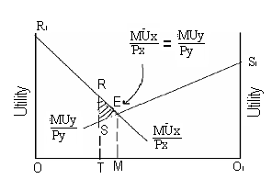
 OO1 =total income of consumer which is to be spent on two goods X & Y.
 MUx = Marinal utility curve of X, also MUx/Px can be obtained as Px is given.
 MUy= Marginal utility curve of Y, also MUy/Py can be obtained as Py is given.
 E = Point of consumer’s equilibrium where MUx /Px=MUy/Py
 It shows that OM amount of income is spent on goods X , O1M amount of income is spent on goods Y.
 Total utility at a point E = Area OR1ES1O1
 Suppose take another expenditure pattern of OO1 income in by point T where MUx/Px>MUy/Py
 IT shows that the consumer spends OT amount on goods X and O1T amount on goods Y now he will get less satisfaction to area RSE.

2. Indifference Curve Approach -
It shows different combination of two goods which provide the same level of satisfaction to the consumer.
- Indifference set- It is a set of combination of two goods which provide same level of satisfaction to the consumer.
- Indifference map- Indifference map refer to a set of indifference curve.
- Budget set-it is a set of all combination of two goods that a consumer can buy with his given income at market price.
- Budget line –It is a set of all combination of two goods that a consumer can buy at given market price.
- Equation of budget line M= PxX + PyY.
- Budget map- It refers to a set of Budget line.

Properties of IC-curve
- Downward sloping to the right.
- Convex to the origin.
- ICs never touch or intersect each other.
- Higher ICs represent higher level of satisfaction.

Consumer’s Equilibrium by indifference curve approach
- Under IC- curve approach with his given budget consumer will try to achieve the highest possible level of IC-curve inorder to maximum his satisfaction.

Two conditions :-
- Budget line must be tangent to indifference curve
i.e. MRSxy = Px/Py.
- IC curve must be convex to the origin at the point of tangency.
i.e. MRSxy must be diminishing.
 IC1,IC2,IC3= Different indifference curve
 LM= budget line
 Point E=AT point E, the budget line is tangent to the IC- curve IC2.
- It is the point of the Consumer’s Equilibrium.
- Consumer will not choose point A,B,&C.
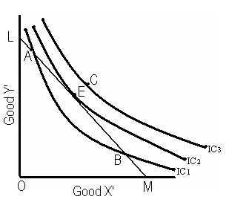

“Production Function”
- Meaning:
The technical relationship between physical input and physical output.
Types:
- Production function with on variable factor (Return to a factor)
- Production function with all variable factors (Return to a scale)

I Return to factor – (Law of variable proportion)
Meaning:
- It is production function with on variable factor.
- If we vary one factor, keeping other factors constant the marginal product will ultimately decline.
- It is shown in the following diagram:

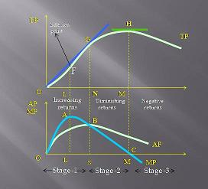
- In 1st stage: TP increases at an increasing rate.
- AP and MP both are also increasing.
- But rise in MP is more than rise in AP

- In 2st stage: TP increases at diminishing rate the
- AP and MP both are decreasing.
- But fall in MP is more than fall in AP.
- At the end of 2nd stage TP is maximum and MP is zero.

- In 3rd stage: TP starts diminishing. Then
- Marginal product becomes negative
- AP continues to fall but remains positive.

Causes for increasing returns to a factor:
- Optimum combination of factors:
TP increases until optimum combination of factors is reached.
- Fuller utilization of resources:
With greater use of variable factor the fixed factors are getting fully utilized.
- Increased efficiency of variable factor:
This is due to process based division of labor.
- Better co-ordination between factors:
Increased use of variable factors leads to improvement in the degree of co-ordination between fixed and variable factors.
Causes for diminishing returns to a factor:
- Crossing the optimum level of combination.
- Fixed factors- when fixed factors gets over utilized there will be diminishing returns.
- Imperfect factor substitutability: Factors of productions are imperfect substitutes.
- Poor co-ordination between factors.

II Returns to scale – (Production function with all variable factors)
- It studies the change in output when all factor inputs are proportionately changed.
- Returns to scale means change in output due to change in all factors.

Types of returns to scale :
- Increasing returns to scale (IRS) – When a given proportionate change in inputs leads to more than proportionate change in output.

E.g. 50% rise in input to 75% rise in output.
- Constant returns to scale (CRS) – When a given proportionate change in inputs leads to equal proportionate change in output.

E.g. 50% rise in input leads to 50% rise in output.
Diminishing returns to scale (DRS) – When a given proportionate change in inputs leads to less than proportionate change in output
E.g.- 50% rise in input leads to 25% rise in output.
Causes of returns to scale:
Economies of scale – The unexpected advantages received by a firm due to change in the scale of production.
Types of economies scale:

Internal economies- Advantages of producer due to individual efforts within the firm.
External economies- General advantages enjoyed by all the firms in locality as a result of growth of industry as a whole.

Types of Internal economies - Technical economies – due to use of modern techniques of production.
- Managerial economies – By further engaging management.
- Labour economies – By division of labour and specialization.
- Marketing economies – Availability of resources at less rate.
- Financial economies – Getting funds at lower cost.

External economies –
- Centralization of Industry : Subsidiary industries can be developed in the same locality.
- Economy of information : By joint publicity and advertisement.
- Economy of decentralization : Different industries can be set up for different processes.

COSTS & REVENUE
Costs
- Total Costs. ( TC)
  - Total cost = Fixed costs + variable costs .
(TC=TFC+TVC)
- Fixed costs- (TFC)
- Costs of fixed factors.
- Also called supplementary costs /Overhead costs / indirect costs.
- Do not change with the change in output.
- Even when output is zero, fixed cost remains the same.
- E.g. Expenditure on machinery, building, salaries of permanent staff.
- TFC curve is a horizontal straight line.
- Variable costs. (TVC)
- Cost of variable factors.
- Also called prime costs/Direct costs.
- When output changes, there costs also changes.
- When output is zero, these costs are zero.
- E.g. Cost of raw materials, wages of casual labour.
- TVC increases at a diminishing rate initially and then it increases at an increasing rate.
2. Average Costs. (AC)
- Cost per unit of output.
- AC=TC/Q.
- AC=AFC+AVC i.e, AC=( TFC/Q + TVC/Q )
- AFC curve is a rectangular hyperbola because AFC x Q = TFC is always the same.
- AVC is variable cost per unit of output.
- AVC curve is U-shaped-due to law of variable proportions.
- AVC falls due to increasing returns to a factor and AVC rises due to diminishing returns to a factor.
- AC curve also is U-Shaped due to law of variable proportions.
- As output increases AC comes closer to AVC because AFC continuously falls.
3. Marginal cost.( MC)
- Change in TC when additional unit of output is produced.
- TVC=∑MC
- MC curve is U-shaped, due to the law of variable proportion.
- Falling MC is due to rising MP when there are increasing returns to a factor.
- Relation between MC and AC.
- When AC falls MC is lower than AC
- When AC rises MC is greater than AC
- When AC is minimum MC is equal to AC
- Relation between TC and MC.
- TC increases at an increasing rate when MC is increasing.
- TC increases at a constant rate when MC is constant.
- TC increases at a diminishing rate when MC is decreasing.
Revenue -
- Money received by the sale of output.
- Total revenue (TR)
- Total money receipts from the sale of output.
- TR= price × quantity sold.
- TR is the area under the price line.
- TR curve is a positively slopping straight line passing through the origin under perfect competition.
- TR curve is inverse U-shaped under imperfect competition.
ii. Average Revenue (AR)
- It is revenue per unit of output sold.
- AR = TR/Q
- [ AR = P x Q /Q = P ]
- So AR = Price.
- AR curve is a horizontal line parallel to X- axis under perfect competition.
- AR curve downward sloping under imperfect competition

iii. Marginal Revenue (MR)
- Addition to TR when additional unit of output is sold.
- It is change in Total Revenue (∆TR)
Change in quantity sold (∆Q)
- MR curve is horizontal line and coincides with AR curve under perfect competition.
- MR curve is downward sloping and lies below AR curve under imperfect competition.

- Relation between MR & TR:-
- MR is addition to TR when one more unit of output is sold.
- When MR is positive TR rises.
- When MR is zero, TR is maximum.
- When MR is negative, TR talls.
- When MR is constant, TR increases at constant rate.
- Relation between MR and AR :-
- When AR is constant AR=MR
- When AR falls, MR also falls but MR falls faster than AR.
- When AR rises, MR is above AR.

Market equilibrium / Price Determination
Under Perfect competition
- Market equilibrium- Fixed number of Firms-Meaning ( in the short run)
- Market equilibrium-A situation in which quantity demanded is equal to quantity supplied corresponding to a particular price.
- Equilibrium price –The price at which demand equals supply.
- Equilibrium quantity – the quantity corresponding to equilibrium price.
- If QD>QS at a price, there will be excess demand.
- If QD<QS at a price, there will be excess supply.
- At equilibrium, there is no excess demand or excess supply.
- Effect of changes in demand on equilibrium
- If demand increases and supply remains constant equilibrium price and quantity will increase.
- (Demand increases due to rise in income, rise in the price of substitutes, etc.)
- If demand decreases and supply remains constant, equilibrium price and quantity will fall.
- ( Demand decreases due to fall in income, fall in the price of substitutes etc.)
- If demand increases and supply is perfectly inelastic, price increases and quantity remains the same.
- If demand increases and supply is perfectly elastic, then price remains the same and quantity increases.
- When demand decreases and supply is perfectly inelastic then price falls and quantity remains the same.
- When demand decreases and supply is perfectly elastic, then price remains the same and quantity falls.
- Effect of changes in supply on equilibrium
- If supply increases and demand remains the same, price will fall and quantity increases.
- ( supply increases due to improvement in technology, fall in input price, fall in unit tax etc. …)
- When supply increases and demand is perfectly inelastic, price will fall and quantity will remain the same.
- When supply increases and demand is perfectly elastic quantity increases and price remains the same.
- When supply decreases and demand is perfectly inelastic, price will rise and quantity remains the same.
- When supply decreases and demand is perfectly elastic, quantity falls and price remains the same.
- Simultaneous Change in both Demand & Supply
- If demand and supply increase in the same proportion, price will remain the same and quantity increases.
- If demand supply decrease in the same proportion, price will remain the same and quantity decreases.
- If demand and supply changes in different proportions, the effect on equilibrium price and quantity depends on the extent of changes in both.
- Market equilibrium- Free Entry & Exit of Firms ( in the long run)
- With free entry and exit of firms equilibrium is where P=minimum AC.
- Equilibrium quantity is determined at the intersection of market demand curve with price line P=minimum AC.
- If P>minimum AC firms earn super normal profits and new firms enter.
- If P< minimum AC firms incur losses and existing firms start exiting.
- If P=minimum AC firms earn normal profits and there will be no entry of new firms or exit of existing firms.
- In equilibrium, quantity supplied will be determined by the market demand at that price.
- At P= minimum AC , each firm supplies same amount of output.
- Equilibrium no. of firms in the market is equal to the number of firms required to supply the total output at Price=minimum AC.
- Thus with free entry and exit, equilibrium price will be always equal to minimum AC of existing firms.
- If demand increases , equilibrium quantity rises and equilibrium no. of firms increases.(Price remains the same)
- If demand decreases, equilibrium quantity decreases and equilibrium no. of firms decreases (Price remains the same)

A 1) Intervention by the govt. and market equilibrium –
1) Price control / price ceiling
- Fixing market price below the equilibrium price.
- To help poor people to buy the necessities.
- Leads to excess demand and shortage of supply.
- Effects:-
- Black market – goods are illegally sold at a higher price.
- Rationing: - Allocating available supply according to fixed quota.

2) Support price / Minimum price / Floor price
- Fixing the market price above the equilibrium price.
- To protect the interest of produces, labours etc.
- Leads to excess supply.
- Effects –

- Producers and laborers benefit due to high income.
- Consumers to pay higher price.
- Increases govt’s costs for procurements.
- May lead to higher taxes.

Market Forms (Features)
- Markets are classified based on the following –
- No. of buyers and sellers
- Nature of the commodity ( Homogeneous or differentiated )
- Knowledge about market conditions
- Degree of price control
- Mobility of goods & factors.
- There are four important types of market
- Perfect competition
- Monopoly
- Monopolistic competition
- Oligopoly.
- Perfect competition – Features
- Large no. of buyers and sellers:
- Each one buys or sells small quantity
- Individual buyer or seller can’t influence price.
- Price is determined by the industry
- Each firm is a “price taker”.
- Homogeneous Product:
- Units of product are identical and perfect substitutes.
- Buyers are indifferent between sellers.
- ... Uniform price for the product of all the firms.
- Free entry and exit of firms.
- No barrier to entry or exit of firms.
- Entry of firms during abnormal profits
- Exit of firms during abnormal loses
- Perfect knowledge regarding price & costs-
- This is a condition for uniform price.
- Perfect mobility of factors and goods.
- Absence of transportation cost.
- Perfectly elastic demand curve-
- Firms can sell any quantity at the prevailing price.
- Price is determined by the forces of demand and supply.
- Monopoly-Features
- Single seller -
- May be a single firm, or a group of partners or joint stock company.
- No distinction between firm and industry.
- Restriction on the entry of new firms –
- Through patent rights, legal barriers, cartel formation or control of resources.
- No close substitutes for the product.
- Full control over price – “ price maker”
- Monopolist can fix whatever price he wishes.
- Quantity demanded will decline with high price.
- Perfect knowledge about market conditions.
- Price discrimination.
- Charging different price from different buyers.
- Less elastic demand curve.
  - Demand curve / AR curve is downward sloping.
  - At higher price quantity demanded is low.
  - Demand curve is less elastic due to the lack of close substitutes for the product.
- Monopolistic competition – Features
- Large no: of buyers and sellers.
- Product differentiation :
- Done through trademarks, brand names, appearance or advertisement.
- May be real or artificial.
- Differentiated products are close substitutes.
- Firm has partial control over the price of differentiated product.
- Free entry and exit of firms.
- Selling costs.
- Cost of promoting demand /sales
- E.g. Cost of advertisement.
- Imperfect knowledge about market conditions.
- Availability of close substitutes.
- Negatively sloping & more elastic demand curve.
- More can be sold only by lowering price
- More elastic due to the availability of close substitutes.
- Oligopoly – Features
- A few dominant sellers.
- A few large firms dominate the market.
- Each firm has significant share of market
- It can impact market price.
- Mutual dependence among firms.
- Price and output policy of one firm leads to reactions from rival firms.
- Barriers to entry of new firms
- Homogeneous or differentiated product.
- Price rigidity.
- To avoid reaction from rival firms.
- Adopt non price competition methods
- Formation of cartels (Collusive oligopoly)
- Indeterminate demand curve
- Demand curve of and oligopolistic cannot be defined.
- This is due to high degree of interdependency among firms.
- When one firm lowers its price demand may not increase due to lowering of price by rival firms.

PRODUCER’S EQUILIBRIUM
- Meaning :-
- It is a situation in which producer maximise his profits.
- Profits = TR –TC
- Therefore Producer is in equilibrium when TR –TC is maximum.
- There are three concepts of profits.
(Abnormal profits : when TR>TC or AR>AC )
(Normal profits : when TR=TC or AR=AC)
(Sub normal profits : when TR<TC or AR<AC)
- Normal profit is part of TC.
- Conditions :-
- MC = MR
- MC cuts MR from below.
- P = AR = AVC in short run and P = AC in long run.
- Two approaches :-
- TR – TC Approach
  - A producer is in equilibrium when difference between TR and TC is maximum.
  - Diagram
(Monopoly)
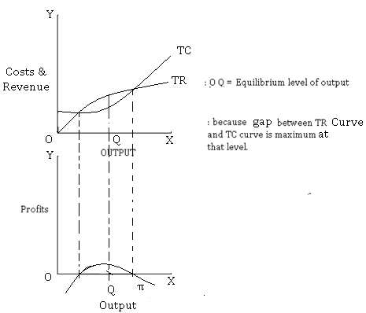

  - Diagram –
(Perfect competition)
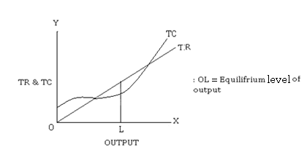

- MC & MR Approach
  - According to this approach, producer is in equilibrium when two conditions are satisfied.
  - (i) MR = MC (II) MC is rising (MC curve cuts MR curve from below).
  - Diagram :
(Under perfect competition)

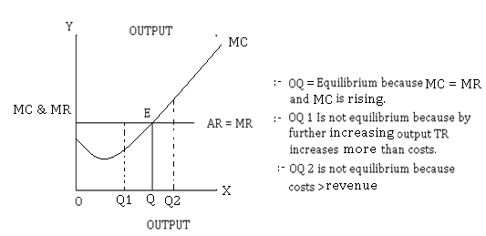

  - Diagram :
(Under monopoly)

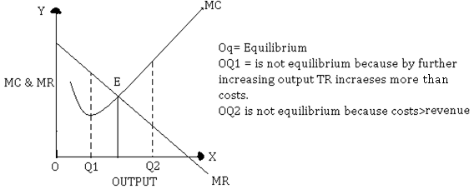

- Producer’s equilibrium – Short period :-

- Short period means a period of time when  new firms cannot enter the industry 
existing firms cannot leave the industry  no. of firms remains constant.
- Existing firms may earns super normal profits.
- TR > TC and AR>AC.
- Because there is no competition from other firms.
- If existing firms in cur losses due to TR<TC or AR<AC they will continue to do so because they cannot profits leave.
- Existing firms may earn normal profits TR=TC or AR=AC
Abnormal profit situation:
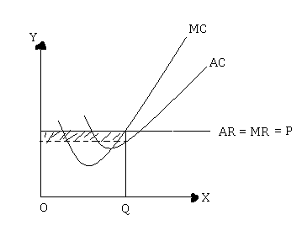

- OQ = Equilibrium output
- At + OQ, AR>AC
- Super normal profits. (Shaded portion)

Abnormal losses situation:

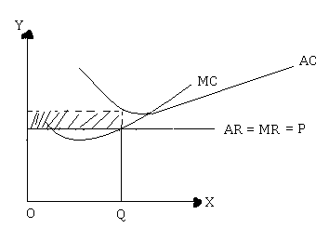
- OQ is Equilibrium output
- At OQ, AR<AC
- Abnormal losses (Shaded portion)
Normal profit situation:
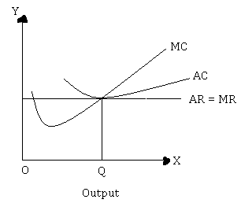
- OQ is Equilibrium level output
- At OQ AR=AC
- Normal profit.
- Firm just cover all its costs.
- Normal profit is part of costs.
- Producer equilibrium - long-period
 Long period means a period of time when  new firms can enter the industry 
existing firms can leave  no. of firms keeps changing.
- New firms enter the industry (due to sub. Normal profits)
- Market supply increases.
 Price (AR) decreases.
 Process continues till all super normal profits are eliminated (when AR = AC)

- Existing firms can leave (due to losses)
- Market supply decreases.
- Price (AR) will increase.
- Process continues until losses are eliminated. (when AR = AC)
- Thus there will be only normal profits in the long run.

- Diagram:

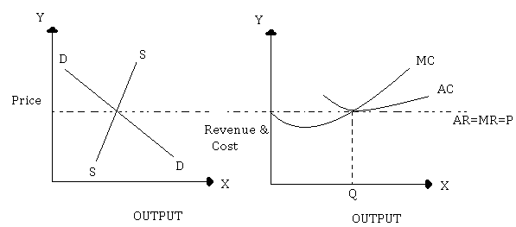

- OQ : equilibrium output in long run because  MC = MR & MC is rising & AC = AR
- Break even point : When TC = TR or AC =AR i. e. normal profit situation in the long run.
- Shut down point : When TR = TVC or when AR = AVC
- Here firm is incurring loss of fixed Cost.
- Diagram -
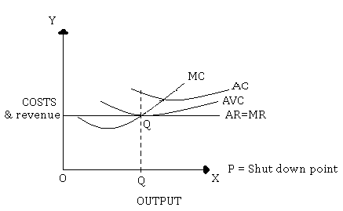

Micro Economics Most Probable Question Areas

- Explain the problem of “ what to produce ? with example 4Marks
or
Explain the problem of how to produce? with example.
Or
Explain the problem of whom to produce?
- What does a PP curve show? Why is it concave to origin?
Or
Explain the effect of economic growth / growth of technology or PP curve.
Or
Draw a PP curve & show the following situations on the diagram. 4Marks
  - Full employment of resources.
  - Under utilization of resources.
  - Economic growth.
- Explain the features of market economy? 4Marks
Or
Explain centrally planned economy.
- Explain the consumer equilibrium by utility approach. 6 Marks
Or
Explain the determination of consumer’s equilibrium through budget
line & indifference curve.
- Explain the determinants of demand. 6 Marks
Or
Explain the determinants of supply.
Or
Explain the law of demand. (Statement, Assumption, Exceptions, Causes)
Or
Distinguish between movement along & shifting of demand curve.
Or
Distinguish between movement & shifting of supply curve.
- Explain the effect of changes in demand on market equilibrium. 6 Marks
Or
Explain the effect of changes in supply on market equilibrium.
- Explain the law of variable proportion. 6 Marks
Or
Explain various returns to scale. Describe the causes of increasing returns to scale.
- Explain the main features of perfect competition. 4 Marks
Or
Explain the features of monopoly.
Or
Explain the features of monopolistic competition.
Or
Explain the features of oligopoly.
- Distinguish between fixed cost and variable cost with example. 4 Marks
or
Explain the relation between average cost and marginal cost.
Or
Why AC curve and MC curve is U-shaped?
- Explain the producer equilibrium with TR-TC approach. 6 Marks
Or
Explain the producer equilibrium with MR-MC approach.

The-End

